**1.Everyday Ayurveda**

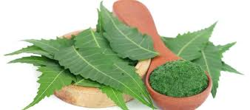

The science of Ayurveda can be viewed as an umbrella discipline or ‘mother’ of many modern-day alternative therapies. An important aspect of Ayurveda lies in its ability to understand and describe the subtle energies and intelligence flowing through our bodies. We will know about different body types, various cycles of Ayurveda, Lifestyle and behaviour etc.

The ancient science of Ayurveda has as much relevance today as it did to people of ancient India, where it originated at least 5,000 years ago. In the 21st century, we use Ayurvedic wisdom as a tool for balancing our lives—whether we want to have more energy, lose weight, improve our moods, or simply feel healthier.

Ayurveda is based on the principles of living in harmony with the cycles and rhythms of nature. As, you will see, its concept is natural and simple, yet highly effective.

The Five Mahabhutas (Elements)

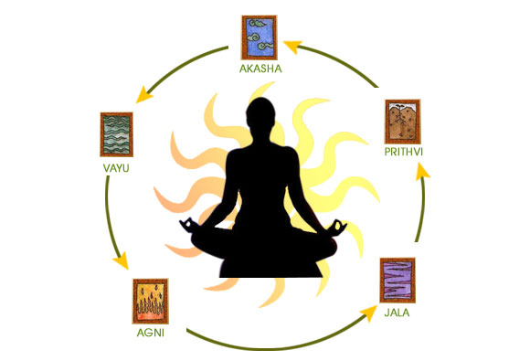

In Ayurveda, the universe, the world, all matter, and all living things (including people) are comprised of combinations of five elements: Space (or “Ether”), Air, Fire, Water, and Earth.These five (pancha) are called the mahabhutas, or panchamahabhutas.

Knowing the physical and energetic characteristics of each of the mahabhutas is key to understanding Ayurveda because these elements combine in infinite variety to create our personal mind/body constitutions, and they are the building blocks for creating balance.

When the body is out of balance, mahabhutas with opposite qualities are used to return that imbalance to balance (ie., health and well-being). The Panchamahabhutas are fundamental to Ayurvedic diagnosis and treatment.

* SPACE (akash in Sanskrit) is empty, formless, weightless, and clear. Sometimes called “Ether,” Space refers to the sky rather than “outer space.” In the body, Space correlates with spacious places such as the abdomen, chest cavity, mouth, nose, and gastrointestinal tract. Psychologically, Space gives rise to feelings of peace, freedom, compassion, isolation, emptiness, and anxiety.

Sense: Hearing (sound) Organ: Ear

* AIR (vayu in Sanskrit) is dry, cold, light, clear, and full of motion. A harsh wind is a good example of this mahabhuta. In the body, air moves through the lungs (respiration), brain (synapses and nerves), muscles (heart and circulatory systems), and through the intestines (elimination). Emotionally, Air expresses as happiness, excitement, fear, and anxiety.

Sense: Touch Organ: Skin

* FIRE (tejas in Sanskrit) is hot, changeable, dry, and illuminating. In nature we see Fire in the sun, which provides light and warmth. Anatomically, Fire is associated with metabolism, sight, and the digestion, absorption, and assimilation of food. Fire is the emotional source of anger, hatred, ambition, and drive.

Sense: Sight Organ: Eyes

* WATER (aap in Sanskrit) is flowing, wet, heavy, cold, and cohesive like the ocean. In the body, Water is represented by plasma, saliva, cerebrospinal fluid, urine, sweat, obesity, and edema. Emotionally, Water creates contentment, love, and compassion.

Sense: Taste Organ: Tongue

* EARTH (prithvi in Sanskrit) is heavy, cold, dense, stable, and solid—just think of the characteristics of dirt. Earth manifests in the body as all the anatomical structures: bones, nails, teeth, hair, and skin. In terms of emotions, Earth is associated with groundedness, growth, forgiveness, attachments, greed, and depression.

Sense: Smell Organ: Nose

**2.Ayurvedic Body Types and Nutrition**

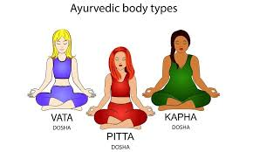

Each of us has a unique body-type, named as Vata, Pitta and Kapha. Vata, pitta and Kapha are known as doshas in Ayurveda; they are the underlying principles that govern the nature, transformation and structure of the physical universe. Each dosha is composed of two of the five elements (ether, air, fire, water and earth) and it is the specific combination of these elements that determines each doshas characteristic qualities and ultimately their overall effect in nature. Every object in the natural world is composed of the elements of vata, pitta and kapha and it is the relative proportion of each dosha or element that determines its uniqueness and differentiates it from another objects.

Vata is composed of the elements of ether and air and governs the principle of movement and communication in our physiology. Pitta is composed of the elements of fire and water and governs the principle of energy and transformation in our physiology. It allows us to digest, absorb and assimilate food, liquid and ideas. Kapha is composed of the elements of water and earth and governs the principle of cohesion or structure. It is the ‘glue’ that holds or binds our physiology together.

A person with a predominance of Vata dosha walks more quickly, has a lighter build and has colder and dryer skin than someone with a predominance of Pitta or Kapha dosha in their constitution. Vata-type people also tend to have very quick, agile minds and can be very creative. However, if their constitution goes out of balance through excessive movement or irregularity they can suffer from feelings of restlessness, boredom, fear, stress and anxiety. This may manifest in the body as poor circulation, cold hands and feet, constipation and dry skin.

A person with more Pitta in their constitution has a hotter, fierier, more dynamic personality. They have lots of energy, high ambitions, sharp intellects and good leadership qualities. However, if they go out of balance and their innate ‘fire’ becomes too high they can quickly become angry, stressed and frustrated. They generally have a strong digestive fire and immune system but when they slip out of balance, they can develop rashes, ulcers, acid stomachs and heart problems.

A person with a predominance of Kapha dosha in their constitution is generally slower, heavier, calmer and more grounded than either Pitta or Vata. They are caring, loving, forgiving individuals with a placid, easy-going nature. They have strong, solid bodies but can suffer from weight gain, lethargy and heaviness when they are out of balance.

**3.A Balanced Diet and Nutrition**



Food is central to Ayurveda because what we put in our bodies ultimately builds our dhatus and provides the fuel for life. For, that reason, Ayurveda favours vibrant foods that are full of vital life energy, or prana. Those foods include organic fruits and veggies, high-quality grains and oils, and whole foods in general that are not overly processed or synthetic.

Foods that are frozen, canned, and refined are devoid of nutritional value and are usually processed with artificial colours, flavourings, additives, preservatives, chemical pesticides, and genetically altered ingredients. These foods lack prana and contribute to an array of imbalances and illnesses.

Increase the following foods in your diet:

• Whole grains and legumes (brown rice, quinoa, barley, beans, lentils)

• Fruits and vegetables (local and seasonal whenever possible)

The following high-quality foods should be used sparingly:

• Natural sources of sugar (honey, maple syrup, stevia, agave)

• Nuts and seeds (sunflower, pecans, flax seeds, walnuts, almonds)

• Unrefined oils (organic sunflower oil, extra-virgin olive oil, ghee)

* SWEET Sugar, milk, butter, ghee, sweet fruit, bread, pasta, grains
* SOUR Yoghurt, lemon, vinegar, wine, soy sauce, grapefruit, aged cheese
* SALT Salt (also in vegetables; especially celery and seaweeds)
* PUNGENT Hot, spicy foods such as pepper, ginger, garlic, cayenne, chilli
* BITTER Leafy greens, olives, turmeric, horseradish, turmeric, fenugreek, nettle, lettuce, aloe
* ASTRINGENT Beans, lentils, dhal, honey, rhubarb, apples, leafy greens, pomegranate, sprouts.

The tongue has taste buds which register all the above six tastes. If the body receives all these tastes in each meal it feels satisfied and will not overeat or feel hungry again soon after eating. However, there are far more taste buds that register the sweet as opposed to astringent or sour taste. This is because we do not require equal amounts of each taste. There are more ‘sweet’ taste buds because this is the taste, we require the most of; sweet tasting foods, such as rice and milk, are nourishing and give us protein, energy and vitality. They are heavy and grounding and are required by Vata types much more than Kapha types.

**4.Ten Tips for Eating Mindfully**



Eating with greater awareness is another primary Ayurvedic dietary guideline. Rather than eating certain foods out of habit or to fulfil cravings, put greater time and attention into the foods you choose. Take the time to savour the food as you’re eating it. Mindful eating can be particularly helpful for managing weight.

1. Sit down to enjoy your meal and foster better digestion. Eat at a moderate speed (no gobbling) and focus on the food, not the TV or other distractions.

2. Favour warm or room-temperature liquids over cold, carbonated beverages.

3. Eat until you’re about two-thirds full rather than completely satiated to avoid overeating.

4. Don’t eat meals late at night.

5. Chew your food thoroughly: 32 times per mouthful.

6. Choose healthy snacks.

7. Take a moment to give thanks for the food you’re consuming.

8. Avoid eating frozen, leftover, packaged, or microwaved foods.

9. Incorporate seasonal foods into your diet.

10. If you don’t currently eat organic foods, begin by buying at least one organic item per week.

**5.Ten Tips for An Ideal Daily Routine**



Ayurveda prescribes a daily routine that’s in tune with nature, called a dinacharya. It’s the way a person would ideally spend the day for good health and well-being. Here’s an outline of a dinacharya:

1. Wake up early.

• Rise at sunrise, or even before, to appreciate the peace and quiet of morning.

• Start the day by consciously feeling gratitude, saying a prayer, or meditating.

2. Practice daily hygiene.

• Brush your teeth and scrape your tongue using a stainless-steel scraper or spoon. If your tongue’s coating is thick and white, that’s a sign of too much ama in the system.

• Wash your face and eyes with cool water.

• Rinse your mouth with sesame oil.

• Put sesame-oil nose drops into both nostrils to clean the sinuses and lubricate the nasal passages— especially during winter.

• Drink a cup of warm water with lemon juice.

• Sit on the toilet at the same time every day and have a bowel movement. Proper and regular elimination is vital.

• Do a full-body self-massage with warm oil, which rejuvenates the skin, stimulates circulation, calms the nervous system, and lubricates joints. This can take as little as 15 minutes.

• Shower or bathe.

3. Exercise or do yoga. Physical activity is recommended in the morning.

4. Eat breakfast between 7:00 and 7:30 am

• This should be a light meal.

• Eat only when you feel hungry.

5. Go to work or school. Perform your tasks throughout the day with awareness and compassion.

6. Eat lunch between 11 am and 1 pm

• Eat only when you feel very hungry.

• This should be the largest meal of the day because your agni is strongest around noon.

• Sit quietly for 5 minutes after eating. Then walk for 5 to 15 minutes to aid digestion.

7. End the day’s work with a walk-in nature. Mild exercise and quiet time when you can reconnect with the natural environment will relax and rejuvenate you.

8. Eat dinner between 6 and 7 pm

• Have a light to moderate meal.

• Sit quietly for 5 minutes after eating. Then walk for 5 to 15 minutes to aid digestion.

• Avoid eating within two hours of bedtime to assure that your food is digested before sleep.

9. Before-bed routine.

• Do some spiritual reading.

• Drink warm milk to induce sleep.

• Meditate for a few minutes.

10. Go to sleep at the same time (around 10:30 pm) each night.

• Ayurveda describes sleep as the “diet of the mind” because it rejuvenates both the mind and body.

• To obtain the most restful sleep, try to retire around 10 to 10:30 pm, go to bed at the same time each night, and eat your dinner at least two hours before bedtime.

• Get at least seven hours of sleep per night. Studies show that anything less makes it more difficult for the body to detoxify and release body fat.

• We’re also likely to overeat when we’re tired, and fatigue can cause sugar and caffeine cravings.

**6.Ten Tips for Positive Lifestyle Changes**

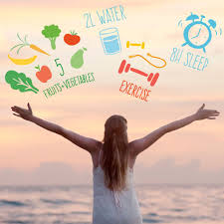

1. Eat foods that are fresh, alive, and vibrant, such as fruits and vegetables, complex grains, nuts, seeds, sprouts, and clean water.

2. Eat small portions and chew your food well.

3. Drink plenty of water, about one ounce per two pounds of body weight each day.

4. Meditate daily for 20 minutes or engage in some form of regular self-reflection.

5. Undertake 30 minutes of brisk physical exercise daily.

6. Practice going to bed early and waking up with the sun.

7. Minimize compulsive habits such as smoking, drinking alcohol, and using drugs or tobacco.

8. Attempt to do something good daily.

9. Treat your body like a temple, not a trash can.

10. Do cleanses twice a year (spring and fall).

**7.Meditation**



Meditation is one of the easiest ways to give your mind a break from an endless stream of thoughts and sensory impressions. The practice of meditation is found around the globe and is not bound to any one correct method. In fact, any person of any culture or faith can meditate.

Modern scientific research has shown regular meditation practices increase positive emotions and immunity, and have the ability to reduce anxiety, blood pressure, cholesterol, and muscle tension.

Health Benefits of Meditation

• Slows breathing, heart rate

• Helps lower blood pressure

• Minimizes muscle tension and headaches

• Reduces anxiety attacks

• Elevates mood

• Allows the body and mind to relax

• Mitigates symptoms of chronic conditions like allergies and arthritis

• Speeds post-operative healing

• Reduces premenstrual symptoms

• Boosts the immune system

Early morning and early evening are particularly good times to meditate. We recommend spending a few minutes each day in meditation and focusing on breathing.

There are a number of techniques that people use to achieve a meditative state: Some use relaxed concentration; others allow a free flow of thoughts and observations.

• Sitting Meditation: Sitting on a floor mat or pillow with the legs folded into a lotus position. (A variant is sitting upright in a chair.)

• Walking Meditation: Walking mindfully while remaining aware of your surroundings.

• Mantra Meditation: Specific sounds or words are repeated to achieve a meditative state.

• Gazing Meditation: A steady gaze is placed onto an object.

Vedic Meditation instructions

• Allow yourself 15-20 minutes of undisturbed silence in a calm, peaceful environment.

• Start by sitting comfortably and relaxing with the eyes closed for a few minutes.

• Have the intention to meditate – this means putting aside any ideas of using the time allocated to simply rest, sleep or mull things over.

• Now slowly, innocently and effortlessly become aware of your breath.

• Notice the gentle sound of ‘so’ on each in breath and the sound of ‘hum’ on each out breath.

• Do not deliberately mentally repeat the sound – just allow it to be there in your awareness – it should almost seem to repeat itself - just observe it and allow it to become naturally independent of the breath - allow it to become fainter and fainter, quieter and quieter, more and more distant until it almost fades away. Allow it to eventually fade away.

• As it fades away the mind settles down, relaxes and occasionally transcends – often stresses are released as this happens. Stresses are released on the back of thoughts – thus, as you release stress you will have thoughts. The more powerful the stress being released the more powerful and absorbing the thoughts will be that surface in your awareness.

• As soon as you become aware of thoughts other than the mantra (‘so-hum’) gently ‘favour’ the mantra again – i.e, gently, innocently and effortlessly go back to witnessing the mantra. The bigger the stress being released the more your mind will present you with thoughts – just innocently and effortlessly let them go rather than staying with them and turn your awareness back towards the mantra (so – hum) instead.

• It is important to realise that it is rare to meditate without lots of thoughts also being present. This is a sign of correct meditation. Meditation releases stress – hence thoughts will frequently arise.

• Meditation is only experienced as ‘difficult’ or ‘boring’ when we start straining to ‘hold’ the mantra in our awareness and ‘try’ to ‘focus’ or ‘concentrate’ on keeping the mantra present in our mind and ‘keeping’ or ‘forcing’ other thoughts out. Thoughts are part of meditation – thoughts are good – thoughts are stresses disappearing forever.

• Meditation is not about concentrating, focusing, contemplating or forcing the mind. Meditation is about gently, innocently and effortlessly ‘favouring’ a sound (mantra) – it is about quietly witnessing and allowing thoughts to flow unhindered and then effortlessly coming back to the sound (mantra) when other thoughts have taken its place.

• After 15-20 minutes stop ‘favouring’ the mantra and sit quietly with the eyes still closed for 2-3 minutes. This allows the mind and body to fully integrate and process the experience to gain maximum benefits.

• If there have been many thoughts during the meditation, rest for longer (up to ten minutes) as it is a sign that you have released lots of stresses and need longer to integrate the experience.

• Practice for 15-20 minutes twice a day. Dawn and dusk are the best times as the mind and body are more alert and relaxed. Avoid practicing immediately after a large meal or before bedtime (it wakes you up!).

• Try and practice at the same times each day so that the mind already comes prepared. Have the intention to meditate and then allow a few minutes for the mantra to appear of its own accord – if it doesn’t spontaneously appear then quietly and innocently introduce it as a ‘vague’, distant idea. It may or may not follow the breath and it is unimportant whether it does or not – some people find it easier if it does and some don’t. Don’t worry about how often the sound disappears and other thoughts arise; just simply bring the mantra back again as quietly as possible.

**8.Panchakarma Therapies**

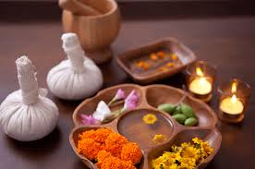

During the various stages of a Panchakarma detox a variety of treatments will be given. They involve the application of warm, herbalised oil through the medium of massage. Many of the massage therapies last over an hour and are harmoniously administered by two therapists working in tandem, one on either side of the body. The aromatic oils help loosen and dislodge toxins and impurities stored within the deeper tissues.

Massage therapies may be followed by a second treatment; either svedana - a herbal steam therapy which dilates bodily channels and mobilises impurities trapped within them - or Shirodhara which relaxes the mind and pacifies the energy of vata dosha.

The primary oil used in the massage treatment is Sesame oil which has been shown to have powerful anti-carcinogenic, anti-melanoma and antioxidant effects. Its potency is increased by a special ‘curing’ process and by infusing the oil with a decoction of Ayurvedic herbs.

The type of massage selected and the depth and speed of the massage depends on your Ayurvedic constitution (prakruti) or imbalance.

Abhyanga: A full body massage usually administered by two technicians working in perfect synchrony on either side of your body. Warm, herbalised sesame oil is lovingly and soothingly applied in a continuous flowing sequence to relax and balance the physiology. The oil penetrates the pores of the skin and subcutaneous adipose tissues and loosens impurities and toxins which have accumulated there. The massage may last for over an hour depending on the speed and depth chosen to suit your Ayurvedic body-type.

Other benefits:

• Balances all three doshas; vata, pitta and kapha

• Promote flexibility and suppleness

• Increases strength, energy and vitality

• Improves the quality of sleep

• Increases softness and lustre of the skin

• Reduces the signs of aging (rejuvenating)

• Decreases stress, anxiety and fear and balances the mind and emotions

Vishesh: An invigorating sports-type massage with firm, kneading actions to help promote the release of deep-seated imbalances, toxins and impurities. It is especially helpful for soothing sore, tired or aching muscles.

Other benefits:

• Balances all three doshas; vata, pitta and kapha

• Promotes weight loss

• Relaxes the mind

• Lubricates and increases flexibility in the joints

Pizzichilli: A unique relaxation experience – two therapists slowly and gently massage and bathe the body in gallons of warm aromatic sesame oil for up to one hour. Aches and pains, cares and worries are effortlessly released in a continuous flow of liquid golden nectar.

Other benefits:

• Pacifies vata

• Lubricates and thereby alleviates pain and promotes flexibility in the joints

• Alleviates pain and soothes tired, aching or sore muscles

• Moisturises and softens the skin

Udvartana: A fast, vigorous massage with a coarse herbal paste of barley and chickpea flour. It enlivens and energises the body helping promote better digestion, healthier skin and firmer muscle tone.

Other benefits:

• Reduces access ama

• Pacifies Kapha

• Increases circulation to the subcutaneous tissues

• Defoliates and cleanses the skin

• Breaks down fatty deposits and cellulite and helps with weight loss

**9.The Seven Dhatus (bodily tissues)**

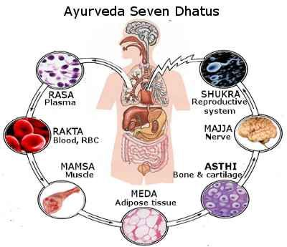

Whilst imbalances in the doshas (vata, pitta and kapha) are the cause of disease the dhatus are the sites of disease. Our tissues are produced from the food we eat - the waste material or by-product is expelled as feces and urine. Each tissue develops from the previous one in a progressive cycle from gross to subtle. Thus, from the grossest tissue, rasa (lymph or plasma) the second tissue, rakta (blood), is formed and from rakta, mamsa (muscle) is formed.

From mamsa, meda (fat/adipose tissue) is formed, from meda, asthi (bone) is formed, from asthi, majji (bone marrow or nerve tissue) is formed and from majji, shukra (reproductive tissue) is formed. This process is similar to the production of cream from milk, butter from cream and ghee from butter – the special cooking of one leads to the formation of the other.

Thus, from the basic plasma of the body, rasa (lymph), all the other tissues of the body are produced – each is produced from the proper digestion of the other and problems in any one tissue tend to cause problems in the rest. Also, the more subtle tissues support the grosser tissues and store their concentrated energy. Thus blood is concentrated plasma, muscle is concentrated blood and fat is concentrated muscle.

The grosser tissues (plasma, blood and muscle) are larger in quantity as only a portion of each is converted into the next more subtle tissue, with reproductive tissue being the subtlest and most concentrated and enduring. It takes thirty-five days for the food we eat to work its way through the seven tissues to become reproductive tissue. As reproductive tissue is the essence of our life-energy and upholds all the other tissues we need to be extra careful that this tissue doesn’t become depleted.

* Plasma (rasa): This tissue is composed mainly of water and is that which all the other tissues of the body are suspended. When properly maintained it helps nourish all the other tissues in the body, providing adequate hydration and electrolyte balance. When plasma is deficient, we are more prone to rough skin, cracked, dry lips, dehydration, lethargy, tremors, palpitations, pain and feelings of emptiness. If we maintain plasma in an optimal state, we have a healthy, glowing complexion with soft, smooth skin and luxurious, shining hair. Balanced plasma tissue creates vitality, stamina, compassion, contentment, pleasure and a happy disposition generally.
* Blood (rakta): This tissue is composed of fire and water and provides oxygen to the tissue cells. It is the container for pitta in the body. Excess blood creates skin diseases, abscesses, fevers, inflammation, bleeding disorders, enlarged liver and spleen, hypertension, jaundice, weak digestion and burning or redness in the eyes, skin and urine.
* Muscle (mamsa): This is a heavy, predominately kapha tissue and makes up much of the bulk of the body – it is composed primarily of the earth element and serves to bind it together whilst giving it strength for action. In excess it creates swelling or tumours in the muscles, heaviness and swelling in the glands, obesity, enlarged liver, irritability and anger. It can also impair sexual vitality and cause fibroids and miscarriage in women.
* Fat (meda): This is another kapha tissue which is composed mainly of water but is more refined type than plasma. It serves to lubricate the body (especially the muscles and tendons) and creates a feeling of being protected or ‘cared for’ – obesity is often the result of feeling unloved or uncared for; fat acts as a psychological barrier or protection instead.
* Bone (asthi): This tissue is composed mainly of earth and air. It functions to support and uphold the other tissues – it gives them firmness and a strong foundation. Bone is the container for vata in the body – it resides in the bone spaces.
* Reproductive tissue (shukra): This is again a kapha tissue and is the essential or causal form of water – it has the power to create new life. In excess we are prone to anger and unhealthy sexual desires, semen stones, inflammation of the prostrate and cysts in the ovaries and uterus.

**10.Pranayama**

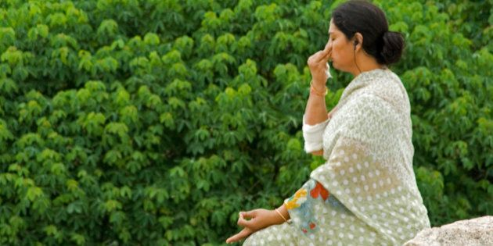

Through the practice of pranayama (a controlled breathing exercise) we bring conscious awareness to the breath, uniting mind and body in a present moment experience. Through this awareness, and with a little practice, we learn how to access our inner wisdom and increase our Prana, the omnipresent life force, that determines the amount of energy, clarity and joy we have in our lives.

Pranayama is best practiced in the early morning when the mind is clear and free from the experiences of the day. Also, practiced after yoga asana, it can be the perfect transition into meditation. This is also a useful and simple tool to bring us into balance before an exam, meeting or presentation. Just a few minutes can bring us back to our centre, easing anxiety and nervous tension.

Alternate Nostril Breathing (Vata Pranayama): Nadi Shodhana, or alternate nostril breathing, is a type of pranayama that balances the right and left hemispheres of the brain and has a calming effect on the nervous system while creating a more alert mind. It cleanses the channels of the subtle energy body by removing energetic blockages along the nadis (channels) that correspond to the nerve ganglia on either side of the spinal cord. It is extremely centering, making it one of the best practices for vata dosha.

Begin by sitting comfortably on a cushion, folded blanket or in a chair, keeping the head and spine upright. Bring awareness to your breathing process, noticing the quality and length of each inhalation and exhalation. Breathe deep into your abdomen and keep the body relaxed. Position the right hand (you may choose to alternate with each practice) in vishnu mudra by folding the index finger and third finger inwards to lightly touch at the base of the thumb. Your little finger rests by the side of the ring finger.

You will alternately use your thumb to close your right nostril and your ring and little fingers, working as one, to close your left. Rest your left hand comfortably in your lap. The breath should never feel forced. Instructions: Breathe in gently keeping the breath relaxed, subtle and light. Block the right nostril with the thumb of the right hand and breathe out through the left nostril. Breathe in gently through the left nostril and then block the left nostril with the fourth finger and breathe out through the right nostril.

Breathe in through the right nostril, block the right nostril and breathe out through the left nostril. Continue for five minutes and finish by breathing in through the right nostril. If you are left-handed you will reverse these finger positions (thumb blocks left nostril and fourth finger blocks right nostril).

Always breathe in and out gently; do not force the breath and do not hold the breath. Breathe naturally and try to sit upright and in a relaxed and comfortable position. Envision the breath as a light thread of silk, lengthening effortlessly with each inhalation and exhalation. Practice for five to ten minutes. Rest after your practice and notice how you are feeling.

Once comfortable with this practice, you can begin mentally counting to four on your inhalation, pause at the space between the breath and then count to four as you exhale, so that the length of your inhalation and exhalation are equal. There are many variations of alternate nostril breathing. These advanced practices involve increased ratios of inhalation to exhalation, longer duration, and the incorporation of breath retention.

It is best to practice these under the guidance of a yoga teacher or therapist. They are intended as developmental stages to work through incrementally as the body gradually adjusts to the increased flow of prana. As with any subtle energy practice which activates prana, it is best to start slowly and steadily incorporate it into your daily practice. A shorter practice on a consistent basis will bring more benefit to the body than a longer practice every now and again.41

Here are some variations that will help with specific dosha imbalances within the physiology:

Left Nostril Breathing (Pitta Pranayama): This breathing exercise helps cool the mind and body and is excellent for Pitta imbalances. If the left nostril is blocked the body often feels overheated (a Pitta imbalance).

Instructions: Block your right nostril with your thumb (fourth finger if left-handed) and inhale gently through the left nostril. Block your left nostril with your fourth finger (thumb if left-handed) and breathe out through your right nostril. Repeat for five to ten minutes, finishing by breathing out through your right nostril.

Right Nostril Breathing (Kapha Pranayama): Helps warm the body and is excellent for Kapha imbalances. If the right nostril is blocked the body often feels cold.

Instructions: Block your left nostril with your fourth finger (thumb if left-handed) and inhale gently through the right nostril. Block your right nostril with your thumb (fourth finger if left-handed) and breathe out through your left nostril. Repeat for five minutes, finishing by breathing out through your left nostril

Fast Pranayama: This practice speeds up metabolism and helps with weight loss. It can also be practiced for 20-30 seconds before ‘alternate nostril breathing’.

Instructions: Repeatedly exhale quickly and forcefully through both nostrils. You will find that you naturally inhale after each out breath. Repeat this for about one minute and then rest for one minute. Repeat up to five times. You may find that the body heats up and begins to perspire slightly indicating that energy is flowing and circulation is improving.

Hissing Breath: This is good for cleansing and detoxifying the lungs and improving lung capacity.

Instructions: Take two deep abdominal breathes. On the next out-breath, breathe out through your teeth to make a ‘hissing’ sound. As you do so lean forward so that your head comes towards your knees. At the end out your out-breath immediately breathe in through your nose quite rapidly as your come up to an upright position again. Once your lungs are three-quarters full and you are in an upright position hold your breath for as long as is comfortable. Now repeat the process six more times.

Kapalabhati: This is also good for cleansing and detoxifying the lungs and improving lung capacity.

Instructions: Take two deep abdominal breathes. Now breathe in to three-quarters capacity. On the next out-breath, breathe out forcefully twenty times by repeatedly contracting the abdominal muscles. Now take two deep abdominal breathes and on the third, breathe in to three-quarters capacity and retain the breath for thirty seconds. Repeat these three more times. As you become more accomplished you can increase the number of ‘abdominal pumpings’ - up to forty and maybe even sixty. You will also find that you will naturally be able to hold the breath for longer – perhaps even up to two minutes duration.

Belly Breath: This is good for toning the abdomen, improving peristalsis and helping with weight loss.

Instructions: In a standing position bend your knees and rest your hands on the top of the knees - breathe out fully (hold the breath) and then contract abdomen up into diaphragm/rib cage – hold for as long as is comfortable. Exhale. Repeat this exercise several times. Alternatively, you can repeatedly contract the abdomen into diaphragm during the holding of the out-breath.

**11.Exercise**

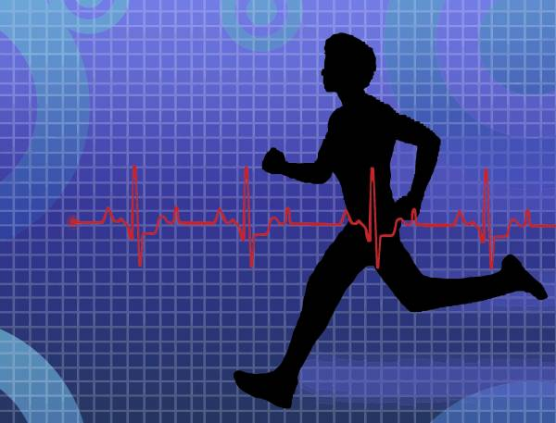

Exercise is an important part of the ayurvedic routine as it helps rid the body of heaviness and stiffness through the burning of ama or toxins. It creates greater flexibility, lightness, energy and stamina. It also pacifies all three doshas, creates balance, enhances digestion, improves immunity, dissolves impurities in the tissues, banishes fatigue, stops early aging and retards weight gain. However, too much exercise can be damaging, causing fatigue, lack of glow in the skin and face, pitta and vata aggravation and strain on the respiratory and cardiovascular systems. It can also create excess free radicals which damage the body and have been linked to over eighty percent of degenerative disease as well as premature aging.

Ayurveda therefore recommends that no more than fifty percent of total capacity is utilised, with individual capacity depending on daily fluctuations of energy, change of the seasons, age, and body type. Vata types needs the least exercise, so lighter activities such as walking are best. Pitta types need moderate amounts with swimming and skiing being good, whilst Kapha types need more intense exercise - jogging and aerobics are good to help them stay in balance. Do more exercise in winter and spring and do less in hot weather as this will create fatigue, especially in pitta body types.

Always start out slowly and only gradually increase the intensity and duration of exercise. Stop when you note signs of overexertion. You know when you're doing the right amount of exercise if you feel energized and calm afterwards. If you feel strained and exhausted, you're doing too much.

You can continue to exercise until you notice one of the following two signs of overexertion:

1. Difficulty in breathing through the nose. If you have to open your mouth to gulp in air, that's a sign that your heart is overexerted, the circulation system is taxed and the coordination of heart and lungs is disturbed. You should stop immediately.

2. Sweating on the forehead or the tip of nose. Sweating elsewhere in the body is fine but when you notice sweat in these two places it's a sign that you are overexerted and should stop.

Yoga asanas are the ideal form of exercise for all body types and ages, because they balance the three doshas, tone the muscles, and rejuvenate all the organs in the body. Practicing pranayama is also a good way to increase endurance. An abhyanga oil massage before exercise will tone the muscles, get the blood circulating and prevent injury or strain Exercise every day as part of your regular daily routine.

If possible, exercise in the morning before 10am as your body has more strength, stamina, and coordination during the kapha time of day. Exercising at this time also energizes you and prepares you for the day ahead. Exercising in the late evening or towards bedtime is not recommended as it can elevate body temperatures and disrupt sleep rhythms.

A light walk or yoga in the evening is fine. Also avoid exercise from 10am to 2pm, the pitta time of day, when the digestive fire is strong – this should be reserved for eating the main meal of the day. It's not a good idea to exercise on a full stomach - wait about two hours after eating a large meal.

However, if your stomach is empty and you are very hungry, have a light snack of fruit juice, cooked apples or some kind of light soup before exercising. It is important to breathe through the nose at all time during exercise as this uses the whole of the lungs and not just the upper portions. If you are breathing through the mouth you are over-exerting.

If you were at the zoo and a tiger escaped from its pen you would most likely take a quick upper-chest “gasping” emergency breath. This breath would trigger a fight-or-flight response in your nervous system as the upper lobes of the lungs are primarily innervated by the sympathetic nervous system.

The kind of “gasping” mouth breathing, much like a hyperventilation breathing pattern, is a normal breathing response to extreme stress. Unfortunately, this how most people breathe during exercise and this triggers the same neurological response. In contrast, the nerves that would calm, rejuvenate and regenerate the body are in the lower lobes of the lungs along with the majority of the blood supply.

The problem is that most people never breathe into these lower parasympathetic dominant lobes. They therefore create a minor but constant emergency situation which creates stress hormones and releases excess toxins into the body. Thus, we can see that exercise can act as a double-edged sword, where it can either incur stress or remove stress, depending on the quality of the breath.

The best way to consistently breathe into the lower lobes of the lungs is by nasal breathing. The nose is intricately designed to filter, moisten and rarefy the air we take in and drive it into the small and distal alveoli of the lungs. It is when these distal lobes are fully perfused with air that the body produces a neurological state of composure even while under extreme stress If you are unfit or aren’t used to exercise first go for a short walk before attempting anything more physical.

For the first ten minutes breath in and out deeply through your nose as you walk fairly slowly. This ensures you are exercising your lungs. Be vigilant and make sure that each breath is deeper, longer and slower than the one before – however, the emphasis should always be on comfort rather than style. It is this experience of comfort that you will eventually take you to higher levels of exertion. If you feel relaxed and comfortable, begin to walk faster but be sure to maintain the same rhythm of the breath you established at the beginning.

At some point you will notice it becoming more difficult to get the air in through the nose and an ensuing urge to take a mouth breath. When your exercise forces you to take your first mouth breathe, you have just forced the body into an emergency breathing response to maintain that faster pace.

Immediately slow down and recapture the original deep, long and slow rhythm of the breath. Once it is re-established, try to walk faster again, telling your body you want more performance. When the breathing gets laboured and you open your mouth again, slow down once more.

Constantly tell your body that you want more performance but that you don’t want to create an emergency response. Soon your body will accommodate a higher level of a natural and more permanent fitness. Because of the years of lower rib cage constriction, you will more than likely find this difficult at first.

But what you couldn't do the first day, you will find yourself effortlessly doing within two or three weeks, whilst comfortably breathing through your nose. When this happens your ribcage is effectively and efficiently massaging your heart and lungs up to 28,000 times a day. When this starts happening, a natural calming influence stays with you all day while you deal with all kinds of extreme stressors. Exercise has now become one of the your most important health-enhancing tools.

**12.Kapha Dosha**

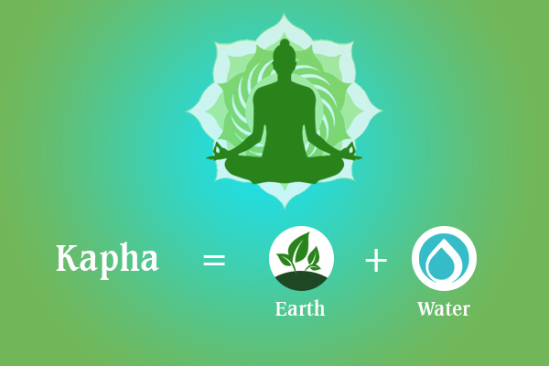

Kapha governs all structure and lubrication or fluid balance in the mind and body. It controls weight, growth, lubrication for the joints and lungs, and formation of all the seven tissues (lymph, blood, fat, muscles, bones, bone marrow or nervous tissue and reproductive tissues). You need to balance the heat of Kapha if many of the following conditions are present:

• You gain weight easily and find it very hard to lose weight.

• You tend to be overweight.

• You often feel dull, bored and lethargic.

• You lack energy and feel lazy or complacent.

• You experience sinus problems

• You have frequent and prolonged chest colds and flu.

• You suffer from congestive problems

• You suffer from asthma or bronchitis.

• You need lots of rest and sleep long hours.

• You wake up feeling heavy and un-refreshed.

• You find that you are possessive, greedy and over-attached.

• You feel discomfort in cold, damp weather.

• You experience bloating or water retention.

• Your digestion is slow and heavy even when you have only eaten a small meal.

• Your joints and muscles feel stiff and heavy, especially in the morning.

**13.Pitta Dosha**

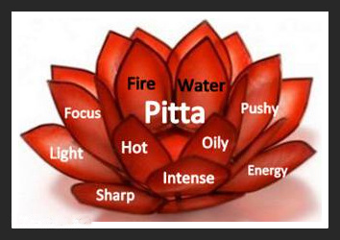

Pitta dosha is made up of the elements of fire and water through which it manifests the qualities of pungent, hot, penetrating, oily, sharp, liquid, spreading and sour. Its primary function is transformation and is the force of metabolic activity in the body associated with the endocrine function, digestion, body temperature, visual perception, hunger, thirst, and skin quality.

In Western terms we can categorise the activities of pitta in terms of amino acids, enzymes, bile, hydrochloric acid and hormones. This explains the seemingly contradictory combination of fire and water to form pitta. Pitta exists as water or oil in the body, thus preserving the tissues from the destructive aspect of fire. It resides in the eyes, blood, sweat glands and lymph but its primary site is in the small intestine.

Mentally it plays a role in understanding, in digesting sensory impressions. You need to balance the heat of pitta if many of the following conditions are present:

• Your skin is overly oily and prone to acne.

• You are prone to rashes, fevers or inflammatory skin conditions

• You have excessive hunger or thirst.

• You sweat profusely and have overly hot hands and feet.

• You suffer from infections, access acidity, ulcers and heart problems.

• You are overly aggressive and prone to anger and frustration.

• You experience lose or hot, watery stools and diarrhoea-type elimination.

• You tend to be overly critical, domineering, obsessive or controlling in nature.

• You experience frequent eyestrain or tension headaches.

• You are going prematurely grey or balding.

**14.Vata Dosha**

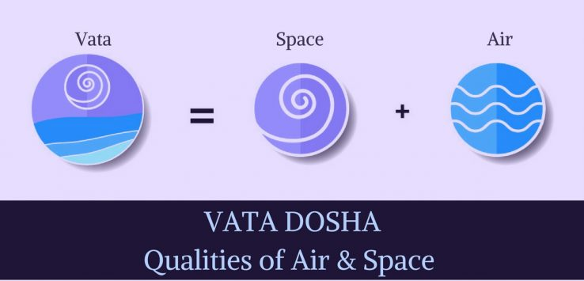

Vata governs all movement in the mind and body. It controls the flow of blood, the elimination of waste products, the act of breathing and the movement of thoughts in the mind. It is considered the leader of the three doshas (energies or energetic principles in the body) as Pitta and Kapha cannot move or exist without it. It is therefore imperative that Vata is brought back into balance whenever it is disturbed.

You need to balance the movement of Vata if many of the following conditions are present:

• Your skin or hair is dry, rough and thin.

• You feel cold easily or have poor circulation with cold hands and feet.

• You are chronically underweight and find it difficult to gain weight.

• Your mind is constantly anxious, restless and agitated and you are prone to worry and fear.

• You experience constipation or have frequent flatulence.

• You suffer from insomnia or have unsettled sleep and disturbing dreams.

• You suffer from vaginal dryness or menstrual cramps and PMT.

• You have spells of forgetfulness and absent mindedness.

• You experience discomfort or stiffness in the joints or lower back pain.

• You easily become fatigued and have poor endurance.

**15. Ayurvedic Herbs & Oils**

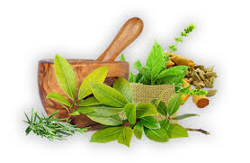

Herbs used in Ayurveda are classified according to their taste (rasa), their energetic effect (virya), their post-digestive effect (vipaka) and their post-digestive effect (prabhava). The initial taste (rasa) indicates the properties it possesses and the therapeutic effects it will have. Thus, a bitter, astringent taste will have a very different action on the body than a sweet, sour taste or a spicy, pungent taste.

It should be noted that no herb or oil should be taken or applied without first consulting with a qualified herbal practitioner, especially in pregnancy or if taking any kind of medication.

Aloe Vera (aloe barbadensis): Contains high concentrations of vitamins, minerals, amino acids, enzymes and natural sugars. It is good for the digestion, liver, blood, reproductive system and as a laxative. As a gel it is excellent mixed with ghee for burns and piles. Also helps with constipation, obesity, inflammatory skin conditions and conjunctivitis.

Andrographis (King of the bitters; Andrographis paniculata): It stimulates the immune system and is good for influenza, sore throat, gastrointestinal parasites and infections, urinary infections, respiratory infections, inflamed skin conditions, sores and eczema. It is also good for increasing bile flow and clearing liver infections and inflammation. Balances: Pitta and Kapha.

Asafoetida (Hing; Ferula asafoetida): Good for digestion and cleansing of digestive tract; it dispels gas and improves the intestinal flora. It is also useful for cramps, flatulence, constipation, arthritis, rheumatism, colic pain and asthma. Balances: Vata and Kapha.

Amalaki (Indian Gooseberry; Emblica officinalis): Good for constipation, ulcers, gastritis, colitis, hepatitis and haemorrhoids. It is a great antioxidant and helps lower cholesterol and heal damaged arteries. It is also good for diabetes, anaemia, hair loss/greying and general weakness. Balances: Pitta and Vata.

Ashwagandha (Winter Cherry, Indian Ginseng; Withania somnifera): The Ginseng of India with powerful rejuvenating and revitalising properties. It is calming and promotes sound sleep while being good for overwork, stress, insomnia, anxiety, ADHD, multiple sclerosis, emaciation, skin problems, rheumatism/arthritis, anaemia, infertility, fatigue, breathing difficulties, hay fever, allergic rhinitis, convalescence and nervous exhaustion. It improves greying hair, increases vitamin C and calcium levels, strengthens muscles and acts as a pain killer and anti-inflammatory for painful or swollen joints. It also helps relieve impotence, increases sperm count and is a tonic for the uterine muscles. Can also be used for dysmenorrhoea and infertility. Balances: Vata, Pitta and Kapha

Bibhitaki (Terminalia Belerica): A powerful Rejuvenative. It helps with liver and heart disease and also improves the voice, vision and promotes the growth of hair. It balances Kapha.

Bhringaraj (Eclipta alba): This rejuvenating herb is excellent for greying and/or balding hair, strengthening bones, teeth and hair and improving sight, hearing and memory. It is the best medicine for cirrhosis and the liver in general as well as being a good brain tonic and sleep-inducer. It is good for the complexion and when applied externally it helps reduce inflammation and draw out impurities from the skin. Balances: Vata, Pitta and Kapha.

Burdock (Arctium lappa): A blood cleanser, digestive stimulant and good for skin problems.

Chywanaprash A truly magnificent Rasayana or ‘super food’ which nourishes and strengthens both the mind and body. It has been taken as an ‘elixir of life’ for thousands of years and is now proving to be one of the strongest antioxidants known to man with the ability to arrest and improve many of our modern day diseases such as cancer and many auto-immune disorders. It is meticulously prepared with up to fifty different herbal compounds and has one of the highest concentrations of vitamin C of any natural product. It balances all three doshas and can be taken on a daily basis to strengthen the physiology and protect the immune system.

Devils Claw (Harpagophytum procumbens): Good for arthritis, rheumatism, gout and tendon damage.

Echinacea (Echhinasea purpuria): It cleanses the blood and lymph and destroys ama. It is good for lung problems, colds, flu, wound healing, skin complaints and viral/bacterial infections.

Gingko (Gingko biloba): An anti-oxidant and good for circulation, heart problems, memory loss, asthma, bronchitis, tinnitus and vertigo.

Ginseng (Panex ginseng): A general tonic for increasing energy levels and promoting weight loss and tissue growth.

Ginger Root (Zingiber officinalis): Helps relieve nausea, travel sickness, headaches, coughs, colds, menstrual cramping, poor digestion and poor circulation. It is toxin-digesting and anti-inflammatory for arthritic conditions, clears phlegm in the lungs, increases digestive enzymes, and is effective for gas, griping and E.coli or Shigella bacillus conditions. Balances: Vata and Kapha.

Gotu Kola (Indian Pennywort or Brahmi; Centella asiatica, Hydrcotyle asiatica, Bacoppa monniera): A brain tonic and best taken with honey to reduce stress, insomnia, ADHD and anxiety whilst improving memory and mental abilities. It detoxifies the liver and blood, reduces tumours, improves energy levels and strengthens the kidneys. It also helps with Alzheimer’s, acne, urticaria, eczema, arthritis, gout, wounds and skin inflammation. Balances: Vata and Pitta

Green Tea (Camelia sinensis): A very effective antioxidant – 200 times more powerful than vitamin E in neutralising free-radicals that attack lipids.

Guggul (Indian Bedellium, Commiphora mukul): Good for skin/tissue regeneration and reducing fat/toxins. It is often used to help arthritis. Balances: Vata, Pitta and Kapha

Haritaka (Terminalia chebula): A classic brain, nerve, digestive and energy tonic. It also helps regulate the colon and is good for both constipation and diarrhoea. Haritaka is the basis for Triphala. Balances: Vata, Pitta and Kapha

Liquorice Root (Glycyrrhiza glabra): Relieves coughs, sore throats, respiratory problems; abdominal pain and hyperacidity.

Neem (Azadiracta indica): A powerful anti-bacterial herb and blood purifier and good for many skin complaints (especially inflammation, eczema, psoriasis, urticaria and acne). In the gastrointestinal tract it helps with hyperacidity, ulcers, colitis, crohn’s disease, candida, fistulas and haemorrhoids. It can also help reduce inflammation in joints and muscles and regulate blood sugar levels in diabetes. It reduces fever and can also be used as a mouthwash for toothache and gingivitis. Balances: Pitta and Kapha

Passiflora (Passiflora incarnata): Promotes relaxation and helps with insomnia, agitation, anxiety, nervousness and stress.

Psyllium Husks Roughage for improving digestion, relieving constipation and cleansing the colon.

Sarsaparilla (Smilax ornate): Good for skin problems, digestion/ appetite, flatulence, gout, arthritis, rheumatism and nervous disorders.

Shatavari (Asparagus racemous): A particularly rejuvenating herb for the female reproductive system as it cleanses the blood and increases fertility. It is good to take during the menopause, as a menstrual regulator and for impotence, dysmenorrhoea, menorrhagia, diarrhoea, stomach ulcers, hyperacidity, cancer and chronic fever. It is also good and for soothing inflammation of the mucus membranes and is useful in colitis, crohn’s disease, hyperacidity, ulcers and gastritis. Balances: V ata and Pitta

Slippery Elm (Ulmus fulva): Reduces inflammation and is good for lung problems and ulcers.

Spiralina: A very high protein sea-plant that is excellent for weight loss, detoxification and reducing appetite.

St John’s Wort (Hypericun perforatum): Calms the nervous system and is beneficial for the treatment of mild depression and insomnia.

Turmeric (Curcuma longa): Used as an anti-inflammatory and circulatory stimulant. It improves skin conditions such as acne, rashes, dermatitis, eczema, urticaria and psoriasis; relieves pain and has anti-oxidant, anti-carcinogenic, anti-tumour, anti-bacterial, anti-biotic, anti-microbial, anti-viral, carminative and immuno-stimulant properties. It is good for asthma, allergies, burns, diabetes, rheumatoid arthritis, osteoporosis, obesity, digestive disorders, gallstones, liver disorders, tumours, reducing cholesterol, thinning the blood, cancer and ulcers. It also helps with uterine cysts and fibroids, endometriosis, dysmenorrhoea, amenorrhoea and leucorrhea. Balances: Vata, Pitta and Kapha

Trikatu A powerful tonic for improving digestion and relieving constipation. It is prepared by mixing ground ginger, black pepper and cayenne pepper (one pinch of each) in a little honey (one teaspoon). It balances Kapha.

Valerian (Valeriana officinalis): Good for nervous disorders such as tension and anxiety. It is also good for insomnia, fainting and menstrual cramps.

Wild Yam (Dioscorea villosa): Helps with hormonal imbalances, period pains, menopause, colic, joint inflammation, flatulence and liver cleansing.

Triphala formula contains Amalaki, Haritaki and Bibhitaki is considered a 'tri-doshic rasayana' – it is one of the most popular Ayurvedic herbal remedies as it helps rectify constipation and bowel irregularity but is also something of a universal panacea for a wide range of complaints.

It helps cleanse the blood and detoxify the liver as it possesses bitter anthroquinones which help stimulate bile flow and peristalsis.

## **16.Ayurveda For Kids**

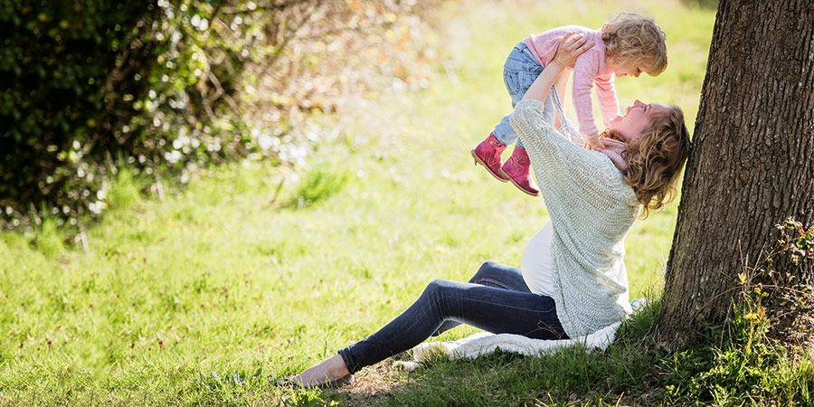

Most of us have had the experience of wanting to offer the best foot forward for the children in our lives—whether we have the privilege of raising them or are simply fortunate enough to know and love them.

As an art and science of living, Ayurveda has a great deal of wisdom that is just as easily applied to children as adults. We hope that this resource will help you to apply some of the ancient wisdom of Ayurveda to the children in your life—in support of their vibrant health.

We can keep kapha in check by feeding kids a balanced diet focused on naturally light, heating, dry, and fibrous foods like fresh fruits, vegetables, legumes, and whole grains. Ideally, we want these foods cooked, using generous amounts of warming, digestive spices such as garlic, ginger, cinnamon, and turmeric, and we want to serve them warm or hot.

Favor the pungent, bitter, and astringent tastes, and reduce kapha-provoking foods like wheat, dairy, and sugary sweets. If you’d like to know more, please see our resource on how to follow a Kapha-Pacifying Diet, as well as our list of Kapha-Pacifying Foods (which includes those best avoided).

### Lifestyle

Maintaining a strong level of physical activity is one of the most supportive lifestyle choices that we can encourage children to make because it improves circulation in the blood and the lymph, balances energy levels, supports the proper flow of nutrients, and bolsters detoxification mechanisms throughout the body’s organs and tissues. Regular exercise—even in the form of play—can dramatically curb kapha’s problematic tendency toward stagnation.

Herbs and Formulas

You can further support agni (the digestive fire) and continue to clear excess kapha from the system by offering children supportive herbs in honey. Experiment with different combinations of things like cinnamon, ginger, trikatu, turmeric, and sitopaladi. Give them a total of ¼ teaspoon of your favorite single- or mixed-herb combo, stirred into a spoonful of raw honey, one to three times per day.

This can be particularly beneficial during kapha season (winter and early spring), times of transition, or whenever a child is experiencing an acute kapha imbalance. You can also sprinkle a bit of trikatu powder (the same formula found in Kapha Digest tablets) on a child’s food like pepper to help to kindle agni and counter excess kapha throughout the system.

The Importance of Digestion

Ayurveda regards digestion as the very cornerstone of health. Therefore, whether they are dealing with an acute imbalance or not, we want our children to have robust digestive strength; it will help them to foster optimal health and well-being throughout their lives.

In order to function at its best, the digestive fire needs to be hot, sharp, dry, light, mobile, subtle, luminous, and clear. In the interest of protecting the natural intelligence of agni, we can also encourage the children in our lives to:

* Drink a glass or two of room temperature or warm water 20–30 minutes ahead of meals, while reducing the intake of fluids during the meals themselves.
* Practice gratitude before receiving a meal and eat mindfully (i.e. not while multitasking, on the go, or engaging with screen time).
* Eat a “ginger pickle” (a nickel-sized slice of fresh ginger, with ¼ teaspoon honey, a squeeze of lime juice, and a pinch of salt) 15–30 minutes before lunch and dinner.
* Enjoy plenty of digestive herbs and spices (garlic, ginger, cinnamon, cumin, coriander, pepper, trikatu).
* Leave plenty of space between meals for proper digestion without snacking in between (ideally, at least three hours).
* Take a deep breath before transitioning from a meal to the next activity. Invite a connection with the sensations of being full and satisfied.

 The Importance of Routine

As many of you who are already familiar with Ayurveda know, a daily routine is considered critically important to our overall health and wellness, and a routine may be even more important for children. Routines create safety, stability, and trust for a child’s nervous system while supporting their physiology to develop healthy habits.

### Healthy Sleeping Habits

Children need considerably more sleep than adults, and while their sleep habits will change dramatically from infancy through puberty, ensuring that they get enough of it is critical.

Develop as much consistency as possible around when children nap during the day (if applicable), go to bed at night, and awaken in the morning. Obviously, their schedule will need to adapt as they grow and their needs change, but there’s no question that consistent sleep routines foster health.

### Healthy Eating Routines

Children do best when their bodies can rely on eating at predictable times each day. Ideally, their eating routines should be focused around several substantive meals, served at about the same times each day, and that provide their primary source of nutrition—with minimal snacking in between.

Most kids do well with three meals a day, but this may need to be adapted according to each individual’s constitutional type and digestive strength. Some kids will need to eat more frequently than that, or at least be supplemented with a snack or two.

Do your best to allow at least three hours between each meal or snack. This will allow the digestive fire to fully process each one before more input is introduced. It also helps the body to develop healthy habits in terms of regulating blood sugar and energy levels.

### Healthy Lifestyle Habits

When it comes to lifestyle, it will generally benefit kids to cultivate consistency and predictability wherever possible—especially around mealtimes, playtimes, nap times, bedtimes, and waking times.

This doesn’t mean that life should be rigidly structured with no room for spontaneity. But it is helpful for kids to have a structural framework within which variety can emerge. A life that’s completely unpredictable is rather hard on children’s nervous systems, and a lack of routine also makes it much more difficult for kids to stay connected to their natural circadian rhythms and bodily intelligence.

Mindfulness and Meditation for Children

Similarly, very young children can be encouraged to observe their bodies and their minds in age-appropriate ways, as long as this is done in short stints that the children can manage.

They can sit and count their breaths, observe a candle as they sit peacefully (in a safely supervised way), close their eyes and invite serenity for a minute or two, or be encouraged to give their full attention to receiving nourishment at a family meal.

Children will also learn a great deal from observing the adults in their lives taking time to engage with mindfulness and meditation, so prioritizing these practices yourself will surely have a long-term impact as well.

Here are a few easily-accessible suggestions:

* **Chyavanprash.** One traditional Ayurvedic formula that is fabulous for children is Chyavanprash, a nutrient-rich jam made of amalaki fruit and other supportive ingredients. Chyavanprash is a strong rejuvenative, which supports the physiology of childhood while bolstering the immune system. Most children like the taste of it and will happily take a spoonful or two every day. You can also stir Chyavanprash into warm milk (or a milk substitute), warm water, or spread it on toast. For children, taking it plain on an empty stomach is often most effective, and you may find it especially helpful in the fall and winter months, during the cold season.
* **Spiced Honey.** Give ¼ teaspoon of single- or mixed-herb combinations (black pepper, cinnamon, cardamom, ginger, manjistha, sitopaladi, turmeric, or trikatu), stirred into a spoonful of raw honey, one to three times per day. The honey offers scraping and cleansing capacities while the herbs bolster digestive strength, support agni, and clear excesses in the doshas.
* **Ginger Honey.**Juice or press a large piece of fresh ginger and add a pinch of salt. Measure the juice and add twice as much raw honey. Mix well and keep refrigerated. Give to children one teaspoon at a time to stimulate agni, guard against stagnation, and promote warmth and clarity throughout the system.
* **Throat Soother.** Throat Soother spray helps to eliminate excess kapha from the throat while bolstering a healthy immune response. Most kids enjoy the taste and will happily take a spray or two several times each day.
* **Bronchial Support.** Bronchial Support syrup rejuvenates and bolsters health in the mucous membranes throughout the respiratory tract.
* **Supportive Teas.** Warming, clarifying herbal teas such ginger tea and licorice tea can be served with a teaspoon of honey to support both the respiratory tract and digestive strength.
* **Garlic and Ginger.** These foods are wonderful for stimulating digestive strength, clearing excess kapha, and strengthening the immune system. Cook with generous amount of them whenever a child needs a little extra support.
* **Garlic Ear Drops.** Peel a clove of garlic, smash it with the flat side of a knife. Let sit in a small bowl for 10 minutes. Pour 2 ounces of boiling water over it and let stand another 10 minutes. Strain into a sterilized dropper bottle. Cool and drop into the ear canal as needed to support the immune response and promote clarity and balance there. You can even fill the ear canal and have the child lie still for a couple of minutes before draining. Use within one week and make a fresh batch as needed.
* **Ear Oil.** These drops are gentle enough for children and can feel calming and soothing. To support healthy ears, use one drop of Ear Oil in each ear daily, warmed to body temperature. Occasionally, more oil may feel comforting. Use several drops in each ear, and like with the garlic ear drops, have the child lie still for a couple minutes before draining. (Ear Oil is not recommended when there is an infection or a perforated ear drum.)
* **Hot Steam and Baths.** Hot steam and water help to liquefy and clear stagnant kapha and can be very useful when children are experiencing an accumulation of kapha anywhere in their respiratory tract.

**17.Ayurveda For the Fifty Plus**

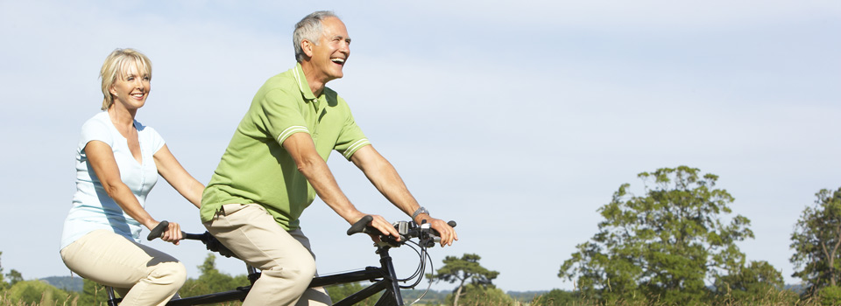

Who doesn’t want to remain looking and feeling young and vibrant as they grow older? Yet over the years, stress, environmental toxins, unsuitable foods and unbalanced lifestyle habits take their toll on your body.

Ayurveda, the world’s oldest system of natural medicine, offers a host of strategies for gaining better health and reversing the effects of ageing.

Each of us has a body-type dominated by one or more of these Doshas:

* **Vata** governs movement and circulation
* **Pitta** governs metabolism, digestion and energy production
* **Kapha** governs strength and bodily structures.

Different times of life are also associated with each of the Doshas:

* Our early, growing years are said to be a Kapha time of life when our body structures are being developed, and the ailments of childhood tend to be Kapha-related.
* Next comes the Pitta phase of life, from around 20 to somewhat beyond 50, where we build businesses, raise families, and generally rush around setting the world to rights.
* The age of 50 to 60 onwards is governed by Vata.

Tips to maintain your health after 50

* Maintain a regular daily routine.
* Get plenty of rest – bed by 10pm, and practise Transcendental Meditation a few minutes each day.
* Take Ayurvedic Rasayanas – strengthening herbal and mineral preparations – particularly Amrit Kalash.
* Enjoy a daily sesame oil massage.
* Exercise regularly to 50% capacity. Don’t strain!
* Have the main meal of the day at lunchtime, and eat mainly cooked foods rather than salads.
* Include Vata-pacifying foods such as carrots, tomatoes, broccoli, spinach, and Vata-pacifying spices such as turmeric, cumin, fenugreek, and asafoetida.
* Keep doshas in balance: From the age of 50 onwards, ailments are often Vata-related. Keeping Vata in balance can play a big role in maintaining health, happiness and energy.
* Stay warm: Vata has certain qualities – cold, rough, dry, irregular – which are balanced by opposite qualities. To help balance Vata, stay warm, avoid raw and dry meals, keep a regular routine and don’t over-do things.
* Maintain a regular routine: “Maintain a regular daily routine. Don’t rush around – use your insights and experience to guide others and delegate!”
* Keep your memory sharp: Memory loss is linked with a Vata sub-Dosha and results from too much strain in life. So avoid straining to help keep a sharp memory.
* Daily exercise: Exercise regularly, but just to 50 per cent of your capacity. A brisk walk every day would be fine.”
* Avoiding Osteoporosis: Bones are linked with Vata,“Keeping Vata settled helps keep bones strong.”
* Take Ayurvedic preparations: Ayurvedic herbal and mineral preparations, known as Rasayanas, are also recommended for nourishing bones, tissues, and keeping Doshas in balance.
* Rest is the best medicine: Vata is associated with movement and is best balanced by stillness.
* Get to bed early:Being in bed by 10 pm promotes good health. In addition, regular practice of meditation intensifies rest and promotes rejuvenation.
* Get deep physical rest:Transcendental Meditation (TM), a simple and easy-to-learn mental technique derived from the Vedic tradition by Maharishi Mahesh Yogi. TM, practised sitting comfortably in a chair, gives deep physical rest and mental alertness, and has been found to produce effects counter to many of those involved in the ageing process.
* Having the time of your life:“With proper attention to balancing Vata, the 50-plus phase should be the best time of our lives.“It’s a more spiritual, mellow, happy, intuitive, compassionate phase of life. And if we remain in balance, we don’t age in the sense of deteriorating so much as we mature, and retain our vitality.”

**18.Ayurveda For Improving Eyesight**

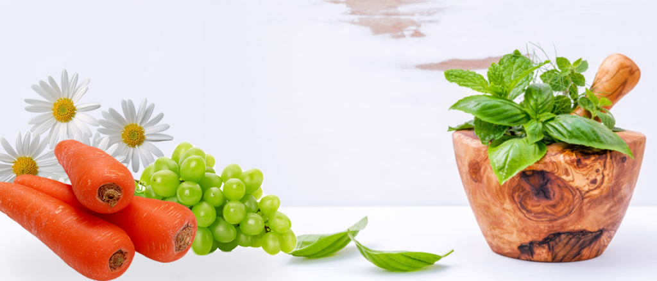

There are various methods in Ayurveda to improve eyesight. If proper care for eye is not take, it can result into various eye conditions such as age related macular degeneration and cataracts, which is a leading cause of blindness in the world.  
The Ayurvedic name for defective eyesight is ‘Drishti Dosha’. Alochaka Pitta is responsible for maintaining eyesight and it weakens with age. Proper caring for the eyes is one preventative measure that helps.

Causes of Defective Eyesight

Prolonged constipation and nervous debility can cause Drishti dosha. Common cold can also lead to eyesight defects. Stress, Diabetes, Excessive smoking, alcohol intake, caffienated drinks are also responsible for defective eyesight.

## Ayurvedic Diet for Improving Eyesight

* - Consuming good amount of apple and grapes helps in improving your eyesight.
* - Carrots have good quantity of vitamin A which proves to be one of the useful natural treatment for enhancing your eyesight.
* - Cucumber juice does wonders for your eyesight as it tries to improve it immensely.
* - Addition of spinach in your diet is beneficial.It purifies your blood, increases the hemoglobin and improves your eyesight.
* - Turnip, fresh milk, cheese, butter, tomatoes, lettuce, cabbage, soya beans, green peas, oranges and dates are good source of vitamin A include them in your diet.
* - Almond is ideal for eyes; it strengthens the vision, and calm mental stress. Take 1-2 t. a day with warm milk or sweet orange juice.
* - You can mix some cardamom seeds with 1 tablespoon of honey. Eat daily.
* - Consuming blueberry juice also considered to be very useful for your eyes.

## Ayurvedic Herbs for Improving Eyesight

* Amla - Extract the juice of fresh amla and drink 20 ml twice daily.
* Asparagus - Mix 1 teaspoon of powdered asparagus in half teaspoon of honey. Take the mixture twice daily with warm cow’s milk.
* Bhringraj - When Bhringraj herb or amla herb oil or paste is applied over eyes, they help in improving eye vision.
* Black pepper- Black pepper powder should be mixed with honey o improve eyesight.
* Ghee - Rub a small amount of ghee on soles of the feet to improve eye vision.
* Garlic - The juice extracted from fresh garlic is used for regaining lost eyesight.
* Rose petals - Freshly extracted juice of properly cleaned rose petals, which can be used both internally and externally for improving eye vision.
* Liquorice - Take approximately half to 1 teaspoon of liquorice powder with cow’s milk twice daily. This powder can also be mixed with ghee or honey.
* Triphala - Triphala is an important medicine for eye health, especially blurred vision or to prevent the development of cataract.

## Exercises for Eyesight Improvement:

* -- Close both the eyes very tightly by shutting the lids firmly. Open them suddenly which allows you to feel the stretch. Once open arch your brows and stretch your face. Repeat this several times a day.
* -- Look as far as possible and inhale then look down as far as possible and exhale. Blink your eyes more than dozen times. Do the same procedure by turning to your left and right then diagonally up to left, down to right, up to right and down to left followed by rapid blinking.
* -- Rotate your eyes in all the directions. Slowly and steadily concentrate one eye at a time. Do this exercise more than dozen times and try doing this with your eyes shut.
* -- By using palming which can be stated as a revised version of the thousand-year-old yoga tradition known was Hatha Yoga. It relieves strain and stress from your mind and eyes which needs the required break. For this you have to warm your hands by rubbing them together vigorously. Once it’s warm cover the eye without touching the eyelids. This relaxes the nerves and helps in blood circulation.
* -- You can also try sunning which means to use sun's light for your eyes. Move your head from side to side for the heat to benefit the eyes. After a while try stretching the eyes to allow more sunlight to your eyes. Directly looking at the sun is never good. It is greatly Naturally Kit: Now You Can Finally Throw Away Those Annoying Reading Glasses!
* Be sure to go to eye doctor and do regular check to see if there are potential eye diseases.

**19.Ayurveda in Treating Cancer: 6 Herbs That Can Help Reduce Risks**

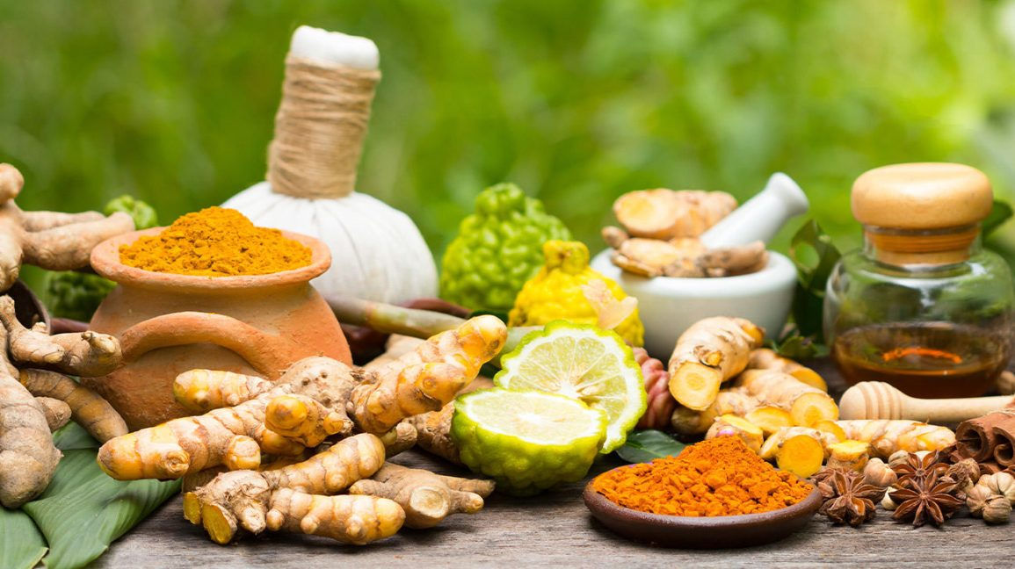

Ayurveda, as we all know, consists of many remedies that have been successfully treating various health problems of people for centuries. While many claims that it has the power to treat cancer as well, medical experts disagree for the lack of scientific research. However, various health institutions are including Ayurveda in their treatment, along with radiotherapy and chemotherapy to reduce the side effects.

Ayurveda originated in India more than 5000 years ago but modern science and allopathy now believe in its principle and more and more research is being directed towards ancient herbs and natural therapies. A lot of health centres and universities are integrating Ayurveda into their programmes to combat the ever, increasing load of non-communicable diseases.

All medical practitioners believe that prevention is better than cure and Ayurveda provides the path to a healthy lifestyle. Ayurveda sees health as a perfect balance between mind, body and consciousness. To achieve this, it promulgates a daily regimen of exercise, emotional balance and a healthy diet. This, in itself, is a great way to prevent the onset of many life style diseases.

Ayurveda recommends a number of herbs for preventing cancer and there is a growing body of scientific studies that backs this ancient knowledge. Here are some common herbs which are proven to have anti-cancer properties.  
  
1. Amla:

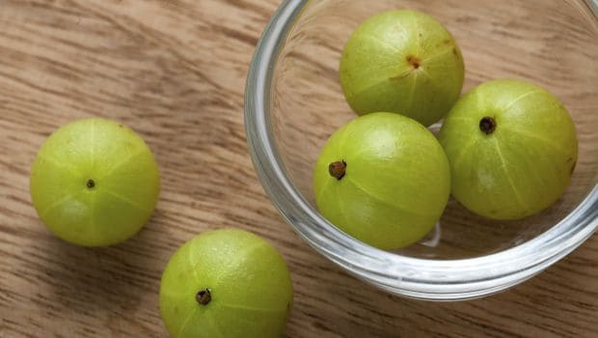

Amla is an Ayurvedic superfood. It is one of the richest sources of Vitamin C and also contains quercetin, phyllaemblic compounds, gallic acid, tannins, flavonoids, pectin and various polyphenolic compounds, making it the king of rejuvenation. Scientific research of three decades has proven the traditional use of amla to be correct. Laboratory trials of amla extracts have shown its ability to kill and prevent growth of cancer cells while not harming the healthy cells.

2. Garlic:  
  
Garlic contains sulphur, arginine, flavonoids and selenium. The bio-active compounds of garlic are formed from allicin when the bulb is chopped or crushed. The European Prospective Investigation into Cancer and Nutrition (EPIC), an ongoing multinational study across 10 countries has shown a positive co-relation between the consumption of garlic and onion and reduced risk of cancer. Studies from the US, China and France have all shown that consumption of garlic is associated with lowered risk of cancer. Garlic is a known anti-bacterial agent with the ability to stop the formation and activation of cancer-causing agents. The World Health Organisation recommends at least 2-5 grams or one bulb of garlic daily for adults.

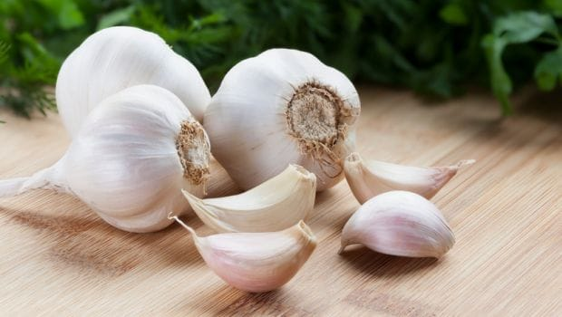

3. Turmeric:  
  
Haldi is one of the most researched herbs for its anti-cancer properties. It is attributed with anti-oxidant, analgesic, anti-inflammatory and antiseptic values. The principle component of turmeric is curcumin which is a potent antioxidant scavenging free radicals and inhibiting the growth of cancerous cells. Almost 2000 published scientific papers have shown that curcumin has the ability to kill cancer cells while not harming the healthy cells.

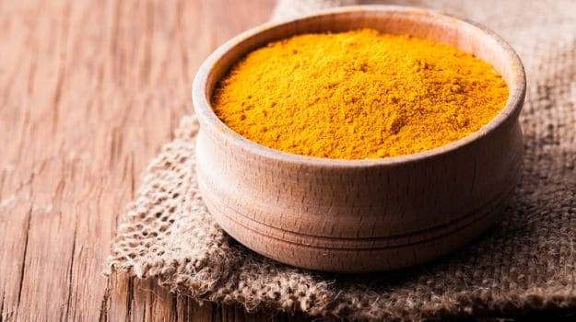

4. Ashwagandha:  
  
Also know, as the Indian ginseng, it has been used to help the body deal with stress in Ayurveda. Its anti-cancer value was realized about 40 years ago when researchers isolated a crystalline steroidal compound (withaferin A) from this herb. Further research on these extracts which were taken from the leaf of ashwagandha showed that they were able to kill cancerous cells.

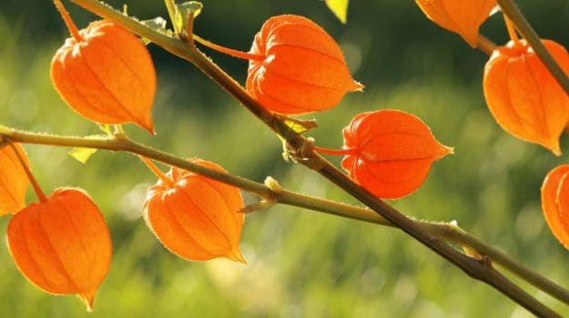

 5. Holy Basil  
  
Commonly known as Tulsi in India, this sacred herb is known for its healing powers. It is used for improving immunity and fighting stress. Research has shown that it also possesses anti-inflammatory, analgesic, anti-diabetic and anti-stress properties. Studies have shown that the phytochemicals present in Tulsi prevented chemically induced lung, liver, oral and skin cancers by increasing the antioxidant activity, altering gene expressions, killing cancer cells and preventing the spread of cancer to other cells.

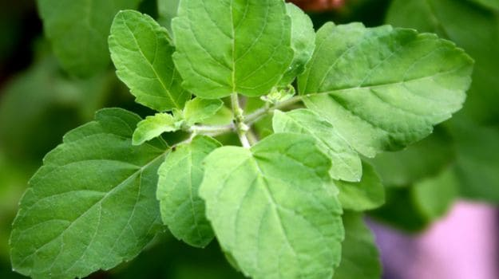

6. Ginger:

Ginger has a 2000-year long history of medicinal use. The active constituents of ginger have potent anti-oxidant and anti-inflammatory properties and some have exhibited cancer preventive activity in experimental models. Today, there are a number of studies that point towards the cancer preventive effect of ginger.

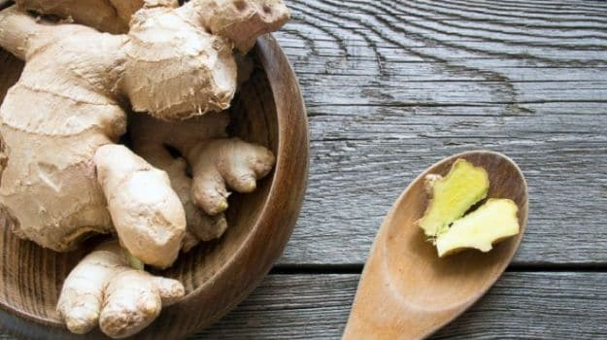

**20.The Ayurvedic Concept of Breast Cancer**

The physical construction of the breast is composed of numerous duct systems, especially connected with the mammary glands. The cellular substance of the mucous membrane or epithelium is very active in the breast. Rohini is the Sanskrit synonym of epithelium, which is considered as the original birth place of the neoplasm or cancer. Ayurveda points out that any physical condition of injury of the epithelial tissue results in abnormal branches of blood vessels.

These blood vessels, in general, start to dry up not causing any big problems. But in some condition of pathogenic defects of the muscular tissues and the blood, these abnormal blood vessels can be active again causing constant impulses in the scar of the injured epithelial tissues. The constant impulses of the abnormal blood vessels, in fact, result in abnormal growth or neoplasm in the epithelial tissues of the affected organ.

This is the general theory of Ayurveda concerning why and how develops the abnormal growth. The cause of pathogenic defects of the muscular tissues and the

blood is the accumulated and decomposed bodily fluid, which is exudates in the abnormal process. This kind of decomposed bodily fluid, if is circulated and accumulated in the abnormal branches of the blood vessels; the affected scar of the epithelium starts to have abnormal growth with different benign and malignant natures. The abnormal growth, smaller in the nature of growing is identified as a “Granthi” and the abnormal growth; bigger in nature of growing is

called “Arbuda”.

The tissues of the abnormal growth are composed of neutral cells, which are called “Napunsaka”, the Ayurvedic word for the cells of abnormal growth or neoplasm. These kinds of cells grow as a parasite; however, they have no natural functions concerned with the organ when they are growing. This abnormal growth or neoplasm is classified into two groups: basic group and individual group.

Causes of Breast Cancer

The fundamental cause of breast cancer either benign or malignant is the injury of the epithelium. The physical or traumatic injury of the epithelium results in abnormal branches of blood vessels; in the process of healing of the injury they dry up not even causing any big problem. But, in some condition of pathogenic defect of the muscular tissues and the blood, these abnormal vessels can be active again causing constant impulses in the scar of the injured epithelial tissues.

The constant impulses of the abnormal blood vessel’s extremities, in fact, result in abnormal growth or neoplasm in the epithelial tissues of the affected organ. It is well investigated that the epithelium has peculiar nature of growing if there are constant impulses. Therefore, the Sanskrit word, Rohini, which is the synonym of epithelium, means

the cellular substances of the mucous membrane with growing nature. In the physical construction of the breasts, these kinds of cellular substances are very active in female. This is the reason why the breast cancer is common to the woman.

The cause of pathogenic defect of the muscular tissues and the blood is the accumulated and decomposed bodily fluid, which is exudated in the abnormal process. The decomposed bodily fluid, which is sour in general, if is circulated and accumulated in the abnormal branches of the blood vessels, the affected scar of the epithelium gets more nutrition to have abnormal growth.

Excessive or daily indulgence in meat or fish; yogurt (curd); cream;butter; sour fruits or foods; salt; contradictory foods e.g. milk to be taken together with fish or acid fruits; overeating; sleeping during the day, especially after meat etc. cause exudation and result in pathogenic defect of muscular tissues.

Excessive or daily indulgence in sour foods and fruits; salt; alkali; alcoholic beverages; soybean products; sesame seed products; leafy green vegetables; over ripped fruits; rotten or stale foods; greasy food preparations; liquid diet; yogurt; hot tea or coffee; hot spicy foods; roasted or burnt foods; anger; effect of heat etc. cause pathogenic defect of blood. These foods and behaviours are considered as acid producing and heat producing agents, which are very bad for the

constituents of blood.

The contamination of the rat’s urine mixed with its semen, which is poisonous, can be the specific cause of minor neoplasm of the breast.

The excessive or daily use of sugar or anything, which is sweet in taste without other counteractive things e.g. bitter, pungent, or astringent things, can be the specific cause of major neoplasm of the breast.

The patient of gout not having proper treatment can develop a major neoplasm of the breast. The excessive or daily use of meat or fish can be the specific cause of myoma of the breast.

The tendency of gaining weight can be the specific cause of lipoma of the breast. The constant effect of hot and cold e.g. swimming or cold bath right after sun bath or vigorous exercise or labor; air-conditioned house etc. can be the specific cause of angioma of the breast.

The wet condition; improper bandage and wrong diet can be the specific cause of neoplasm developed within ulcer or wound of the breast.

The problem of excessive volume of blood in the circulation, especially localized in the physical structure of the breasts e.g. it is common during the period of menstruation, can be the specific cause of malignant chain like abnormal growth of the breast.

The breast by nature is a delicate organ. There are many conditions, which can be the cause of injury of the breast epithelium. Squeezing in love affair; tight dress on the breast; constant vibration of the breasts as caused by certain type of vehicles or strenuous exercise; avoidance of breast feeding right after child birth or during the period of breast feeding while the mammary glands are very active; baby bite (it is common when there is no enough milk secretion); blockage caused by thickness of milk or any abnormal condition of the intercostals veins; problem of the breast abscess; irregular menstruation; depression, mental anxiety or any other condition which cause declining of the breasts etc. are the main causes of injury of the breast’s epithelium.

Breast cancer whatever may be the condition and character of it, is common to the age of adult when the mammary glands are active.

Symptoms of Breast Cancer

The abnormal minor cyst like growth of Vataja-Granthi is bluish in color; the affected area is soft and distended like a bladder. It stretches out at the beginning, and then starts to have retraction with neuralgic pain, spasm and pressure. Finally, it causes ulceration and bleeding. The discharge of the light blood is the characteristic of it. In this case, the nervous system of the breast is found more

aggravated.

The abnormal major cyst like growth of Vataja-Arbuda has the same symptom of Vataja-Granthi, however, the abnormal growth of it is bigger in size and shape.The abnormal minor tumor like growth of Pittaja-Granthi is light red and yellow in color and in sensation just like burnt in fire. The cause of it is inflammation of the abnormal growth, which results in retraction and ulceration very quickly. The discharge of hot blood from the ulceration is the characteristic of it. In this case, the vein system of the breast is found more aggravated. The abnormal major tumor like growth of Pittaja-Arbuda has the same symptoms of Pittaja-Granthi; however, the growth of it is bigger in size and shape.

The abnormal minor tumor of the Kaphaja-Granthi does not change the color in the affected area. It is very hard just like a stone, cold in touch and not so painful. It grows very slowly with itching sensation.

Finally, it causes ulceration. The thick and white pus like discharge is the significance of it. In this case the artery system of the breast is found more aggravated.The abnormal major tumor of Kaphaja-Arbuda has the same symptoms of Kaphaja-Granthi; however, the growth of it is bigger in size and shape.

The abnormal major growth of Medoja-Arbuda (Lipoma) has the same symptoms of Medoja-Granthi; however, the abnormal growth is bigger in size and shape.

The abnormal major growth of Mamsaja-Arbuda (Myoma) develops at the beginning in the form of swelling. Then it localizes as a hard growth, which is immovable; greasy and non-infectional. The color of the affected skin does not change. In this case, the muscular tissues of the breast are found more defective.The abnormal minor growth of Mamsaja-Granthi (Myoma) has the same symptoms of Mamsaja-Arbuda; however, the growth of it is smaller in size and shape.

The abnormal minor growth of Siraja-Granthi (Angioma) develops in round shape erected very quickly. It is bluish red in color, painful and movable, however, in advanced stage; it is not painful and movable.In this case, the structure of the veins of the breast is found defective.

The abnormal minor growth of Branaja-Granthi (Neoplasm developed within the ulcer or wound) manifests around the margin of ulcer or wound with the symptoms of itching, hot sensation and bleeding.

The abnormal chain like glandular growth of Visarpa-Granthi(Adenoma) is very painful, irregular in shape and size and red in color in the affected area. It has two different natures: one develops slowly and another is opposite of it i.e. grows very quickly. In the metastatic condition of it, fever, intoxication, loss of appetite, lung’s cancer, decaying of the affected organ, sleepy all the times, coma, coughs, diarrhea etc. can be appeared as complicative symptoms.

The breast cancer either benign or malignant if is ulcerated can develop some symptoms of metastatic condition e.g. fever, lung’s cancer, loss of appetite, indigestion, intoxication etc. The metastatic condition of neoplasm is considered to be very difficult to cure or even not to be curable; however, it can be well maintained for time being. The metastatic condition of neoplasm is called “Adhyarbuda” or “Dwirarbuda”. In this condition, the neoplasm develops from one organ to the other or the neoplasm develops another abnormal growth on the same neoplasm or at the same time, two different abnormal growths can be appeared unanimously or one by another.

Prevention of Breast Cancer

Right after the birth of a child whether male or female, the breasts of a healthy baby are naturally full of milky liquid. This milky liquid must be taken out daily for a period of one month. The best practice is to squeeze it gentle once or twice a day. The cleaned breasts, especially for a woman at the age of puberty, will function in proper way and will not have any problems of blockage which is very good for the health of the breasts.

At the time of monthly period or menses, the breasts are generally affected by menstrual sensation, which causes it to expand with slight pain. The breasts must return to its original position or normal condition automatically at the end of menses. In this natural process, if the breasts remain expanded with pain; this indicates that there is some kind of abnormal condition of blockage in the blood vessels.

For the health of the breasts this condition must be corrected as soon as possible, using hot compress or hot fomentation to clean the duct system. A hot water bottle or hot roasted salt wrapped in thick cloth is prescribed for hot compress; a steam bath or bathing in hot water is beneficial means of fomentation. During the period of such treatment, sleeping during the day or napping, awakening in the middle of the night and squeezing the breast are strictly prohibited.

Breast-feeding plays a very important role to clean the breasts. If a woman avoids breast-feeding, it can cause blockage in the duct system of the mammary glands, which is very bad for the health of the breasts.

To have proper breast-feeding, right after child birth, mother must make a simple test of the purity of her milk. Pure milk dropped in water will dissolve completely. If it does not dissolve, that indicates impurity of the milk, which may create blockage and infection. In this condition, some bitter drugs are beneficial to purify the milk. Breast feeding, in general, should be stopped when the child starts to have the teeth. If the child unable to suck the milk of the breast, the

accumulated milk must be manually squeezed out from time to time, for few days.

The natural functions of the uterus and the breasts are interrelated; a regular menses affect the breasts to have healthy function. The problem of menorrhagia or amenorrhea can cause the defective function of the breasts. Therefore, the problems of the uterus have to be treated in proper way as soon as possible. The genital organs and the breasts have a mutual relationship, which become clearer in the age of puberty. They develop side by side resulting in sexual maturity. With respect to this interrelationship, proper sexual activity is very important in keeping breasts healthy.

Overindulgence in sex causes the declining condition of the breasts and malfunction. Excessive or daily use of meat; fish; greasy foods including milk products; sugar or sugarcane products; tight dress; sleeping during the day or napping; condition of hot and cold; squeezing of the breast in the love affair etc. are very bad for the health of the breast.

The excessive blood volume, which is common to the woman in the condition of overeating or obesity, has to be controlled with proper diet and bloodletting practices. The breast should be protected from any kind of injurious conditions of impact or blow etc.

Treatment of Breast Cancer

The treatment of breast cancer is divided into two different drugs: drugs for general treatment and drugs for specific treatment. The general treatment is based on the drugs, which subdue the abnormal growth, clean the blood and muscular tissues, restore the balance of the bodily systems, maintain the stamina and heal the ulceration.

Besides these applications of drugs, surgery can be recommended in any condition of the breast cancer. And the specific treatment depends upon the condition of the breast cancer e.g. drug for neuralgic condition, drug for hard tumor, drug for lipoma, drug for myoma, drug for angioma, drug for neoplasm developed within the ulcer or wound and drug for adenoma.

The drugs, which subdue the abnormal growth developed in the nature of swelling, are beneficial, in general, to prescribe in the beginning stage of the breast cancer. Poultice made of meat cutlet steamed with grease and carminative spices; plaster made of Stamonium datura and Shilajatu (Bitumen like rock secretion); hot compress or application of steam; mild laxative drug; bloodletting practice etc. can be applied to subdue the swelling like abnormal growths.

Shankhachurnadilepa, a compound of conch shell ash with other alkalis, is one of the best remedies to dissolve the abnormal growth. It is used to plaster on. Gugguluyoga, a compound of Balsamodendron mukul with other herbs or Kanchanara guggula, a compound of Bauhinia variegata with other herbs is one of the best remedies for internal use.

The drugs, which clean the blood and the muscular tissues, have to be prescribed, in general, in any condition of the breast cancer. Chandraprabha, a compound of camphor with Shilajatu (bitumen like rock secretion) and other herbs and minerals, is one of the best remedies to clean the blood and the muscular tissues. It is used for internal use.

The drugs, which restore the balance of the bodily systems depend upon the conditions of the breast cancer e.g. drugs to restore the balance of the nervous system in the case of the cyst like neoplasm, drugs to restore the balance of the vein system in the case of neoplasm with inflammation and hard tumor. The drugs, which restore the balance of the nervous system, contain some carminative, oily and heat producing ingredients or sweet; sour and salty things.

The drugs, which restore the balance of the vein system, contain some sweet, bitter or astringent things, which counteract the heat. Also, contents in this are some laxative or something, which counteract the heat. And the drugs, which restore the balance of the artery system, contain some bitter, pungent or astringent ingredients or heat producing ingredients.

The drugs, which maintain the stamina, are prescribed, in general, in any condition of the breast cancer. Raudrarasa, a compound of mercury with other herbs, is one of the best medicines to maintain the stamina.

The healing drugs depend upon the ulcerative condition of the breast cancer. Any neoplasm of the breast if is neglected, can have the problem of ulceration. In this condition as soon as possible the process of healing treatment should be applied, however, the ulcerative condition is not easy to cure without surgery.

Ayurveda emphasizes that any kind of neoplasm of the breast can be taken out with proper operation, however, it is very dangerous too. After, an operation if any abnormal cells of the neoplasm remain, then like fire or poison, they can spread in metastatic condition, which is very harmful.

Prohibited foods and behaviours

Meat; fish; yogurt; greasy food preparations; sugar or sugarcane products; sesame products; soybean products; peanut; vinegar; fried, roasted or burnt food preparations; sleeping during the day; indulgence in sex; withholding the natural urges of stool, urine, gas; over eating; anxiety etc.

**21.Things to Know About Mouth Cancer**

Oral cancer can appear anywhere in the mouth, including the inside of the cheeks and the gums. It is a type of head and neck cancer.It often comes under the category of oral and oropharyngeal cancer. Oropharyngeal cancer affects the back of the mouth and the lining of the throat.

Symptoms

In the early stages, there are often no signs or symptoms of oral cancer. Smokers and heavy drinkers should have regular check-ups with the dentist, as tobacco and alcohol are risk factors for mouth cancer. The dentist may be able to spot any signs at an early stage. A person should see a dentist regularly if they are a smoker or heavy drinker.

Signs that cancer could develop eventually include:

**Leukoplakia**: This is where there are white patches in the mouth that do not disappear when a person rubs them.

**Oral lichen planus**: This is where there are areas of white lines with a reddish border, possibly with ulceration.

Many oral lesions may be precancerous. They do not mean that someone has cancer, but people should speak to their doctor about any changes that occur in the mouth.Monitoring changes may help spot mouth cancer in the early stages when it is easier to treat.

If cancer develops, a person may notice:

* patches on the lining of the mouth or tongue, usually red or red and white bleeding, pain, or numbness in the mouth
* mouth ulcers or sores that do not heal a lump or thickening of the gums or lining of the mouth loose teeth with no apparent reason poorly fitting dentures swelling in the jaw
* a sore throat or feeling that something is stuck in the throat
* a hoarse voice difficulty chewing or swallowing difficulty moving the tongue or jaw.

Surgery

A doctor may recommend surgery to remove the tumor and a margin of healthy tissue around it.

Surgery may involve removing:

* part of the tongue
* the jawbone
* lymph nodes

If the procedure significantly changes the person’s appearance or their ability to talk or eat, they may need reconstructive surgery.

Radiation therapy: Oral cancers are sensitive to radiation therapy. This treatment uses beams of high energy X-rays or radiation particles to damage the DNA inside the tumor cells, destroying their ability to reproduce.

**External beam radiation**: A machine targets the affected area with radiation beams.

**Brachytherapy**: The surgeon will use radioactive needles to deliver radiation to the tumor inside the body. A doctor may recommend this for people with early stage tongue cancer.

Adverse effects of radiation therapy in the mouth may include:

* tooth decay
* mouth sores
* bleeding gums
* jaw stiffness
* fatigue
* skin reactions, such as a burn

Treatment will likely be more effective in people who do not smoke or have already quit.A person with early stage mouth cancer may only need radiation therapy, but a doctor can recommend combining it with other treatments to reduce the risk of cancer progressing or recurring.

Chemotherapy

If cancer is widespread, a doctor may recommend combining chemotherapy with radiation therapy.

Chemotherapy involves using powerful medicines that damage the DNA of the cancer cells. The drugs undermine the cells’ ability to reproduce and spread.

Chemotherapy medications destroy cancer cells, but they can sometimes damage healthy tissue, too. This can lead to severe adverse effects.

These effects may include:

* fatigue
* nausea and vomiting
* hair loss
* a weakened immune system
* increased risk of infection

These effects usually go away after a person finishes their treatment.

Hyperthermia therapy

In this emerging technique, a doctor will heat the area above normal temperature to damage and kill cancer cells. This therapy method can also increase the sensitivity of the cancer cells to radiation therapy. The stage of cancer refers to how far it has spread.

In the earliest stages, there may be precancerous cells that could eventually become cancerous. This is sometimes called stage 0 cancer, or carcinoma in situ. A doctor may advise a person to stop smoking and to monitor for further changes.

**Localized cancer** only affects one area and has not spread to other tissues. **Regional cancer** has spread to nearby tissues.

**Distant cancer** has spread to other parts of the body, including, possibly, the lungs or liver.

Untreated, oral cancer may start in one part of the mouth, then spread to other parts of the mouth. It may also spread to the head, neck, and the rest of the body.

The treatment options and outlook will depend, to some extent, on the stage of cancer.

Complications

Mouth cancer and its treatment can lead to a range of complications. Complications after surgery include the risk of:

* bleeding
* infection
* pain
* difficulty eating and swallowing

Long term problems may include the following:

**Narrowing of the carotid artery:**This can result from radiation therapy and may lead to cardiovascular problems.

**Dental problems:**These can develop if surgery changes the shape of the mouth and jaw.

**Dysphagia, or difficulty swallowing**: This can make it hard to eat and may increase the risk of inhaling food, and subsequent infections.

**Speech problems**: Changes to the tongue, lips, and other oral features can affect speech.

**Mental health issues**: Depression, irritability, frustration, and anxiety may arise.

Risk Factors

Doctors do not know why these changes happen, but some risk factors seem to increase the chance of mouth cancer developing.

There is evidence that the following factors increase the risk:

* smoking or chewing tobacco
* using snuff, which comes from tobacco
* regularly chewing betel nuts, a popular habit in parts of Southeast Asia
* excessive alcohol consumption

Other factors that may increase the risk of mouth cancer include:

* ultraviolet (UV) exposure to the lips from the sun, sunlamps, or sunbeds
* gastroesophageal reflux disease (GERD)
* previous radiation therapy in the head, neck, or both
* exposure to certain chemicals, especially asbestos, sulfuric acid, and formaldehyde having a long standing wound or chronic trauma, for example, from jagged teeth drinking very hot mate tea, popular in South America

Following a healthful diet that contains plenty of fresh fruit and vegetables may reduce the risk.

If a person has symptoms that could indicate mouth cancer, a doctor will:

* ask about their symptoms
* carry out a physical examination
* ask about their personal and family medical history
* If mouth cancer is a possibility, they may also recommend a biopsy, he doctor takes a small sample of tissue to check for cancerous cells.This may be a brush biopsy where the doctor collects cells painlessly using a special brush.If the biopsy reveals mouth cancer, the next task is to determine the stage.

Tests to stage cancer include:

**An endoscopy**: The doctor will pass a thin tube with a light and small camera down the person’s throat to see if cancer has spread and, if so, how far.

**Imaging tests**: An X-ray of the lungs, for example, will show if cancer has reached that area.

Apart from the stage of cancer, other factors affect a person’s chance of a longer life, such as:

* their age
* their overall health
* the grade or type of cancer, as some are more aggressive than others
* their access to a range of treatment options

Prevention

Smoking is a significant risk factor for mouth cancer. To reduce the risk of mouth cancer, people should:

* avoid using any form of tobacco product
* avoid excessive alcohol consumption
* avoid chewing betel nut
* have a regular dental check monitor for changes in the mouth and see a doctor or dentist if any occur
* have the vaccination to protect against HPV

**22.Psoriasis in Ayurveda**

Psoriasis is a chronic, non-contagious disorder which affects the skin and joints, characterized by flaking, redness and inflammation of the skin. Once thought to be a skin disorder, psoriasis is now understood to be a condition originating in the immune system.

The scaly patches caused by psoriasis, called psoriatic plaques, are areas of inflammation and excessive skin production. Skin rapidly accumulates at these sites and takes on a silvery-white appearance. Plaques frequently occur on the skin of the elbows and knees, but can affect any area including the scalp and genitals. In contrast to eczema, psoriasis is more likely to be found on the extensor aspect of the joint.

The disorder is a chronic recurring condition which varies in severity from minor localized patches to complete body coverage. Fingernails and toenails are frequently affected (psoriatic nail dystrophy) – and can be seen as an isolated finding. Psoriasis can also cause inflammation of the joints, which is known as psoriatic arthritis. 10 to 30% of people with psoriasis have psoriatic arthritis.

Psoriasis is considered a non-curable, long-term (chronic) skin condition. It has a variable course, periodically improving and worsening. It is not unusual for psoriasis to spontaneously clear for years and stay in remission. Many people note a worsening of their symptoms in the colder winter months.

Psoriasis is seen worldwide, in all races, and both sexes. Although psoriasis can be seen in people of any age, from babies to seniors, most commonly patients are first diagnosed in their early adult years. Patients with more severe psoriasis may have social embarrassment, job stress, emotional distress, and other personal issues because of the appearance of their skin.

Signs and Symptoms

Psoriasis typically looks like red or pink areas of thickened, raised, and dry skin. It classically affects areas over the elbows, knees, and scalp. Essentially any body area may be involved. It tends to be more common in areas of trauma, repeat rubbing, use, or abrasions.

Psoriasis has many different appearances. It may be small flattened bumps, large thick plaques of raised skin, red patches, and pink mildly dry skin to big flakes of dry skin that flake off.

Sometimes pulling of one of these small dry white flakes of skin causes a tiny blood spot on the skin. This is medically referred to as a special diagnostic sign in psoriasis called the Auspitz sign. Genital lesions, especially on the head of the penis, are common. Psoriasis in moist areas like the navel or area between the buttocks (intergluteal folds) may look like flat red patches. These atypical appearances may be confused with other skin conditions like fungal infections, yeast infections, skin irritation, or bacterial Staph infections.

On the nails, it can look like very small pits (pinpoint depressions or white spots on the nail) or as larger yellowish-brown separations of the nail bed called “oil spots.” Nail psoriasis may be confused with and incorrectly diagnosed as a fungal nail infection.

On the scalp, it may look like severe dandruff with dry flakes and red areas of skin. It may be difficult to tell the difference between scalp psoriasis and seborrhea (dandruff). However, the treatment is often very similar for both conditions.

Classification

The symptoms of psoriasis can manifest in a variety of forms. Different types of psoriasis exhibit different characteristics that may change over time. One form may change to another, or several forms may exist at the same time.

* Plaque psoriasis: This is the most common type of psoriasis. It is characterized by raised; red lesions covered with silvery white scales. The scales are caused by a building up of dead skin cells. It may appear on the knees, elbows, scalp, trunk or any other skin surface.
* Guttate psoriasis: It is characterised by numerous small red dots of psoriasis. The lesions may have some scaling. These numerous spots of psoriasis appear over large areas of the body, such as the trunk, limbs, and scalp. It may appear suddenly following a bacterial or viral infection or the administration of drugs like ketoconazole and salicylic acid.
* Inverse psoriasis: This is usually found in the folds of the skin in the armpits, groin, under an overweight stomach or under the breasts. It appears as smooth, red lesions without scaling and may cause irritation due to rubbing and sweating.
* Pustular psoriasis: It is characterized by blisters filled with pus on the skin. The blisters are not infectious. It may be found on the hands and feet or may be spread all over. The skin under and surrounding pustules is red and tender.
* Psoriatic arthritis: About 10% to 30% of the patients with psoriasis may develop a form of arthritis called psoriatic arthritis. This may cause redness and swelling, primarily on the hands, feet, knees, hips, elbows and spine. It may cause stiffness, pain and joint damage.
* Nail psoriasis: produces a variety of changes in the appearance of finger and toe nails. These changes include discolouring under the nail plate, pitting of the nails, lines going across the nails, thickening of the skin under the nail, and the loosening and crumbling of the nail.
* Erythrodermic psoriasis: involves the widespread inflammation and exfoliation of the skin over most of the body surface. It may be accompanied by severe itching, swelling and pain. It is often the result of an exacerbation of unstable plaque psoriasis, particularly following the abrupt withdrawal of systemic treatment. This form of psoriasis can be fatal, as the extreme inflammation and exfoliation disrupt the body’s ability to regulate temperature and for the skin to perform barrier functions.

Diagnosis

Diagnosis of psoriasis is usually based on the appearance of the skin. There are no special blood tests or diagnostic procedures for psoriasis. Sometimes a skin biopsy, or scraping, may be needed to rule out other disorders and to confirm the diagnosis.

Psoriatic Arthritis

Here, Psoriatic Arthritis requires a special mention as it may develop in up to 30 percent of people who have the chronic skin condition Psoriasis. Anyone who has psoriasis and joint pain may have psoriatic arthritis. Common symptoms of psoriatic arthritis include:

* Pain, swelling, or stiffness in one or more joints.
* Joints that are red or warm to the touch.
* Sausage-like swelling in the fingers or toes, known as Dactylitis.
* Pain in and around the feet and ankles, especially tendinitis in the Achilles tendon or Plantar fasciitis in the sole of the foot.
* Changes to the nails, such as pitting or separation from the nail bed.
* Pain in the area of the Sacrum (the lower back, above the tailbone).

Psoriatic arthritis most commonly involves the fingers and toes. Joints in the neck, back, knees, ankles, and other areas also may be affected. In addition to being painful and stiff, the involved areas usually feel hot. Affected joints tend to have a purplish discoloration.

Almost 90% of people who develop psoriatic arthritis see nail involvement first. The nails may pull away from the nail bed or develop pitting, ridges, or a yellowish-orange discoloration. Dermatologists urge their patients who have psoriasis that involves the nails to contact them if they experience any joint problems. Joint deterioration can be prevented with treatment.

Early warning signs of psoriatic arthritis include hand pain, foot pain, and “tennis elbow.” These early warning signs may be overlooked if psoriasis lesions are not present. Other indications are shoulder, neck, or back pain.

Psoriatic arthritis ranges in severity. It can involve one digit or an entire hand. It can become so severe that it is disabling. According to the National Psoriasis Foundation, about 20% of patients living with psoriatic arthritis have more than five totally damaged joints, which significantly impairs their ability to perform everyday tasks and reduces their quality of life.

**23.The Ayurvedic Concept of Diabetes**

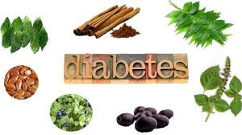

Oja is the Ayurvedic term for the blood sugar. It is greasy and has the nature of sweetness. The blood sugar, whenever is counteracted with the physical properties of astringent taste, loses its greasiness. Because, the drying effect of the astringent taste is counteractive to the grease. The greaseless blood sugar cannot be assimilated for the nourishment of the bodily tissues and separated from the bodily fluid. In this condition, it dissolves easily in the bodily fluid and

elevates the sweet urine. That, in fact, is the fundamental cause of diabetes. The greaseless blood sugar is similar to the nature of honey, which has counteracting effect to grease. Therefore, Madhumeha, honey like sweet urine is the Ayurvedic name for diabetes.

The stimulated mucous membrane secretes more viscous slime or mucous, which can be the cause of blockage in the duct systems. The duct systems being blocked, the nervous system cannot function in proper way. In this condition the aggravated function of the nervous system, which causes dryness can counteract the grease of the blood sugar. In another sense, the person who is fat and has strong digestive power can have the problem of diabetes. This type of diabetes is called “Abrita

Madhumeha”. It is common to someone who has the nature or body of blood or mucous. The blood natured body type (Pitta Prakriti) can be identified with robust body, aggressive attitude, ego, attractive or dominating personality, careless behavior and selfish mentality. The mucous natured body type (Kapha Prakriti) can be recognized with fatty body, lazy or slow action, charming personality, compassion and careful behavior. The case of diabetes of the person who has the blood or mucous natured body type or combined of them is curable with proper treatment and diet.

The urinary diseases e.g. glycosuria, albuminuria, chyluria, hematuria, polyuria, phosphaturia etc. not being treated in proper way can be chronic. In this condition, the constant wastage of vital substances result in the aggravated function of the nervous system and counteracts the grease of the blood sugar, which finally leads to have the problem of diabetes. This kind of diabetes is called “Dhatuksayaja Madhumeha”, which is not curable, however can be maintained with proper treatment and diet. Diabetes whatever may be the cause of it, cannot manifest its real symptoms without aggravating causes. Sugar and sugar cane products; milk and curd; meat especially of cow, goat, buffalo and sheep; new rice (right after harvesting); sweet foods (anything which is sweet in taste); overeating; greed for eating; sleeping during the day; sedentary life; not to have exercise and bath, etc. are the aggravating causes of diabetes. Excessive or daily use of these foods and behaviours are found to be the main factors to have the counteracting situation of the blood sugar. It is especially true to someone who has no idea of combination of diet and indulges in the food what he likes. In general, the regular diet must be combined with ingredients, which are sweet, sour, salty, bitter, pungent and astringent in taste.

Ayurveda indicated that the kidneys while filtering the dirty bodily fluid of urine should protect the bodily grease including the blood sugar. This is very important. But, the grease of the blood sugar, whenever is counteracted in the situation of the aggravated nervous system, becomes no greasier. In this morbid condition, the kidneys can not

protect the blood sugar and causes urine with sugar. In regard to this condition, the patient of diabetes complains much urination, which is sweet astringent in taste, much thirsty, because the body has to keep the balance of water and loses weight very quickly, because, the bodily fluid, which is mixed with the blood sugar, is draining through urinary frequency and there is less nourishment for bodily tissues.

Causes of Diabetes

The fundamental cause of diabetes is the morbid condition, which counteracts the grease of the blood sugar. The greaseless blood sugar can be assimilated for the nourishment of the bodily tissues and increases in amount in the blood, bodily fluid. The main function of the kidneys is to filter the dirty bodily fluid or urine and to protect the greasy substance of the blood, which includes even the greasy blood sugar. The blood sugar when loses it grease mixes with bodily fluid, increases the amount of abnormal urine and escapes from the

kidneys because it is not greasy. The morbid condition of diabetic case, which counteracts the grease of the blood sugar, can be classified into the three stages. The first stage is directly concerned with the weak function of the pancreas.

The second stage is identified with the blockage of pancreatic duct system. And, the third stage is concerned with the wastage of the bodily vital substances caused by chronic urinary diseases. The person, who has nerve natured body type by birth, gets the weak, pancreas. The main cause of it is the over activity of the nervous system, which causes dryness and less fat formation. The pancreas as fatty organ when is counteracted with the over activity of the nervous system cannot develop in proper way. In this condition, any food or behaviour, which causes more problem of aggravated function of the nervous system, can be cause of diabetes (Dhatuksayaja Madhumeha). Excessive or daily indulgence in mental agony; traumatic problems; lack of nourishing foods; heavy labour; heavy work in the sun; withholding the urges of stool, urine or gas; awakening at night; problem of insomnia etc. aggravates the function of the nervous system. The patient who is suffering from diabetes gets worse the problems, if the diet contains sugar or sugarcane products; rice; meat; milk products; potato; sweet fruits etc.

The person, who has blood natured body type or mucous natured body type or combined with them, by birth, gets fat, because his pancreas is well developed and become active to consume more foods. In this condition, any food or behaviour, which causes more fat, can be the cause of diabetes (Abrita Madhumeha), if the pancreatic duct system is blocked with over fat formation. Excessive or daily indulgence is sweet, sour and salty foods; greasy foods; new rice (right after harvesting); newly made alcoholic beverage; overeating;

greedy for food what he likes; over sleeping; sedentary life; not to have exercise and thinking job etc. can increase more weight.

The person who has the problems of chronic urinary diseases, wastage the vital substances e.g. blood sugar, albumin, minerals etc. because the kidneys cannot protect them and drain these vital substances through the urinary frequency. In this condition, the nerves being aggravated finally causes diabetes (Dhatuksayaja Madhumeha) with the same character of the weak pancreas, which is common for the nerve natured body type.

Symptoms of Diabetes

Matting condition of hair, sweetness of the mouth, numbness, and hot sensation in the hand and legs, dry mouth, thirst, laziness, dirtiness on the skin, white coating on the tongue, waxy ears, and bad smell of the body, drowsiness, abnormal urination and sweetness of urine can be the primitive symptoms of diabetes. These symptoms come and go not even being known as the significance of diabetes.

The patient of diabetes having primitive symptoms, during the interval of few days or weeks, complains much urination, which is sweet astringent in taste and clear just like water, much thirsty (no satisfaction with constant drinking of water), because, the body has to keep the balance of water and loses weight very quickly because, the bodily fluid which is mixed with the greaseless blood sugar is draining through urinary frequency. In this condition, the patient feels very weak and complains muscular cramp, dizziness, hot sensation

and lack of energy even to walk and stand.

The symptoms of diabetes at the beginning are very drastic, and then the patient adjusts them gradually because there is less bodily fluid with the greaseless blood sugar. In this condition, if he is careful in diet, slowly he can maintain his problems to survive, otherwise, coma, heart problems and insomnia can be developed which are considered

as complicative symptoms of diabetic case. Also, the strong desire for food, which in general is one of the worst symptoms of diabetic patient, can cause many indigestion problems along with deadly symptoms of coma etc.

The diabetic patient of nerve natured body type, if is not treated in proper way and proper diet, finally can have failure of kidneys, tremor, pulmonary tuberculosis and heart problems.

The diabetic patient of blood natured or mucous natured body type, if is not treated in proper way and proper diet, can have many problems of boils and pimples, hyperacidity, coma, urinary infection and common cold.

Treatment of Diabetes

The general treatment of diabetes is divided into two categories. The first treatment contains the drugs, which restore the balance of the nervous system, increase weight, promote digestion and reduce the abnormal blood sugar. This treatment has to be applied to the skinny person who is suffering from diabetes (Dhatuksayaja Madhumeha).

The drug, which restores the balance of the nerve, in general contains the sweet, sour and salty things, which are contradictory in the treatment of diabetes because, these ingredients increase the blood sugar. In regard to these facts, while treating to restore the balance of the nervous system, some drugs which have dilatory effect to increase heat and oily components to maintain the bodily heat, have to be prescribed in the treatment of diabetes.

Narayana tail, the oil preparation made from asparagus with some other herbs, is one of the best oil preparations. It is prescribed for internal use and cooking foods. It is well investigated that the bodily heat being preserved, the function of the nervous system cannot be aggravated. During the treatment of diabetes, the oily drug should be prescribed only in the condition when the diabetic person develops the adjusting power to face the problems of high blood sugar. At the beginning, when all the drastic symptoms of diabetes are getting worse, oily drug should not be prescribed.

The drug, which increases the weight, also, is sweet, sour and salty. In, the case of diabetes to increase weight something, which is sweet, sour and salty, should not be prescribed because they are contradictory to the drugs, which reduce the blood sugar. In this condition, while treating to gain weight, some drugs, which are bitter in taste, but increase weight, have to be prescribed.

Ashwagandha (Convolvulus arbensis) is one of the drugs to gain weight in the treatment of diabetes. Some meat from the wild animals and birds also has medicinal value to gain weight in the treatment of diabetes. It is very important to pay attention that any drug or diet, which increases weight, should not be prescribed at the beginning stage of diabetes. It is advised to prescribe only in the condition when the diabetic patient develops the adjusting power to face the problems of high blood sugar.

The digestive drug, which contains purified sulphur, black pepper, dry ginger, long pepper etc. is very important in the treatment of diabetes. This kind of drug, in general, stimulates the functions of the pancreas and promotes the power to digest the blood sugar. It is prescribed to take during the meal. Trikatu Rasayana is one of the best digestive drugs, which has to be prescribed from the beginning stage of diabetes.

The drug, which reduces the blood sugar, contains Vanga Bhasma (Tin oxide), Yashada Bhasma (Zinc oxide) Naga Bhasma and some other herbs, which has counteraction with the function of the mucous membrane and the effect of hyperglycemia. This Tribangayoga is one of the best remedies to reduce the blood sugar. It is prescribed from the beginning stage of diabetes along with the digestive drugs. Diabetes whatever may be the cause of it or character of it, the medicine to reduce the blood sugar and the digestive drug has to be prescribed side by side until the urine is free from sugar. In this condition, the patient of diabetes feels better; there is no more frequency and thirst; the condition of emaciation gradually disappears and gains weight. It is very important to pay attention the blood sugar being reduced and the urine free from sugar, the case of diabetes

should not be considered as cured. In this condition if someone is careless in diet, the problems can appear again. Therefore, the diabetic case especially of the nerve natured person is considered not to be cured.

In regard to this problem, it is well investigated that diabetes can be cured only in the condition, one who walks two-three hours a day and takes Shilajatu (a bitumen like rock secretion) for years with the proper diet along with symptomatic treatments against contradictory effect of diabetes (Abrita Madhumeha).

The second treatment which is applied to the person, who is fat and has the mucous natured or blood natured body type, contains the drugs, which restore the balance of the artery system (Kapha), reduce the abnormal blood sugar, promote the digestive power and decrease the weight. The drug, which restores the balance of the artery system, counteracts the effect of hyperglycemia and the stimulation of the mucous membrane. Chaturdasangayoga, a compound of Cinnamomum tamala and some other herbs is one of the best

remedies to restore the balance of the artery system. It is prescribed together with the medicine to reduce the blood sugar (Tribangayoga) and the digestive drug (Trikatu Rasayana). The use of Tribangayoga and Trikatu Rasayana is mentioned in the first categories treatment of diabetes.

Recommended Food For Diabetic Patient

The diabetic patient should know that there is no cure with any medicine without proper diet. The food arranged in proper way has medicinal value to control the problems of diabetes. In regard to this fact, Ayurveda presents some basic idea of foods. Barley, millet, corn, wheat etc. which are less sweet and have less grease are the main grains for bread and some other food preparations; Mung bean, lentil, orange lentil, horse gram, kidney bean etc. (not sprouted) are good for bean soup and some other food preparations; eggs and bird meat, especially wild bird meat, which is easy to digest are good for soup and some other food preparations; green vegetables, especially bitter in taste e.g. asparagus, bitter cucumber, fenugreek, lettuce, celery, mustard, spinach, watercress etc. are beneficial; linseed oil and mustard oil are good oil; cinnamon bark, bay leaf, cardamom, cumin seeds, ginger, black pepper etc. good for spice; ghee, butter, milk, cheese and yogurt can be prescribed moderately only in the condition when the diabetic patient adjusts the problems of high sugar. (At the beginning stage, the milk products are strictly prohibited); fruits e.g. prescribed moderately only in the condition of adjusting the problems (At the beginning stage, fruits are strictly prohibited); water infused with the powder of turmeric or beetle nut and cutch has medicinal value to drink especially at the

beginning stage; fatless meat and fish can be prescribed only in the condition when the patient adjusts the problems of diabetes and still is loosing weight (at the beginning stage, meat e.g. mutton, beef, fish, and buffalo etc. are strictly prohibited.).There must be three meals a day, but very small in amount arranged with grains, beans, meats, milk products, vegetables, fruits, oil and spices, which have to be changed time to time. Eating same food daily or in excessive amount is not good.

Prohibited Food and Behaviour

Sugar and sugarcane products; rice, especially new rice right after harvesting; potato, yam, and some other vegetable tubers; greasy yogurt; newly made alcoholic beverages; overeating; greed for foods; irregular time for food; sleeping during the day; not to have exercise and body clean; sedentary life; melancholy etc. are strictly prohibited.

Eight Ayurvedic Tips to Help Manage Diabetes

There are many ways in which you can manage your diabetes and untimely blood sugar fluctuation like by maintain a healthy diet. Ayurveda has many tips that could help you through.

Here are a few home remedies that the book suggests:  
- Mix one part of guduchi, a part of shardunika, a part of kudki and 2 parts of punarnava and mix them well into a diabetic-friendly herbal mixture. Drink this herbal mixture for two to three times a day and consume with warm water.  
  
- Turmeric Treatment: Increasing the intake of turmeric in the diet is also beneficial in diabetes management.  
  
- Drinking Water In Copper Vessel:  Since time immemorial, drinking water from copper vessel has been considered very healthy for overall functioning of body. On reviving this practice may help prevent fluctuation of blood sugar levels. The water stored in a copper vessel is called 'Tamra Jal' and it helps in balancing of all three doshas. "Put one cup of water into a copper vessel at night and drink the water in the morning." 

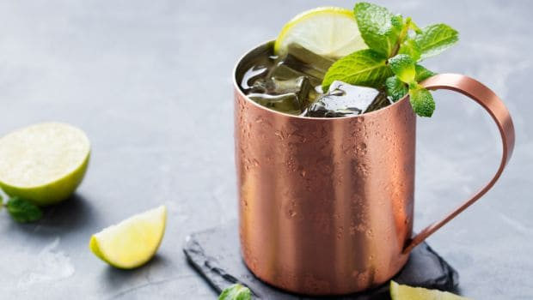

2. According to Ayurvedic experts, diabetics should definitely have a stock of methi dana in their homes. You can consume methi dana sprouts or drink fenugreek water the first thing in morning.   
  
3. Bitter Is Better: In addition to refraining from sweets, loading up on bitter ingredients like hemp seeds, bitter gourd, amla and aloe vera have also been found effective in managing and controlling diabetes.

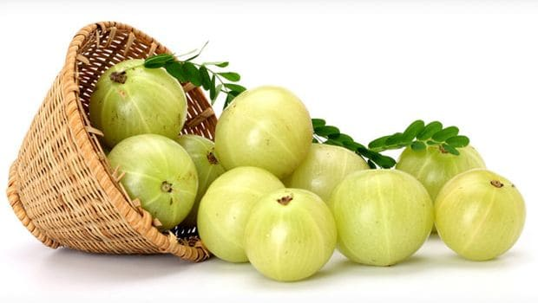

4. All ailments in Ayurveda are due to some imbalance in an individual's doshas. Type 1 is described as an imbalance of the Vata (air and wind) dosha. Type 2 is an excess of the Kapha (water and earth) dosha. Eating regimented meals that contain fewer fatty foods thrice a day is very important. Try and avoid dairy products and opt for skimmed milk and low-fat yogurt. Ginger tea helps stimulate digestion, which is very beneficial in reducing the excess Kapha in your system."

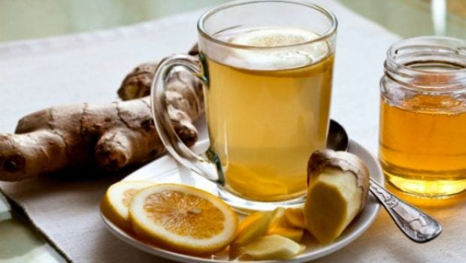

5. Use Your Spices Wisely: There are many spices that have shown antidiabetic properties. For instance, asafoetida, turmeric, cinnamon, mustard and coriander, use them in your meals, drinks and manage diabetes naturally. 

**24.General Outline of Treatment of Heart Diseases**

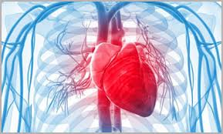

Till early eighties, it was widely believed that heart disease was virtually irreversible. This meant that once developed, the disease ran a progressive course until the coronary arteries were completely blocked. But recent studies have proven beyond doubt that not only it is possible to stall the process of artery blockage but also the blockage can be really reversed. This implies that through measures other than angioplasty (ballooning) or bypass surgery, it is quite possible to increase the blood flow to the areas of the heart that receive less than adequate blood supply due to clogging of the coronary arteries.

It is quite disheartening that the highly technological approach of the modern medicine literally bypasses the underlying causes of the heart disease. Ayurveda, on the other hand, aims at striking at the very root of the disease. A real cure for this disease is only possible if we adopt a holistic approach as the one advocated in Ayurveda and address the problem at its very root. Shunning the age-old principles of healing described in the Vedas- the great Indian heritage, as unscientific only just because they are old, is most unfortunate. However, due to the intensive research work of some doctors in the west, people now have come to believe that Heart Disease can be reversed.

## Effective Natural Treatments for Strengthening Heart

Here are some of the recommendations that Ayurveda makes:

Nourishment: Use of Amla fruit as an excellent anti-oxidant that can help to prevent arterial damage from free radicals as well as nourishing the heart tissue. Amla can help boost the immune system and nourish the heart. Chywanaprash is a delicious nutritive herbal jam that contains Amla and is a real boost to the strength of the heart.

Increase circulation: A major cause of heart problems is due to hardening, inflammation or congestion of the arteries which can restrict blood flow as well as putting pressure on the heart muscle and tissue. Arjuna is one of Ayurveda's wonder herbs for strengthening the cardiac muscle, reducing arterial congestion and lowering blood pressure.

Reduce Blood fats and high cholesterol: If you suffer from high cholesterol try Triphala Guggul which combines a range of herbs known to tackle the causative problems of high cholesterol as well as reduce high levels of blood fats.

Relaxation: If you suffer from excess tension try using Ashwagandha. It is a wonder herb for helping reduce tension in the body and mind as well as strengthen the heart muscle.

Dietary suggestions: Eat a nourishing diet that removes all processed foods, poor quality dairy, poor quality oils, hydrogenated oils. Increase foods that are excellent for the heart. Use garlic, turmeric, ginger and saffron. Include whole grains, pulses and foods high in essential fatty acids such as hemp seed oil. EFAs are renowned for helping to keep arteries clean and the heart strong.

Avoid over-eating and eating frequently. Eat a light breakfast and dinner. Lunch should be the main meal. Milk products, fried foods, cold foods and acidic foods should be taken in small quantities. White flour products and foods that contain chemical preservatives and additives should be avoided. Animal products, especially red meat, are not good as they take a long time to be digested, and create a lot of toxins in the stomach.  
Seasonal fruits and fresh vegetables (steamed or cooked), Brown bread or Chapatti, salad, sprouts, vegetable soup, buttermilk, cottage cheese (paneer), a little quantity of fresh milk and ghee (clarified butter) prepared from cow's milk, make up an ideal list of food items to choose from. Anything sweet should be taken in moderation. Honey and jaggery are healthier than purified sugar.

Fried things, pulses and their preparations, and groundnut oil are prohibited. Ayurvedic physicians allow butter or ghee, and not groundnut oil. Cow's ghee, cow's milk and cows' butter are useful for the patient. Buffalo ghee and buffalo milk are not recommended. Stimulants like tea, coffee and alcoholic drinks are very harmful for such patients.

In addition to maintaining a healthy eating pattern, specific foods are often recognized as particularly heart-healthy. One of the most popular of these healthful foods is fatty fish with its high omega-3 fatty acid content. A recent study determined that women who consumed more omega-3 fatty acid laden fish (two servings weekly) had a reduced rate of death due to heart disease. These researchers found that this was independent of cardiovascular risk factors or other dietary sources that may influence the development of heart disease. Good sources of omega-3's besides fish are: flaxseeds, flaxseed oil, canola oil, olive oil, sesame oil, peanut butter and oil, sunflower seeds and oil, avocado, soybean oil, and safflower oil. Additionally, flavonoids found in tea and cocoa have been recognized for their antioxidant benefit. By blocking oxidative damage to LDL cholesterol and reducing platelet clumping, flavonoids may help to reduce the risk of cardiovascular disease. An inverse association between dietary fiber intake and cardiovascular disease risk has also been proposed. This underscores the recommendation for increased consumption of fiber-rich whole grains, legumes, fruits and vegetables.

## Lifestyle Suggestions for Heart Diseases

Your heart needs a regular supply of oxygen and it also must not be overstressed. Practice light aerobic exercise and regular relaxation. Ayurveda would recommend some nourishing yoga practices, such as the dynamic 'Sun Salutation' as well as daily breathing practices (Pranayama). Ayurveda suggests exercising within your own limitations and does not encourage excessive exercise that leaves you tired. Yoga is exercise that leaves you energised and fitter.

A very common cause of heart diseases is mental stress. Regular practice of yoga and Pranayama (breathing exercises) reduces stress levels. Also, meditation has been scientifically proven to prevent as well as cure heart diseases.  
Ayurveda considers the functions of heart and mind inter-linked. Disturbance in one affects the other. Therefore, patients having heart disease are advised to refrain from anxiety, worry, excessive sexual intercourse and wrathful disposition. All efforts should be made for the patient to have good sleep at night. Even rest during the day is essential. He should never be permitted to remain awake at night for long.

The patient's bowels should move regularly. If there is constipation, he is advised to take a glass of water early morning and go for a walk every day. A gentle laxative like Triphala choorna may be used if required

**25.Manovikara (Mental disorders) In Ayurveda**

Ayurveda aims at preservation and promotion of heath, and prevention and cure of diseases through the concepts of positive physical and mental health. Management of mental disorders or psychological medicine was an area of specialization even during caraka’s time (500 B.C.) Caraka suggests that, treatment for mental illnesses should be south through an expert in the field of mental illnesses. Chakrapani (11 A.D.) commenting on this statement, uses the phrase ‘manasaroga bhesaja vetti’ (Knowers of treatment for mental illnesses).

These references fortify the above statement. But unfortunately, due to historical reasons, Ayurvedic literature dealing exclusively manas and manasavikara, are not available. However, the scattered aphoristic material related to manas and manasavikara as available in the Ayurvedic treatises are richly useful in understanding manas and treating mental disorders only if they are carefully collated in view of our present needs. It is also a fact that various mental disorders are being treated for centuries over, by Ayurvedistis with the help of these ancient literary descriptions.

In statute of Mental Health and Neuro Sciences, Bangalore, has been studying from 1971 the role of Ayurveda in understanding and the management of various mental disorders. In the following lines, it is attempted to delve systematically on some of the important aspects of manas and manovikaras described in ayurveda.

Ayurveda has duly recognized the individuality of manas (psyche) and sarera (body) and their inseparable and interdependent relationship in a living body. The following descriptions available in the classics of Ayurveda, bear proof to this statement. While defining ‘Ayu it is said that ‘life is the combined state of body, senses, mind and soul. Further, the expectant parents are advised to contemplate on the physique, complexion, and mental traits they wish to have in their child, in support of their desire. Indicating the influence of manas even at the embryonic stage, Ayurveda states that ‘the foetus grows steadily with the help of the reproductive element, the five protoelements namely, prthvi, Ap, Teja Vayu and Akasa, the subtle mind and sap of food taken by mother.

The statement that ‘manifestation of manas occurs during 5th month of pregnancy in the foetal body’ indicates the coexistant nature of mind and body. Indicating the direct influence of manas on certain physiological functions, it is said that anger, and fear could cause diaphoresis. Similarly, grief and anger are counted among the causes of the loss of breast milk. Describing the role of manas in the digestion of food consumed, Ayurveda advises that food should be consumed with rapt attention.

Defying this, is liable to allow the food go wrong way or injure the health or the food is not properly placed in the stomach and there is no appreciation of either the good or bad qualities of food taken. Further, indicating the need of mental poise for drug action Ayurveda says that no one who has not rid oneself of the evils of both mind and body beginning with the gross ones, can ever expect to reap the benefits resulting from vitalization therapy.

Vayu which is one of the tridoshas (the three bioentities viz., Vata, Pitta and Kapha which are generally more related to shareera) is said to be the controller and prompter of manas. It is also said that the excited vayu depresses mind, gives rise to fear, grief, stupefaction, feeling of helpness, delirium etc. These descriptions enable one to conclude that Ayurveda is perhaps the earliest system of medicare to have certain clear concepts about the psychosomatics. Manah Swaroopa:

(Concept of mind): According to caraka, ‘that entity which is responsible for thinking is known as manas’. It is said to have been inherited from the previous birth and evolved from the compination of vaikarika and tejasa ahankara. It is acetana (inactive) by itself but gets cetana (activeness) from atma (soul). It is called a dravya (substance).

Although beyond sensory perceptions, it is called so since it has got both action and quality, coexistent within itself. It is connected to both jnanendriya sensory ce­ntres) and karmendriya (motor centres). That is why it is called Ubhayatmaka (combined psychomotor entity).

Manas is understood by its actions which are, indriyabhigraha (sensory and motor perceptions and control), svasyanigraha (self-control), uha (speculation), and vicarya (thinking) .Its objects are those, which are chintya (thought about), vicarya (discriminated from), uhya (speculated upon), dhyeya (aimed at), and sankalpya (decided upon) . Manoguna (qualities of mind): Manas has two basic qualities viz., anutva (atomic nature) and ekatva (unitary nature). But it is difficult to understand these qualities directly and clearly. Therefore, manas is said to be constituted of 3 more operational qualities viz., stave, rajas and tamas.

These are understood by the role the play in the emergence of three different mental response patterns. For example, satwa or kalyana bhaga is understood by self-control, knowledge discriminative ability, power of exposition, etc. Rajas or rosabhaga is understood by violence, despotic envy, authoriatativeness, self-adoration, etc. tamas or moha bhaga is understood by dullness, non-action, sleep etc.

Manasthana (location of mind): Manas is said to be active throughout body except nail ends, hairs, and such other structures. Its seat of control is said to be between siras (head) and talu (hard palate). Also, it is said that siras is the seat of all senses. Since the senses are controlled by manas, it is necessary to consider siras in understanding manas.

Similiarly Hrdaya (heart) is also said to the seat of chetana or atma. Since manas is always associated with atma an different emotion generally influences blood circulation, consideration of hridaya will also be important while studying manas. Jnanotpatti (mechanism of knowledge): Manas indicates both presence and absence of cognition. Knowledge occur when the sequential relationship in the order of indriyartha (sensory objectives), indriya, (sense organ), and manas with atma (soul) is established. Manasaroga Samprapti (pathogenesis of mental disorders) Generally for all types of mental disorders, alpasatwa (weak mind), manovahasrota (channels conveying manas/conveyers of manas), manasadosha viz., Rajas and Tamas and tridosha viz., Vata, pitta and Kapha are said to be responsible, according to ayurveda . Alpasatwa which is the most important component is indicative of premorbid personality.

Involvement of saririka dosa is more prominent in Ubhayatmaka vikara like unmade apasmara etc., than in manasavikara viz., kama, krodha, abhyasuya etc. similarly manadosa will be more vitiated in the latter group than in the former. Manoroga Nidana (Aetiology of mental disorders): Emotional disturbances, volitional transgression, unwholesome food is said to be the causes of mental disorders, in general.

**26.Infertility in Ayurveda**

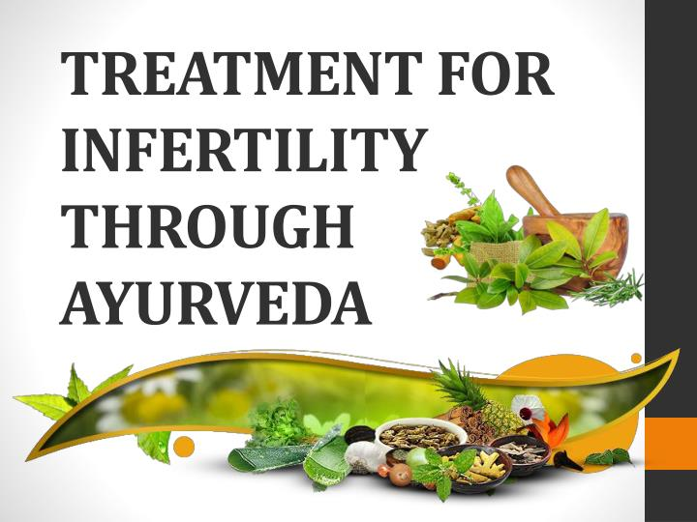

According to Ayurveda Infertility primarily refers to the biological inability of a woman of reproductive age to contribute to conception & also the state of a woman who is unable to carry pregnancy to full term. Infertility is also defined as the failure to conceive after a year of regular intercourse without contraception according to modern science.

The problem of infertility is fairly common nowadays and it has become need of the hour to find out solution which is having less complications & affordable. Ayurvedic background about importance of treatment of Infertility is fully explored in ancient literature Atharvaveda.

Causes of Infertility

Infertility may be due to male or female factors. Causes of infertility in woman include ovarian factors, tubal factors, age-related factors, uterine problems, PCOS, endometriosis etc. Menstrual cycle can be affected by many factors, such as diet, emotional instability, excessive physical exercise, life-style, and stress responsible for creating an imbalance of the Doshas (control the activities of the body-Vata, Pitta and Kapha).

Male infertility is usually caused by problems that affect either sperm production or sperm transport which include varicocele, infections, ejaculation problems, tumours, hormone imbalances, defects of tubules that transport sperm etc.

In Ayurveda main cause of any abnormal function in body is agnimandya (vitiation of the digestive fire of body) & tridosha dushti (vitiation of three governing factors of body).

Management of Infertility In Ayurveda

Ayurveda supports health by strengthening body's own self-healing and balancing mechanisms and doesn't rely on intervention by any outside or foreign substance to replace or correct the hormones in the body. It focuses on the treatment of infertility holistically with an aim of improving the overall health and quality of life of the individual.

#### Dietary management

Diet plays a vital role in the prevention and cure of diseases and in maintenance of good health. "Annam Brahmam" - Food has been compared to God, in the ancient Indian scriptures since it is the main factor for sustaining and nourishing life.

Dietary management involves strict compliance and adherence to foods that increase Ojus (an intersection factor of physical, mental and spiritual health of the body, responsible for overall health, energy and liveliness) and to avoid the substances which diminish the Ojas.

This is important to regulate ovulation and enhances fertilization. Eating whole foods provides all nutrients for the health of the body in addition to the fibres that influences hormonal levels of the body. Foods such as processed carbohydrates, excess starch, antibiotic and hormone laden meat and milk and canned produce destroy fertility.

Ojas building food include as milk, ghee, nuts, sesame seeds, dates, pumpkin seeds, honey, saffron and avocados, fresh organic fruits and vegetables, protein from plant sources like beans, and peas, sweet, whole grains, spices such as ajwain powder, turmeric (improves the interaction between hormones and targeted tissues), cumin (purifies the uterus in women and the genitourinary tract in men) and black cumin boost fertility.

Diet should be free from Trans-fats as they block arteries, threaten fertility and harm the heart and blood vessels and therefore, must be avoided. Foods containing preservatives and other chemicals, like artificial sweeteners, Monosodium Glutamate (MSG), diet high in fat and other artificial flavouring and colouring, excess alcohol and caffeine, tobacco, soda, smoking, red meat, refined carbohydrates, such as pasta, white bread, rice etc can exacerbate the problem of infertility.

Treatment Principles of Infertility In Ayurveda

1. Agni deepana and Ama pachana  
   Ama formation (toxins created when undigested food forms in the stomach) by the imbalance in Agni (the power of digestion) lead to many diseases. Therefore, the treatment of Ama must always include the treatment of Agni, including the use of digestive and carminative Ayurvedic formulations, eating meals at proper time following an appropriate schedule. Ayurveda Panchakarma treatments help to eliminate Ama thus corrects Agni. Healthy Agni will also contribute to healthy Ojas.
2. Vatanulomana  
   The main dosha involved in infertility is Vata. So Vatanulomana (correcting the functions of Vata) is very important in the treatment of infertility. Ayurvedic formulations, following routine exercises and strict diet schedule will help in Vatanulomana.
3. Sodhana  
   Suitable sneha-swedas are done prior to sodhana. Then treatment modalities like Vamana (emesis), Virechana (puragation), Vasti (medicated enema) and Utharavasti special enema administered through urethral or vaginal routes) are done as per the condition of the patient. The patient has to follow peyadi krama (strict dietary regimen to be followed after Sodhana). This detoxification therapy helps in the expulsion of the toxins from the body. These therapies help to correct ovarian, tubular and uterine problems causing infertility.
4. Ayurveda treatments help in releasing tension and removing impurities from the body. They nourish the body, revitalize the mind and strengthen the immune system. They are beneficial in reducing stress, nourishing all dhatus of the body and pacifying Vata.

Ayurvedic Herbs Used in The Treatment for Infertility:

* Ovulation disorder - Ashoka, Dashmoola, Shatavari, Aloe vera, Guggulu etc.
* Premature ovarian failure (POF) - Ashoka, Dashmoola, Shatavari, Guduchi, Jeevanti etc.
* Blocked fallopian tubes, adhesions (scar tissue) and pelvic inflammatory disease - Guduchi, Punarnava etc.

The right combination of herbs helps in regulating menstrual cycles, enhancing general health and wellness, revitalizing sperm (enhancing a man's sperm count, morphology and motility), reducing stress, enhancing sleep, controlling anxiety and increasing energy level, balancing the endocrine system and improving blood flow in pelvic cavity, thereby promoting fertility.

**27.Ayurvedic Concept of Low Blood Pressure**

The morbid condition of low blood sugar (hypoglycemia) is called “Ojaksaya”. It is, in general, concerned with the deficiency of serum (Rasaksaya), which weakens the function of the heart. The weak heart cannot circulate the blood in proper way especially through the arteries. That, in fact, is the significance of low blood pressure, which results in low or weak pulses, poor digestion, general debility, constipation, and back pain, loss of weight, dizziness, headache, mental distraction, irritation, heart diseases, pale looking and weakness of hearing.

There are many causes of hypoglycemia. Some of them are concerned with anemia, bleeding diseases e.g. menorrhagia, hematuria, bleeding hemorrhoids, hematorrhea, ulcer, traumatic hemorrhage etc, diarrhea or chronic diarrhea (Sprue); dysentery or chronic colitis; hepatitis or chronic hepatitis; urinary diseases e.g. albuminorrhea, chyluria, polyuria, glycosuria etc; overindulgence in sex; heavy labor; anxiety; fear; awakening at night; malnutrition; fasting; little food; shock; heat; old age etc.

It is well investigated that the condition of hypoglycemia whatever may be the cause of it, is common to the person who has the nerve natured body type. Unproportionate face, big mouth, thin skin with clear veins especially on the face, lean and thin body, restlessness, intellectually brilliant, compassionate activities, talkative and fearful

caricatures are the sign of the nerve natured body type. The main cause of it is the weak function of the pancreas.

Some symptoms of low blood pressure concerned with the brain and extremities are the same as of hypertension. The reason of it is the poor blood circulation carried through the arteries, which cannot force the blood circulation of the veins.

In this condition, the arteries cannot supply enough blood to the brain and some other organs, for their proper functions, and the veins contain more blood, which results in dizziness, headache and hot sensation. This is very important to pay attention for proper diagnosis.

Loss of appetite and poor digestion whatever may be the cause of them, are the aggravating causes of low blood pressure. Not having good appetite and proper digestion of food, the liver cannot function in proper way to store enough sugar and to excrete enough bile, which is very important to stimulate the pancreas for good appetite and digestion of food.

In this sense, it is very clear that the poor function of the pancreas is indirectly concerned with the chronic low blood pressure or hypoglycemia.The symptoms of low blood pressure come and go, not even being noticed in its beginning stage. The patient of low blood pressure or hypoglycemia feels better when he is active and does some creative

work. Woman compared to man complains more the problems of hypoglycemia. The reason of it is the loss of blood during the period of menstruation. It is especially true to the woman who has the nerve natured body type.

The general treatment of low blood pressure depends upon the drugs, which stimulate the digestive power, strengthen the bodily stamina and relieve the problems of particular diseases, which are concerned with low

blood pressure.

The drug, which stimulates the digestive power, contains the carminative, digestive and appetizing ingredients.

The drug, which strengthens the bodily stamina, includes the general tonic and aphrodisiac medicine.

The drug, which cures the particular diseases concerned with hypoglycemia should be arranged according to the proper diagnosis of chronic diarrhea; chronic colitis; chronic hepatitis; deficiency of serum; chronic urinary diseases; chronic diseases of the uterus etc.

Causes for Low Blood Pressure

Deficiency of serum is the main cause of low blood pressure because the amount of blood sugar depends upon the quantity of serum. Any morbid condition of low blood sugar related with deficiency of serum weakens the heart. The weak heart cannot function in proper way for blood circulation and results in weak pulses manifesting the particular

symptoms of low blood pressure.

Anemia whatever may be the cause of it results in low blood pressure, because the deficiency of blood including serum is the significance of anemia. Any bleeding diseases e.g. menorrhagia, hematuria, bleeding hemorrhoids, bleeding ulcer, traumatic hemorrhage, hematorrhea etc. cause low blood pressure because there is the deficiency of blood including serum.

Diarrhea or chronic diarrhea (Sprue), dysentery or chronic colitis causes low blood pressure. In this condition, the food cannot be digested in proper way. Foods not being well digested, the essence of them cannot be assimilated. That results in deficiency of serum.

Hepatitis or chronic hepatitis causes low blood pressure. Because the injured liver cannot stimulate the pancreas to digest sugar and store sugar. In this condition, the by-products of the blood cells e.g. bile etc. filtered in the liver reverse back to the blood circulation and destroy the blood sugar.

Urinary diseases e.g. albuminorrhea, chyluria, polyuria, glycosuria etc. cause low blood pressure because there is abnormal wastage of vital ingredients of serum. Overindulgence in sex causes low pressure because of wastage of semen degenerating the function of

the bone marrow, which results in anemia.

Heavy labor causes low blood pressure. In this condition, the destruction of blood ingredients results in the deficiency of blood including serum.Anxiety or fear or shock causes low blood pressure. In this condition, the mental tension weakens the cardiovascular system, which cannot circulate the blood in proper way for in and out transition. Awakening at night results in dryness that can be the cause of low blood pressure.

Effect of heat results in dryness that also can be the cause of low blood pressure. Old age is the lack of immunity’s result and the poor function of the bodily organs. In this condition, the deficiency of blood including serum, by nature, manifest the symptoms of low blood pressure.

Malnutrition or fasting or insufficient food intake, by nature, results in deficiency of blood including serum. In this condition, the problems of low blood pressure are very common. It is especially true for poor people.

In regard to these causes and conditions of low blood pressure, it is very important to pay attention for diagnosis that the person who has the nerve natured body type, weak digestion and loss of appetite, in general, suffers from the chronic low blood pressure because his or her pancreas is weak. Otherwise, the symptoms of low blood

pressure come and go.

Symptoms f or Low Blood Pressure

General debility, constipation, back pain, dizziness, often on headache and depression are the main symptoms of low blood pressure. Weak pulses are the significance of poor blood circulation. Careful investigation of pulses is very important for diagnosis.

The patient of low blood pressure often complains of poor digestion and loss of appetite. In this condition he gets more low blood pressure with all the symptoms of it. In general, when he is hungry, especially in the morning, he feels very weak and irritable. After eating, he always feels better.

Sleepy all the time, laziness and body ache are some other clear symptoms of low blood pressure. In this condition, when sitting if stands up quickly, causes numbness, blurred vision and dizziness. It is especially true when sitting in the sun.

The condition of blood pressure, if is very low, can be the cause of collapsing for a moment. It is very common in the accidental trauma.

The patient of low blood pressure not being treated in proper way can have heart problems e.g. palpitation angina pectoris, fear, irritation with sound, and depression etc. in this condition he looks pale and sad. Woman suffering from low blood pressure or hypoglycemia, in general, gets very bad depression and mental distraction.

Besides all these symptoms, weak hearing, noise in the ear, weak vision, hot sensation of the extremities (sometime very hot in the hot season or very cold in the cold season), reaction with refrigerant drugs, breathlessness etc. also can be accompanied with the regular symptoms of low blood pressure.

Low blood pressure is not a particular disease; it is a side effect of some other diseases. In regard to these facts, it is very important to know that the diagnosis of particular diseases concerned with low blood pressure must be well investigated. Otherwise, the symptoms of low blood pressure, being much clear, cannot be identified with the related conditions, which are very important for the proper

treatment.

Prevention for Low Blood Pressure

The regular check-up for blood pressure must be carried out to see the function of the heart. Appetite and digestive power must be maintained with proper diet. If is necessary, some digestive, appetizing and carminative drugs can be taken.

Over eating or heavy meals can disturb the digestive power, which is very bad. Regular time for eating is very important for regular function of digestion and to have desire to eat in the meal time.

The person, who has tendency to have low blood pressure, should be away from anything, which causes mental distraction, fear and shock. Regular exercise is very important to have proper blood circulation, which stimulates the function of the pancreas.

Any disease concerned with low blood pressure e.g. urinary disease, bleeding disease, diarrhoea or chronic diarrhoea, dysentery or chronic colitis, anaemia, hepatitis or chronic hepatitis, constipation, angina pectoris etc. should be treated as soon as possible with proper treatment and diet.

Diet with full protein should be arranged in proper way. In some condition, alcoholic beverage is beneficial to drink after meal but not before meal. Also, the dose of it should be moderate; otherwise, it causes heavy intoxication.

Sound sleep is very important. There should not be any disturbances during the time of sleeping. Fasting, laxative drugs, bloodletting practices (blood donation etc.) and constrictor refrigerant drugs are prohibited (unless it is necessary to prescribe in some condition).

Treatment for Low Blood Pressure

The general treatment of low blood pressure is based on the combination of drugs, which stimulate the digestive power, strengthen the bodily stamina and relieve the problems of particular diseases concerning low blood pressure.

The drug, which stimulates the digestive power, contains some digestive, appetizing and carminative ingredients. Trikatu Rasayana, a compound of Piper longum with other herbs is one of the best compounds to stimulate the digestive power. In the same way, some tincture of drugs e.g. Karpurasava, made of camphor etc; Lavangasava, made of clove etc. can be prescribed after meal, at least, for two to three months.

The drug, which strengthens the bodily stamina, includes the general tonic and aphrodisiac medicine. Draksyasava, a formentated drug made of grapes etc; Mallayoga, a compound of iron oxide with other herbs; Chyavanaprasha, a paste made of Emblica officinalis and some other herbs etc. are well known Ayurvedic tonics and aphrodisiacs.

The drug, which relieves the problems of particular diseases concerned with low blood pressure, should be arranged according to the problem of patient. In this case, the regular treatment of hepatitis or chronic hepatitis, diarrhea or chronic diarrhea, dysentery or chronic colitis, anemia, urinary disease, bleeding etc. is very important to treat side by side with other regular treatments of low blood pressure.

Diet for Low Blood Pressure

The patient of low blood pressure must have proper diet with full protein. Especially vegetarians should arrange their diet to have enough protein from different sources of foods and the food preparations must be spicy with different appropriate spices e.g. ginger, black pepper, cardamom, turmeric, bay leaf, cinnamon, nutmeg etc.

**28.Treatment of Breathing Disorder and Cough**

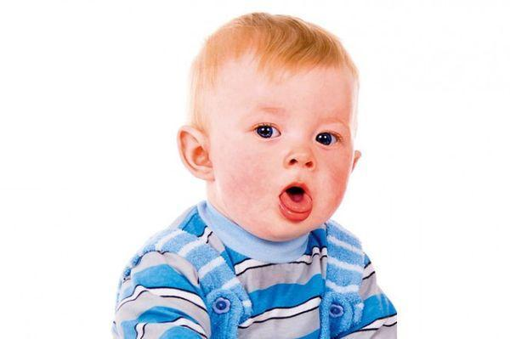

Breathing disorder with shortness of breath can occur for various reasons. Typically, these are diseases of the respiratory tract, but the problems can also affect other systems, for example, shortness of breath due to larynghospasms caused by an emotional state such as fright or anger.

Breathing disorder may be caused by affected upper respiratory tract – the nasal cavity, pharynx or larynx. Most common health problems in children are the runny nose and inflammations of the pharynx – either individually or in combination. Concomitant symptoms include itching or burning in the nose, abundant secretion – from watery to slimy or purulent secretion, headache and temperature. Breathing becomes more difficult, as well as wheezing and snoring occur after falling asleep.

The lower respiratory tract can also be affected – trachea, bronchi, bronchioles, alveolar paths whose activity involves certain muscle fibers, the functions of which may be disturbed.

Among the most common respiratory diseases both in children and adults are bronchitis and pneumonia, as well as asthma. In children, the condition can often occur due mechanical entrance of a foreign body in the respiratory tract with food or as an object.

However, the predominant causes of these health problems in children are the respiratory infections. Usually they affect the upper respiratory tract, as children suffer from these diseases approximately 5 times a year. In one third of the cases is affected the lower respiratory tract, which leads to bronchitis and pneumonia, or bronchiolitis.

The causers are viruses and bacteria, with over two-thirds of childhood diseases being respiratory infections caused by viruses. These are flu, pharyngitis, rhinitis, etc. In addition to infectious, the respiratory diseases can be allergic, traumatic and so on. As children’s immunity is not yet formed, the kids can easily get infected and complications may occur.

Apart from diseases of the pulmonary system and the upper respiratory tract, breathing disorders can occur also as a result from psychological conditions /such as fear/, cardiac problems /for example, heart failure/, brain or chest injuries, poisoning, for example, from chemicals or poisonous spiders, etc.

## Causes of Cough

The cough is a reflex response through which the body tries to free the respiratory tract, and it can occur both in diseases of the pulmonary system and as a result of other health problems that lead to disturbed breathing.

At the same time, it can be suppressed or caused intentionally. Cough’s manifestations are generally two types – with or without secretion, respectively wet and dry cough. The secretion in wet cough can be slimy, bloody or purulent.

The cough can also be acute – lasting up to 3 weeks and associated with a cold, flu or sinus infection. The sub-acute cough continues for up to 8 weeks, and if it lasts for a longer period, then it is chronic. Its course may be in waves – such as asthma and whooping cough; permanent – for example, chronic bronchitis, tuberculosis, heart failure, and periodic: with severe attacks during the chronic cough.

The specific causes cover a very wide range – from colds to flu, from sinusitis, asthma, allergies, lung infections and diseases, to drinking cold and fizzy drinks, polluted air and smoking, and so on.

Treatment of cough and breathing disorders should be prescribed by a physician. The specifics of the child’s organism must be taken into account. If the trachea and bronchi, for example, are shorter and wider, even colds can quickly go down and reach the lungs. If the organs are with smaller volume, the inhalations are more frequent and respiratory diseases can quickly cause a dangerous oxygen insufficiency.

Especially important is the diagnosis, as the causes can be numerous and differ significantly. Moreover, unsuitable treatment may lead to allergies /especially in children/ and severe complications. We have to take complex measures with regard to viral diseases. The nasal mucosa must be recovered and strengthened, because it „acclimatizes”over 10 thousand liters of air /up to 170 thousand times higher activity/, by warming it up and moisturizing for its absorption by the body. The western medicine uses antibiotics to treat inflammations. Medicines for liquefaction of the secretion are also applied for its easier elimination, as hot liquid foods also contribute to that, as well as humidification of the air in the room.

Treatments

According to Ayurveda, breathing disorder and cough can occur due to imbalances in the three energies that are responsible for the vital processes in the body.  
Kapha is the energy /the Dosha of the water element in the body/ which accumulates mainly in the lungs and stomach.

In case Kapha dosha is increased and out of balance, mucus from the stomach enters the lungs, and when it accumulates there, it can flow into other body parts, and the build-up can lead to various diseases. The energy deviations in Kapha Dosha usually cause coughs and respiratory infections, asthma, pneumonia and other problems of the respiratory system.

But Vata dosha, which is the energy of movements, can also affect the lungs, as inhalation and exhalation are part of these movements. Through the breathing process the vital energy enters the human body. If the breathing problems are accompanied by dehydration, heavy shortness of breath and blockages, this is an indication that Vata is increased.

The extremely severe disease tuberculosis, for example, is of the Vata type of respiratory diseases. Infectious respiratory diseases are related to the third dosha – Pitta. The disturbances in this energy, which is responsible for transformations, cause weakening of the digestive fire Agni, and this leads to poor digestion and accumulation of excess mucus. This in turn increases Kapha dosha. Therefore, the treatment of respiatory problems includes also the enhancement of Agni to improve digestion and metabolism.

Apart from the impaired degradation of food, respiratory diseases depend also on the seasonal changes, the prolonged exposure to cold, improper breathing practice, immobilization or overloading. Sadness, fear and love are among the mental and emotional causes of these diseases.

The Ayurveda treatment of breathing disorders and cough is focused on bringing back the balance of the doshas. It includes breathing exercises and other yoga practices, proper diet, detoxification form toxins, healing herbs, potions and oils.

The ayurvedic procedures include insertion of potions and oils through the nose, herbal gargle, pouring and massages with wam oils or pastes on the chest, back, as well as of the head.

**29.The Ayurvedic Concept of Asthma**

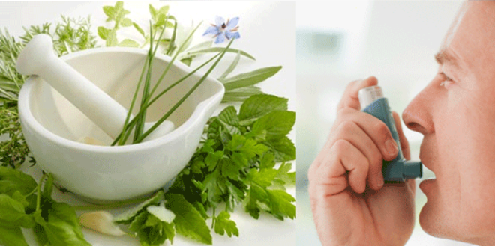

The fundamental cause of asthma is the bronchiospasm, which depends upon the blockage of the respiratory system for inhaling and exhaling. The bronchi connected especially with the lower lobes of the lungs, if are blocked, the upper lobes of the lungs, by nature, become more active. In this condition enough oxygen cannot be supplied through the passages of the respiratory system that in fact, causes breathlessness to activate the lungs for enough oxygen supply.

The Ayurvedic words Vata and Kapha are the keynotes to designate the physical condition of asthma. The word, Vata is the significance of spasm and the word, Kapha indicates the blockage whatever may be the cause of it. Bronchial edema; congestion; mucous exudation; partly failure of the respiratory function; exhaustion; inflammation etc in general, results in blockage in the passage of respiratory system for inhaling and exhaling.

Asthma is classified into the three categories:

* General asthma.
* Malignant deep asthma and allergic asthma.

The malignant deep asthma has three different conditions related with failure of the kidney function; failure of the respiratory function; failure of the exhaling function. The allergic asthma also has two different natures: one is common in the winter season and another in summer season.

The general asthma is called “Ksudraswasa”. It is concerned with the exhaustion whatever may be the cause of it. In general, it appears as a symptom of related diseases.

The malignant deep asthma related with the failure of the kidney is called “Mahaswasa”. It is common in old age and causes death.The malignant deep asthma related with the failure of the respiratory function is called “Chinnaswasa”. It is common in old age or complicative situation of patient and causes death. The malignant deep asthma related with the failure of the exhaling function is called “Urdhwaswasa”. It is common in the old age or complicative situation of patient and causes death. The allergic asthma, which is common in winter season, is called “Tamakaswasa”. It is related with cold atmosphere, cold water, cool breeze, and mucous exudation whatever may be the cause of it.

Causes of Asthma

The bronchiospasm or periodical reversed function of the respiratory system is the fundamental cause of the asthma and the cause of the bronchiospasm is the airways obstruction. The bronchi particularly connected with the lower lobes of the lungs, if are blocked, the upper lobes of the lungs, by nature, becomes more active. This is the morbid condition of the reversed function of the respiratory system. In this condition, enough oxygen cannot be supplied through the air

passages of the respiratory system. That, in fact, causes

breathlessness to activate the lungs for enough oxygen supply, which is very important for proper functions of the heart and brain. The Ayurvedic words, Vata and Kapha are the keynotes to designate the physical conditions of asthma. The word, Vata is the significance of spasm which is concerned with frequent impulses of the respiratory nervous system and the word, Kapha is the significance of blockage or airways obstruction which depends upon the conditions of

bronchial edema or swelling; congestion; mucous exudation; partly failure of the respiratory function; exhaustion; accumulation of air; inflammation; shrinking condition of the lungs etc.

The main cause of general asthma is the weak heart concerned with another diseases e.g. bronchitis, fever, bleeding diseases, obesity; urinary diseases; hepatomegaly; general edema; peritonitis; general debility etc. The particular causes of malignant deep asthma can be varied e.g.failure of the respiration function; failure of the kidney’s function; failure of the exhaling function etc. these causes often are associated with old age. It is well investigated that the person who has well expanded chest (that in general is common to the person who do exercise) in the old age or in some other condition if the chest is declined; can have the problem of deep asthma.

Symptoms of Asthma

Difficulty for breathing or breathlessness is the general symptom of asthma. Uneasiness in the heart, abnormal colic pain, tympanitis or bloated stomach, bad taste in the mouth and slight headache especially affecting the temples are the primitive symptoms of the asthma which indicate the attack of asthma. Difficulty for breathing, especially in the condition of exertion is the main symptom of general asthma. It is often associated with other symptoms of related diseases e.g. heart problems, chronic bronchitis,pulmonary T.B. hepatomegaly, edema, excitement etc. This kind of asthma which having rest causes no problems and the attack of bronchiospasm automatically disappears.

Treatment of Asthma

The general treatment of asthma is based on the combination of drugs, which open the blockage of respiratory system and subdue the attack of spasm. The drug which opens the blockage depends upon the condition e.g. drug for swelling; drug for inflammation; drug for congestion; drug for mucous exudation. And, the drug, which subdues the spasm, contains some specific antiasthma medicine.

Swasakasantaka, a compound of Adhatoda vasica with other ingredients, is one of the best remedies against asthma to counter the problems of blockage and spasm. It is prescribed with warm water or honey for three to four weeks for immediate relief.While treating the problems of general asthma, if it is symptomatic, the related disease also has to be treated side by side with regular drugs. It is very important.The general treatment of allergic asthma, which has different natures related with hot and cold condition should be based on the specific combination of drugs, which open the bronchial blockage; subdue the attack of spasm; strengthen the functions of the pulmonary nervous system and artery system; correct the unseen problems neurasthenia.

To open the blockage whatever may be the condition of it,Mrityunjaya, a compound of Aconitum palmatum with other ingredients, is one of the best remedies. In general, this medicine is very effective to subdue the problems of congestion and inflammation of allergic asthma either related with heat or cold. Lavangasava, a fermented drug of clove with other herbs, is very important to prescribe with Mrityunjaya.To subdue the attack of spasm, Chaturdasanga, a compound of carminative ingredients with anti-asthma drugs is one of the best remedies. The drastic spasm of allergic asthma related with cold has to be controlled with Chaturdasanga along with Nimbadi, a compound

of Azadirachta indica and other herbs. And the drastic spasm of allergic asthma related with heat has to be controlled with Surasadiyoga, a compound of Ocimum sanctum with other herbs.These drugs, which open the blockage and subdue the attack of spasm, have to be prescribed for three to six months.

Prohibited Foods and Behaviour Of Asthma

Cold drinks; ice cream; milk products; especially yogurt; fruit juice; salad; mushroom; watery vegetables e.g. pumpkin, squash etc; vinegar; greasy food preparations; pork, beef and fish; water of well, pond or river; nuts e.g. peanut, walnut, cashew nut, coconut etc.; sleeping during the day; swimming; cold bath; effect of damp, hot and cold condition; rain wet; heat on the brain (sun bath) windy or cold atmosphere; running; jogging; heavy exercise or labour; withholding the natural urges of urine, stool and gas; smoking, effect of smoke; pollution and dust; sleeping naked; over indulgence in sex etc. are prohibited during the treatment of asthma.

**30.The Ayurvedic Concept of Varicose Veins**

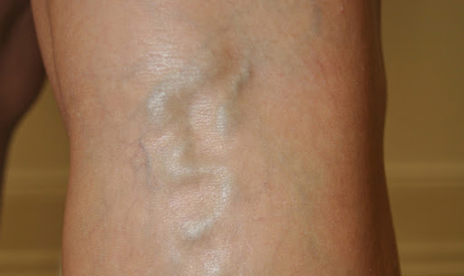

The fundamental cause of varicose veins is the loss of elasticity of the vein’s wall, which depends upon the condition of the weak nervous system. Loss of blood, blockage in the circulation, weak digestion, malnutrition, nerve natured personality, old age, anxiety, fear etc, in general, have been found to be the aggravating causes of the weak nervous system. The veins attached with the weak nervous system, at the beginning, become overactive and the overactive veins can be seen dilated in abnormal ways. The dilated veins, while having relaxation, have to assume the normal position. This is the nature because the wall of the veins has the elastic physical properties.

But in the constant effect of the aggravating causes, the elastic physical property of the vein’s wall remains no more to assume the normal position. That, in fact, results in varicose veins. The elastic physical property of the vein’s wall depends upon the bodily grease and viscous elements. The weak nervous system when often on becomes overactive, by nature of over functioning of the affected part or organ, results in dryness counteracting the bodily grease and viscous element. In this condition, the vein’s wall can be seen enlarged changing the size and shape, which remains even in the relaxation.

Varicose veins, in general, are very common to the woman. The reason of it is concerned with menstruation and pregnancy. Any woman, who has the problem of heavy menstruation, can have the problems of weak nervous system. It is especially true in the old age, when the monthly period gradually disappears in the stage of menopause, or one who has a life style to spend a long time hanging the legs in the chair. In this condition, the enlarged veins of legs can be the cause of varicose veins. At, the period of pregnancy, the expanded uterus generally causes pressure in the iliac veins. In this condition, the iliac veins cannot have proper circulation, because there is blockage due to the pressure. That, in fact, in certain condition of the nerve natured personality, loss of blood in the time of delivery and lack of proper rest and diet, can be the cause of varicose veins of the legs.

Enlarged and tortuous veins, especially of the legs, are the obvious symptoms of varicose veins. It appears, at the beginning, in the joint of the veins. Then the effect of it spreads here and there and causes heaviness and pain in the legs. It is not a complicative disease; however, it is progressive and causes the ugliness of the legs.

The general treatment of the varicose veins depends upon the theory of treatment to restore the balance of the weak nervous system. For that, the application of medicated steam, warm fomentation, oil massage, general nerve tonics are beneficial.

Causes of Varicose Veins

The bodily grease and viscous elements are very important to maintain the elastic physical property of the vein’s wall. These greasy and viscous elements in case, are counteracted, the elasticity of the vein’s wall remains no more to assume the normal position. In this condition, the veins, especially of the legs, are being enlarged and tortuous manifest the morbid condition of the varicose veins.

The bodily grease and viscous elements often have been seen counteracted in the physical condition of the weak nervous system. There are many causes, which weakens the function of the nervous system.

Some of them are: loss of blood; blockage in the circulation; weak digestion; malnutrition; nerve natured personality; old age; anxiety; fear etc. Any woman who has the problem of heavy menstruation can have the problem of weak nervous system. It is especially true in the stage of menopause. In this condition, one who has a life style to spend a long time hanging the legs in the chair, can have the problems varicose veins of the legs. At, the period of pregnancy, the expanded uterus generally causes pressure in the iliac veins.

In this condition, the iliac veins cannot have proper circulation, because there is blockage due to pressure.

That, in fact, in certain condition of the nerve natured personality, loss of blood during the period of delivery and lack of proper rest and diet, can be the cause of varicose veins.

The nerve natured personality is the result of the overactive nervous system by birth. Thin skin with clear veins, difficulty to gain weight (skinny), unproportionate face, and restless, nervous, talkative and weak physical condition are the main caricatures of the nerve natured personality. It is well investigated that a woman, in particular, having this kind of personality, suffers from the problem of varicose veins of the legs.

The problem of hypoglycemia or low blood pressure is very common to the woman. The cause of it is the weak pancreas and loss of blood in menstruation. In this condition, the weak nervous system can be the cause of varicose veins.

Symptoms of Varicose Veins

The skin if is white and thin, the enlarged veins can be seen clearly with deeper blue colour and changed the natural size and shape of them. At the beginning, the problem of varicose veins takes place at the back of legs. Then it spreads here and there, because it is a progressive disease. The veins are being enlarged and tortuous, in general, the patient feel heaviness and painful in the affected area.

Especially, the pain and heaviness get worse in the winter, humidity, cloudy day, walking too much and during the period of menstruation. Varicose veins is not a harmful condition of the disease, however, it is a problem to the society with the dress of skirt, as the disease is ugly looking.

Prevention f Varicose Veins

During the period of delivery, any woman must have oil massage daily for one or two months. The application of the oil massage isvery effective to restore the normal function of the nervous system. After delivery, she must have complete bed rest, at least, for two months. High protein and greasy diet is recommended. Cold bath, swimming, salad, yogurt, vinegar etc. are strictly prohibited; warm dress and warm atmosphere in the sleeping room is very important; to sit on the chair hanging the legs for long time is not good.

The problem of heavy menstruation has to be treated as soon as possible. The problem of low blood sugar or hypoglycemia has to be solved as soon as possible. A nerve natured person has to gain weight with high protein and greasy diet along with digestive and appetizing drugs.

In this condition, some kind of activity on business, which should create name, fame, reputation or money, also is very important to be cheerful. The cheerful mood is found always good to control and regulate the function of the nervous system. It is more important to any woman in the stage of menopause. The stage of menopause is a universal truth. Any woman in this stage, if is alone and has no any creative work, can have many problems.

Treatment of Varicose Veins

The general treatment of varicose veins depends upon the application of the medicated steam, warm, fomentation, oil massage and general nerve tonics. The main aim of these applications is to restore the weak nervous system. In another sense, the aim of the treatment of varicose veins is to restore the elastic physical property of the vein’s wall. For that the function of the weak nervous system must be counteracted with proper blood circulation, heat, general

tonics which should increase the bodily grease and viscous elements.

The medicated steam is made out of decoction of Dashamula, a compound of Aegle marmelos with other herbs. It is applied with an instrument of pipe to spray on to the affected area. The application of the steam subdues the over-activity of the weak nervous system and makes the walls of the veins soft. It is especially used in the advanced stage of varicose veins.

The warm fomentation is made out of warm salt water. It is applied with a thick cloth soaked in the warm salt water to have compress in the affected area. It has the same effect as of medicated steam. It is prescribed in the early stage of the varicose veins.

Narayanatail, an oil preparation made of asparagus root with other herbs, is one of the best oil preparations for massage. It is applied after steam or fomentation to rub on gently on the affected area. The oil massage subdues the over-activity of weak nervous system, softens the vein’s wall, creates heat and increases the proper blood circulation. Oil massage, in another sense, is very important to replace the elastic physical property of the veins, because, it is greasy and increases the viscous elements of the body. It can be prescribed in any stage of varicose veins.

The general nerve tonic contains some minerals e.g. iron etc., along with some other herbs, which increases the vital energy and strengthens the function of the nervous system. Yogaraja Guggulu, a compound of Balsamodendron mukul with other herbs and minerals, is one of the best general nerve tonics. It is prescribed in any condition of the varicose veins, for internal use.

In regard to the treatment of varicose veins, it is very important to pay attention that the effect of the treatment is very slow. The treatment of varicose veins in the early stage must be continued, at least, for three months. And the treatment of advanced varicose veins needs to continue, at least, for six months.