**1.What is Aviation Safety?**

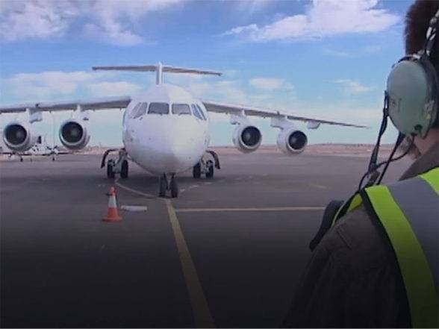

Deep down, most of us have an idea about safety. We can logically expand a safety definition to encompass the aviation industry. Yet this takes work to consider the broad implications. I've taken a few moments to discuss what is aviation safety, since I've never defined it in the past.

Aviation safety is the condition that affected elements are protected from hazards and risks arising in the operating environment. These affected elements may include:

* Operations personnel;
* Customers;
* Equipment;
* Environment; and
* Reputation.

**2.Aviation Safety Focuses on Hazard Identification**

Aviation safety focuses on hazard identification and risk assessment with mitigation strategies to reduce risk to as low as reasonably practical (ALARP). If you are an aviation safety professional, ALARP should be very familiar to you already; however, to the layperson, ALARP is may seem mysterious.

As aviation service providers' safety cultures mature, they move from a reactive risk management strategy to proactive risk management. The **ultimate goal of aviation safety** is for all aviation service providers to achieve the ability to predict events and be prepared to mitigate risk scenarios whenever hazards manifest themselves. This predictive ability hinges on many factors, including:

* Top management support;
* Data collection;
* Organizing data properly; and
* Ability to decipher data on a routine basis.

**3.Is the Aviation Industry Already Safe Enough?**

Most laypersons believe the aviation industry already enjoys a high degree of safety. To an outsider or regular consumer, the aviation industry appears highly controlled and very safe.

Personnel involved in daily operations, both flight and maintenance, realize that many close calls go unreported and that there is considerable opportunity to increase safety in the aviation industry. These close calls may not be close at all, but events such as:

* Poor communication between actors;
* Lost tools;
* Hangar rash; or
* Unreported damage caused by baggage handling equipment.

**4.Who Is Responsible for Aviation Safety?**

Most passengers take aviation safety for granted. They believe "somebody is always watching." This is not true.

Aviation safety is more than merely the responsibility of the aviation service providers. Since the aviation industry is an open system that is affected by many environmental variables, aviation safety is also the responsibility of:

* Governmental organizations providing oversight (civil aviation authorities);
* ICAO (International Civil Aviation Organization);
* Aircraft and parts manufacturers;
* Employees;
* Maintenance organizations;
* Fuel providers;
* Customers; and
* Related service providers.

As stated, aviation service providers operate in an open system that remains exposed to many external variables, including;

* Political;
* Legislative;
* Economic;
* Technological change;
* Weather;
* Cultural norms; and
* Vendors and suppliers.

To reach the highest level of aviation safety, you will need proper tools to predict events before they occur and be prepared to mitigate the risk. At a bare minimum, you should have an effective Safety Reporting Solution that not only allows stakeholders to affordably report issues, but also to

* Manage risk;
* Conduct investigations;
* Track corrective actions and preventive actions; and
* Quickly generate reports to analyse risk.

**5.History of Aviation Safety**

First Recorded Passenger

The first person to fly as a passenger was Leon DE LaGrange, who rode with French pilot Henri Farman from a meadow outside of Paris in 1908. Charles Furnas became the first American airplane passenger when he flew with Orville Wright at Kitty Hawk later that year.

The Record

The National Transportation Safety Board (NTSB) investigates transportation accidents. It also publishes transportation safety statistics. As part of its accident investigation function, NTSB gathers facts about the accident and seeks to determine the reasons for it. If appropriate, it can also make recommendations to regulatory bodies for safety improvements.

The airline safety record also compares very favourably with many other everyday activities. Since 1938, when the government began keeping records of aviation accidents, the very worst year for airline fatalities was 1974, with 460 deaths. By contrast, more than 40,000 people die each year in highway accidents. Sadly, in a typical three-month period, more people die on the nation's highways than have died in all airline accidents since the advent of commercial aviation.

The National Safety Council publishes an annual report on accidental deaths in the United States that also helps put the U.S. airline safety record into perspective. According to the council's 1999 report for 1998, 16,600 people died that year in accidental falls, 9,000 from poisoning, 4,100 from drowning, 3,700 from burns, 3,200 from suffocation brought on by ingestion or inhalation of food and other objects, and 900 from guns fired accidentally.

The Government's Safety Role

The federal government plays an important role in assuring the safety of air travel. It has done so since the enactment of the Air Commerce Act of 1926, and it continues to play a leading role in aviation safety today. Although the Airline Deregulation Act of 1978 ended all domestic economic regulation of the airlines, it did not end government regulation of safety. All safety requirements and programs in place at that time are still in force, and many new regulations have been added.

**6.The Federal Aviation Administration (FAA)**

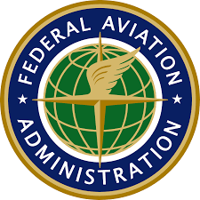

The primary responsibility for airline safety regulation lies with the Federal Aviation Administration. Congress established the FAA as an agency of the Department of Transportation when it created the department in 1967. It is the successor to the Federal Aviation Agency, an independent agency created by the Federal Aviation Act of 1958.

Aircraft Certification

Federal law requires that all civil aircraft operating in the United States be certified as airworthy by the FAA. There are well over 200,000 licensed civil aircraft in the United States, the vast majority of them privately owned general-aviation aircraft (small planes used primarily for pleasure flying, training, corporate travel and agricultural purposes like crop spraying).

FAA's certification process begins with the design of an aircraft. FAA aeronautical engineers participate in the design process. They also oversee the construction and flight testing of the prototype. If all tests are successfully completed, FAA issues a type certificate for the new aircraft, followed by a production certificate, once FAA is satisfied that the manufacturer has everything in place to properly duplicate the prototype.

The final step in aircraft certification is the issuance of an airworthiness certificate, which essentially is FAA's stamp of approval for each aircraft coming off the assembly line. It attests to the fact that the plane has been properly built, according to an approved design, and that it is safe for commercial service.

The FAA requires that all commercial transport aircraft be designed with built-in redundancies, so they can fly even when a structural element fails. For example, there is more than one way to lower the landing gear, more than one way to communicate with the ground and more than one way to control the aircraft.

Design problems, discovered after a plane is in service, that result in a possible unsafe condition, are addressed through airworthiness directives, or ADs. Through these directives the FAA informs all operators of the aircraft or engine type of the repairs or modifications needed to correct the problem. Usually, ADs are written in consultation with the manufacturer, but unlike manufacturer-generated service bulletins, ADs carry the force of law and airlines must comply with them. If the problem poses an immediate safety hazard, the FAA will direct the airlines to complete the work quickly, sometimes even before further flight. In most situations, however, there is no immediate safety hazard and the airlines are given a specified amount of time to complete the ADs.

Operating Certificates

Federal aviation regulations (FARs) require FAA certification of all airline companies, as well as the equipment they use. Every airline therefore is issued an operating certificate by the FAA. FARs spell out the requirements for engaging in large-plane service. These are operating requirements. The Department of Transportation mandates that financial, insurance and citizenship requirements be complied with before it issues to the airline a second, separate certificate known as the certificate of public convenience and necessity.

Among other things, a commercial operator must have FAA-approved training and maintenance programs, as well as comply with airworthiness certificates for each aircraft. The maintenance program must specify the intervals at which certain aircraft and engine parts will be inspected and, in some cases, replaced. In addition, the maintenance shops the airline intends to use (both its own shops and those of subcontractors) must be certified by FAA and open to inspection, on demand. Records of all maintenance work must be kept and also must be open to FAA inspection. Other requirements address such things as:

* the equipment a carrier must have aboard each aircraft;
* flammability standards for cabin materials;
* floor lighting for emergency evacuation;
* onboard smoking rules;
* the number of flight attendants that must be aboard;
* the content of pre-flight announcements;
* rules for carry-on baggage;
* security procedures;
* aircraft de-icing procedures.

**7.Certification of Airline Personnel**

As with aircraft and airlines, the people who work on, fly or manage airplanes must be personally licensed by the FAA and have minimum levels of training and experience. These certification requirements apply to aircraft mechanics, pilots, flight engineers, aircraft dispatchers and the FAA's own air traffic controllers. The schools where these aviation professionals get their training, as well as the teachers in those schools, also require an FAA license.

Large aircraft airline pilots must have a minimum of 1,500 hours of flight time, including at least 250 hours flying as a pilot in command of an aircraft. They must pass a written exam testing their knowledge of aircraft operations, meteorology, navigation, radio communication and other subjects important to flying aircraft in commercial service. They must demonstrate their flying skills to an FAA examiner (or FAA-designated examiner), performing various types of take-offs and landings, inflight manoeuvres, and emergency procedures, either in an airplane or a simulator. They also must pass a medical exam, both pre-employment and every year after they are hired. Recurrent training also is required. FAA Flight Standards Service establishes all training and operating requirements for the airlines.

Airport Certification

FAA also regulates airports, although to a lesser extent than pilots, airlines and aircraft. It was empowered to do so by the Airport and Airway Development Act of 1970, with a primary purpose of promoting the development of new aviation infrastructure. The act states that all airports with commercial service must be certified by the FAA and that certification will be granted only if the airport complies with certain safety criteria set by the FAA. Among those criteria are ones dealing with the number and type of fire-fighting vehicles at the airport, runway lighting and storage facilities for fuel.

The FAA also issues advisory circulars to airport operators on such topics as runway paving, drainage and apron design. FAA also provides grants for airport projects that enhance safety and increase the capacity and efficiency of the airport.

Industry Safety Programs

Although the FAA is charged with the responsibility for setting and enforcing minimum safety standards, the ultimate and primary responsibility for safety rests with the airlines themselves. The Federal Aviation Act that established the FAA's predecessor agency stated that every license holder assumes "private sector responsibilities for maintaining the highest degree of safety." Of course, it also makes good business sense for the airlines to do everything they can to ensure safety. To airlines, safety is a top priority, and every year they work jointly through the Air Transport Association on an agenda of safety-related programs.

Aircraft Maintenance

The airlines always have practiced a sophisticated and comprehensive form of preventive medicine when it comes to maintenance. The nature of the airline industry leaves no choice but to make sure that essential equipment is in good working order before an aircraft goes into service.

Every airline has a maintenance program for each type of aircraft it operates. The programs are developed jointly with the manufacturers of the equipment and, as mentioned earlier, must be approved by the FAA. Each involves a series of increasingly complex inspection and maintenance steps pegged to an aircraft's flying time, calendar time, or number of landings and take-offs. With each step, maintenance personnel probe the aircraft, taking apart more and more components for closer and closer inspection. Among the many inspection and maintenance procedures, a typical program involves:

* a visual "walk around" inspection of an aircraft's exterior, several times each day, to look for leaks, worn tires, cracks, dents and other surface damage; important systems inside the airplane also are checked;
* an inspection, every three to five days, of the aircraft's landing gear, control surfaces such as flaps and rudders, fluid levels, oxygen systems, lighting and auxiliary power systems;
* an inspection, every six to none months, of all of the above, plus internal control systems, hydraulic systems, and cockpit and cabin emergency equipment; a check, every 12-17 months, during which aircraft are opened up extensively, so inspectors can use sophisticated devices to look for wear, corrosion and cracks invisible to the human eye;
* a major check, every three to a half to five years, in which aircraft are essentially taken apart and put back together again, with landing gear and many other components replaced.

In between these scheduled maintenance checks, computers onboard the aircraft monitor the performance of aircraft systems and record such things as abnormal temperatures and fuel and oil consumption. In the newest aircraft, this information is even transmitted to ground stations while the plane is in flight.

All of the major U.S. airlines have extensive maintenance facilities and do most of their own maintenance work. Some tasks, however, are contracted to independent shops, both domestic and foreign, since many airlines now operate globally. As mentioned, all of the repair stations the airlines use must be FAA-approved, and no matter where the work is done, the airline itself retains ultimate responsibility for the quality of the work.

The airlines also have ultimate responsibility for all of the parts they buy. To ensure that parts meet original manufacturer specifications, airlines have rigorous purchasing procedures and quality-control programs that test parts when they are delivered.

Aircraft manufacturers provide considerable product support to their airline customers. In effect, the manufacturers stand behind each of their aircraft for as long as they are in service. If a problem develops, it is immediately reported back to the manufacturer who, in turn, alerts other owners of the aircraft model through service bulletins about the problem and the steps that need to be taken. The FAA also gets the bulletins, and if the problem poses a serious safety hazard, FAA converts the bulletin into an airworthiness directive - mandating inspections, modifications, repairs, or whatever else is necessary to maintain safety.

The FAA permits airlines to temporarily operate aircraft with certain items inoperative, but only if adequate back-up systems are available, or if the item is optional or installed solely for passenger convenience. Airlines are given a specified period of time to repair or replace these items. They may not postpone repairs that relate to the safe operation of the aircraft. Items affecting safety or airworthiness must be repaired prior to further flight.

Training

Airline employees in general receive an extensive amount of training, but especially those who work aboard the aircraft and whose performance directly affects safety.

Pilots are among the most highly trained individuals in any field. Applicants for jobs with a major airline must go through several steps just to get into a training program, then several more steps before they actually begin to fly.

Although airline hiring procedures may differ, those accepted for an interview are judged by many of the same criteria used to judge applicants for any job, including experience and professionalism. The second step is a screening process involving psychological and aptitude tests and a stringent medical examination. Step three usually is a test in a flight simulator that evaluates an applicant's flying skills. Between 10 and 15 percent of an airline's applicants typically make it through this process to gain acceptance to an airline's training program.

Programs vary, but as mentioned, all must meet certain standards established by the FAA, and all must be individually approved by the FAA. Proficiency is the common goal of today's training programs. In many areas, the FAA and the airlines no longer require a set number of hours of training at various tasks as they did in the past. Instead, they require whatever training is necessary for trainees to become proficient at the required tasks. The process recognizes the fact that applicants with different prior experiences enter training programs with different skills and abilities.

The airlines use various training methods, depending on subject matter. The methods include classroom instruction, training in simulators, hands-on equipment training, and the use of self-pacing, self-testing, computerized video presentations. In all cases, the training exercises conclude with exams, drills or flight checks to ensure understanding and competence.

Airline pilots and flight engineers also are required to complete certain recurrent training each year. Normally, recurrent training is done in an advanced simulator and takes from two to four days, depending on the type of airplane the pilot flies. Pilots in command, or captains, must complete some elements of recurrent training every six months.

Security

The U.S. airline industry began security screening of passengers and their baggage in 1973, following a rash of aircraft hijackings. Passengers were required to be screened via metal detector prior to entering the concourse leading to their gate area, to prevent weapons from being carried aboard an aircraft. Subsequently, airlines began to screen carry-on baggage by x-ray machine. This screening system has been in place for over 40 years and it has been extremely successful in preventing hijackings.

During the 1980s, a new and much more serious threat emerged - the threat of sabotage and terrorist acts of aggression, particularly against U.S. flag carriers' originating flights from overseas locations. FAA and the airlines, working closely together in 1985, took steps to significantly increase and add new aviation security measures. In the 1990s, measures were once again enhanced to include the following steps for certain international flights:

* guarding aircraft at all times while they are on the ground and parking them in secure areas overnight;
* searching aircraft cabins, cockpits and cargo holds prior to their first flight of the day;
* inspecting the property of all people who service aircraft, such as cleaning personnel, mechanics, caterers, and cargo and baggage handlers;
* accepting baggage only from ticketed passengers and only at ticket counters inside an airport;
* hand searching or x-raying all checked luggage;

matching checked baggage against the names of people who have boarded a flight and pulling bags from the baggage compartment for further inspection if they do not match a passenger aboard the flight;

questioning passengers before each flight to make sure they have not accepted gifts or packages from people they do not know.

In 1993, terrorism struck the United States directly with the World Trade Center bombing, followed by the bombing of the federal building in Oklahoma City, Oklahoma. Once again, security was increased at U.S. airports. As a result of the recommendations of the Vice President's Commission on Aviation Safety and Security, published in February 1997, the FAA is purchasing and deploying sophisticated explosive- detection screening equipment at certain U.S. airports for use by the airlines. U.S. airlines are also employing a government required and approved Computerized Passenger Screening System (CAPS), which automatically determines, using government-approved, objective criteria, which passengers require additional security scrutiny. Enhancements are taking place in passenger screening procedures and training. Also, mandatory background checks are now required for airline screening personnel. Various improvements in cargo screening procedures are also being implemented.

All aviation security measures are designed to be flexible. The airlines work closely with the FAA to increase security with additional procedures and personnel when the need arises. FAA security personnel work closely with law enforcement and intelligence officials worldwide and advise the airlines of any information that could affect their flight operations. A credible threat against a specific flight could result in that flight being cancelled, if the threat cannot be resolved.

Aviation security is a fluid process requiring continuing analysis and review by the law enforcement and intelligence communities, as well as both the FAA and the airlines to ensure the highest level of protection for the traveling public.

Joint Efforts

Government and industry officials commonly work together to address recognized safety problems, usually through committees or task forces comprised of representatives of equipment manufacturers, airlines, pilots, mechanics, FAA and the National Aeronautics and Space Administration. Examples of recent efforts are:

Aging Aircraft

Following a highly unusual fuselage failure, a major effort was undertaken to re-examine and revise maintenance and modification procedures for older aircraft. Now, as aircraft age, many components are automatically replaced at specified intervals, well ahead of the time they would be expected to fail.

Collision Avoidance

Years of joint research between government and industry resulted in the development and deployment of the Traffic Alert and Collision Avoidance System (TCAS), which warns pilots when aircraft are getting too close and tells them what they should do to maintain adequate separation. TCAS is now in all commercial jets with 10 or more seats.

Wind shear

As with TCAS, government and industry jointly developed warning devices for aircraft that alert pilots to wind shear conditions so they can take appropriate action to avoid these dangerous downdrafts of air.

De-icing

Following an accident attributed to ice on the wings of the aircraft (a condition that disrupts airflow over the wings and makes it difficult for aircraft to fly), government and industry officials conceived and implemented new procedures for pilots to follow in icy conditions. After de-icing (a process in which a fluid that melts ice is sprayed on an aircraft exterior), pilots have a specific amount of time to take off, depending on weather conditions, and must be de-iced a second time if they exceed the allotted time.

Flammability

In a series of steps, airlines and government officials have upgraded aircraft interiors with more fire-resistant materials for seats, cabin sidewalls, overhead bins, and other cabin and cargo bay materials.

Human Factors

Recognizing that most accidents are caused by human error, industry and government alike have focused resources, in recent years, on studying human-factor issues. While ongoing, these efforts already have produced improvements in training and in the management of tasks in the cockpit.

Accident Investigations

The NTSB, mentioned earlier, is responsible for investigating all transportation accidents, including all civil aviation accidents. Congress created the board under the same legislation that created the Department of Transportation in 1967. Prior to that time, the Civil Aeronautics Board handled accident investigations.

Initially, the five-member NTSB was an autonomous agency within the DOT, which was used for administrative support only. It became a completely independent federal agency, outside the DOT, through the 1974 Transportation Act. The President appoints the members of the board, with confirmation by the Senate. Terms of service are five years. The Board Chairman and Vice Chairman, are appointed from among the members and serve terms of two years each.

NTSB investigations have two goals - to determine the cause of an accident and to serve as the basis for recommendations that enhance safety. The board does not have the authority to impose new aviation regulations. Only the FAA has that power. Many of the board's recommendations through the years, however, have been implemented as new regulations, and are always carefully examined by the FAA, as well as the aviation industry.

When an airline accident occurs, the board dispatches a go team of experts in various phases of accident investigations. The teams typically consist of one member of the board and specialists in air traffic control, aircraft maintenance, aircraft operations, and someone trained in witness interrogation. The team spends whatever time is necessary at the crash scene. Attention then shifts to the NTSB laboratory where, among other things, the aircraft's cockpit voice recorder and flight data recorder (the so-called black boxes) are deciphered. The cockpit voice recorder continuously records the last 30 minutes of cockpit conversation, both in the cockpit and between the cockpit and people in other aircraft, or on the ground. The flight data recorder maintains a continuous record of an aircraft's operating parameters, including altitude, speed and the position of key controls.

**8. Aviation Safety | Importance & Strategy**

Aviation safety is a fundamental objective of International Civil Aviation Organisation (ICAO). ICAO is constantly working in close collaboration with the entire air transport community, to further improve aviation safety and standard.

To keep passengers and flight crew safe while flying, **Safety** always comes first. **Aviation safety** is important because there are lives involve in every operation of aircraft.

Safety must be number one priority for any airlines in all aspect of air transportation. Due to poor safety management in aviation not only damages associated with a single airplane crash but loss of many valuable human life.

**Aviation safety** is step towards prevention of accidents and incidents in aviation industry. In other words, we can say “**Safety is no accident** “. In fact, an accident or incident is rarely by accident. It betrays many tell-tale signs during its building up stages that can be easily identified for timely intervention.

Accident is seldom the direct result of a single failure. Invariably, it is the coming together of various causal factors that stack up sequentially and converge into a single point in time, where the last trigger results in the overlap of all failed barriers.

It is usually, an instance of a single error or oversight, that finds unobstructed passage through a string of absent, ineffective or failed barriers. The idea is to break the link in the chain leading to an undesirable and unsafe outcome.

Safety is of paramount importance, wherever humans are involved be it home, workplace or in a vehicle.

In aviation, safety determines the very existence of the industry. Aviation is a complex business and involves the participation of people in more spheres than one.

From the manufacturer, maintenance, ground support, ATC, inflight to the flight crew and even passengers, every agency plays a role in the safe take off to landing of every flight. This is achieved through an intricate network of procedures that prevent errors and omissions as well as processes that are in place to capture such lapses. People are working around equipment and in conditions that themselves have potential as hazards. This safety entails not only the safe operation of aircraft but also the safety and wellbeing of personnel involved behind the scenes.

Aircraft Design Consideration

**Safety is the primary consideration while designing an aircraft.** Every aircraft system vital to the safe operation of an airplane has a backup, and more than one backup in some cases. For example, airplane equipped with twin-engine are designed to safely take off, fly and land even if one engine fails.

Extra margin of protection is also considered while designing an airplane to allow pilot to safely exceed the limit in case of an extraordinary emergency situation.

Airplanes are rigorously tested by manufacturers in order to ensure they meet or exceed design standards and certification requirements.

Apart from airplane equipment and technology, manufacturer study and apply **human factors** to the design of commercial airplanes.

New technology to enhance safety

New safety enhancing technology has been developed through research, development and collaboration. These developed sophisticated technologies have helped to improve aviation safety and provide distinct safety advantages.

Glass cockpit, FLY-BY-WIRE, Terrain avoidance warning systems like Enhanced Ground Proximity Warning System (E-GPWS) and Predictive wind-shear equipment are excellent examples of how technology has made aviation safer.

Glass Cockpit technology provide better visual awareness to the pilots.

Strategy to maintain Safety in Aviation

From a proactive perspective, the best strategy for aviation safety is prevention which can be achieved through various means. One of these is the identification of any hazards before they become risks, and the finest tool for this is reporting.

**Risk Management**

Improved safety is also a reflection of risk management. The risk management is identifying the problems before they become a significant issue.

**Hazard Reporting**

We come across hazards in everyday life all the time. It may be riding without a helmet, driving without seat belts, a damaged handrail at home or deviating from checklists and SOPs at work. Timely reporting of these deviations can break the chain and save serious injury or loss of life.

Each one of us needs to be compliant, vigilant and sincere in our commitment to not overlook even the smallest hazard that we may come across and to proactively intervene in time and report it immediately before someone gets hurt. We cannot choose to look the other way that someone could be us.

Workplace safety is set in the backdrop of the construction industry. It has a universal relevance especially in our field of aviation. It examines the silent and subtle escalation of errors and violations towards an accident and how there is potential for its prevention at every stage of escalation.

Let us pledge to be safe from harm to us, and to those around us – at work, at home or in transit between the two.

**9. Why Airport Security is so Important?**

Airport security has evolved with time. Before 1960’s, airport security wasn’t a big issue and was not that strict.

But a series of high jacking and terrorist attacks that took place eventually changed the entire airline security industry. These incidents led to the creation of the modern airport security system.

We have often seen how people get angry and agitated during security checks. But it is a necessary measure which must be taken to avoid incidents that can cause you harm.

Here are the reasons why airport security is so Important!

1.Protection Against Terrorists

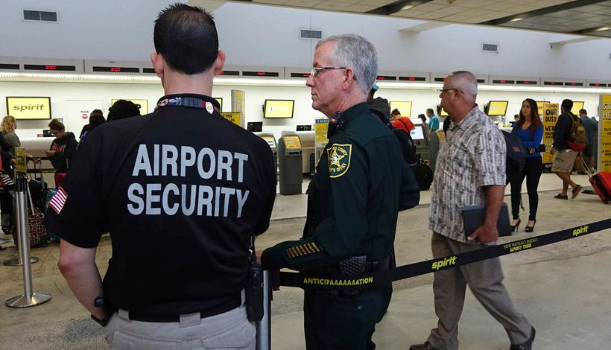

High jackings of various airplanes in the 1960s and 1970s led to the system of screening, ticketing and monitoring procedures, which were followed till 2001.

However, all this changed after the 9/11 incident. It was a wake-up call for authorities who had become complacent with airport security.

New security measures have been developed to stop more elaborate and intelligently planned actions by terrorists.

Things are different now. It is difficult to get through airport security even with a bottle of water. These tough security measures have helped airlines avoid potential terrorist threats.

2.Fight Against Narcotics

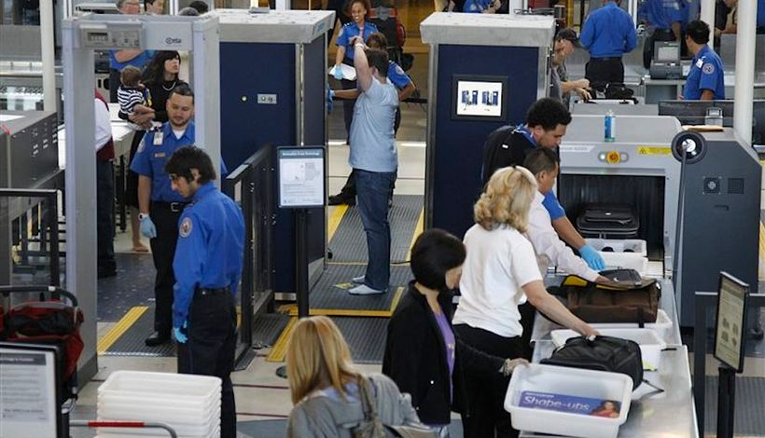

Drugs trafficking went up very quickly once smugglers started using airplanes. Drug lords like Pablo Escobar and others made billions using the flying routes to transport drugs.

This had a negative effect on the aviation industry, affected the society and disrupted the economy countries where drug trafficking was prominent.

Even today we see reports of people coming up with new ways to traffic drugs on airplanes, but modern-day airport security measures have helped to catch the people responsible.

3.Prevent Smuggling



Apart from drugs, airport security has been trained to detect different products that are transported illegally across borders on airplanes.

People in the past have tried to carry things like gold, stolen antiques and in some cases, rare and exotic animals in carry-on bags, but airport security has been successful in stopping such practices.

4.Cyber Security



Airport security doesn’t only involve security checks before boarding a flight.

Hackers are coming up with new and sophisticated ways to attack aviation network computers, Air Traffic Control systems and gain unauthorised access to airport and airline databases.

With the aviation industry becoming heavily dependent on digital technology, cyber-security has become a serious and urgent concern.

Authorities and Airlines are investing heavily in cyber-security and have been able to tackle cyber threats which can cause heavy financial losses and disrupt the air transportation network.

5.Protects Passengers Inside Airport

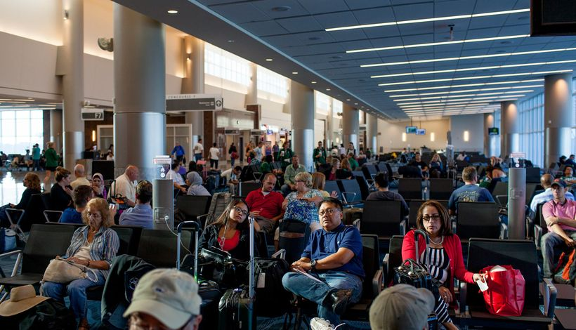

With mass shooting incidences on the rise, airport security keeps passengers protected inside the airport.

If there was no airport security, the airport would be left vulnerable to surprise attacks from terrorists and criminals.

Security measures taken at the airport, discourage criminals from committing such crimes. CISF (Central Industrial Security Force) is a paramilitary organization that looks after the airport security in India.

**10.Applications of Aviation**

With the advancement in technology, airports are now taking the help of modern tools and machines to tackle potential threats to the flyers and make air travel safer. Here are a few examples of these modern machines!

1.A.I.T Scanners

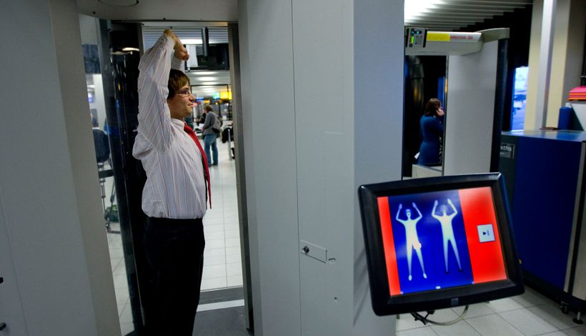

Since its introduction in 2007, Advanced Imaging Technology (AIT) scanners have replaced manual checking at many airports.

These scanners help the security personnel detect any concealed (purposely or not) metal, plastics, ceramics, chemical materials and explosives with the help of 3-dimensional images created by the machine after scanning the passenger.

2.Biometric System



The Biometric Boarding System has had a positive effect on an airport’s security all around the world.

Biometric scanners at airports help security identify the passenger and get their information which is present in the government’s database.

This helps the security personnel to determine whether the passenger is a potential threat or not.

3.MRI Luggage Scanners

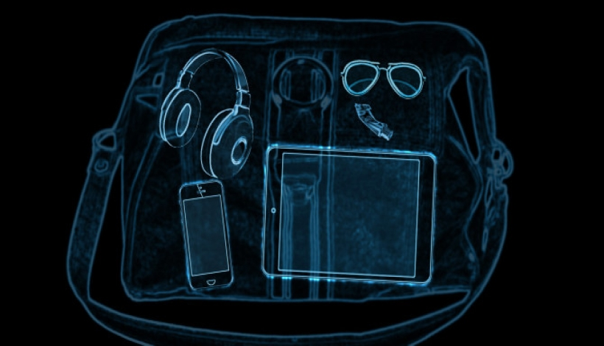

These scanners are similar to MRI scanners present at the hospital.

They help airport security detect liquids and prohibited items in checked-in luggage.

They are currently being used at airports around the world such as London’s Luton Airport and Schiphol Airport in Amsterdam.

4.Cyber Security Solutions



With airports adopting smart technology, aviation cyber-security solutions are being set up.

This software protects aviation networks, computers, and databases from cyber-attacks and unauthorised access.

Due to globalization, airlines are expanding their operations worldwide and are not limited to the country of origin. That is why advanced cyber-security solutions have become a prominent tool for maintaining security.

Airport security is important because it keeps the passenger at ease while flying. It assures that the airplane will make it to the destination safely and the person sitting beside has been deemed as a safe flyer.

If you want to know about your airline’s security policy and location of security checkpoints within the airport, look no further. Simply download the AirWhizz app and get all the information you need about airport security on your phone itself.

Have a safe journey and Fly Stress-Free!

**11. TSA Screeners**

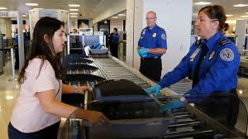

The Transportation Security Administration (TSA) employs thousands of individuals, known as TSA screeners, who maintain security at airports across the United States. The TSA also hires security guards, inspectors, directors, air marshals, and managers. TSA screeners may enjoy such advancement opportunities as TSA trainer, bomb appraisal officer, and transportation security manager. Advancement depends on a screener's job performance and “professional and educational credentials,” according to the TSA.

Career Description, Duties, and Common Tasks

TSA screeners provide security for persons traveling into and through the United States. They screen passengers at primarily at airports, but may also be posted at railways, subways, and other transportation hubs to help prevent attacks. Screeners use a variety of techniques and equipment, including x-ray machines, standing and handheld metal detectors, physical searches of persons and luggage, and canines and other security devices, such as cameras and surveillance equipment. TSA agents also search for weapons, drugs, and other contraband that can make travel unsafe.

TSA screeners are federal government employees with the Department of Homeland Security. Their primary duties include:

Discover and stop emerging transportation security threats by using state-of-the-art technology

Educate and provide friendly customer service to travellers

Screen passengers and gather intelligence

Coordinate security involving aviation, rail, and other surface and maritime transportation

Coordinate heightened security for transportation during national emergencies

Steps for Becoming a TSA Screener

Prospective TSA screeners must be US citizens or US nationals at least 18 years old at the time of application. Prospective TSA screeners usually possess a bachelor's degree or associate's degree in criminal justice, but some jobs only require a high school diploma to be hired. Check with the specific job to learn about the exact requirements. Following are the steps you can expect to follow when applying to become a TSA screener.

Acquire the necessary education and/or experience.

Apply for an open position on the USAJOBS website.

Take and pass a background investigation.

Pass a medical examination.

Take and pass a drug test.

Successfully pass an image interpretation test.

Be hired as a TSA screener.

Receive on-the-job training once hired.

TSA Screener Job Training

Training is an ongoing part of a screener's job. New hires must go through 120 hours of training before being assigned to screen their first passengers. TSA screeners must also pass written examinations and image interpretation tests annually to maintain agency certification. TSA screeners must always remain alert while on the job. As such, they will face unannounced tests – such as an undercover TSA agent trying to pass through security with illegal contraband – to determine if the screener is effectively doing his or her job.

Other Helpful Skills and Experience

Prospective TSA screeners should be able to work and to communicate with diverse individuals and to thrive while working independently, especially when screening passengers. Transportation security officers with law enforcement experience may have a hiring advantage. Applicants should be proficient in English and have excellent customer service skills. They should also be dependable and able to operate with integrity, able to repeatedly lift and/or carry up to 70 pounds, and able to maintain focus and awareness in a stressful environment.

Possible Job Titles for This Career

TSA Agent

Transportation Security Officer (TSO)

Transportation Security Administration (TSA) Screeners

Transportation Security Screeners

TSA Screener Salary and Job Outlook

The Bureau of Labour Statistics (BLS) reports there are about 45,250 TSA screeners in the US, earning an average annual wage of $41,490.1 Populous states like Florida, New York, Texas, Illinois, and Virginia employ the largest number of TSA screeners.1 The vast majority of these screeners work for the federal government.1 The US government's ongoing effort to combat terrorist activity at home and abroad influences the opportunities for employment with the Transportation Security Administration.

**12. Aviation Security Basic Course**

The course is designed to train base or entry level airport security personnel to enforce, monitor and apply airport security measures in accordance with locally approved programmes, and to communicate and cooperate with other airport agencies. The course should be followed by a minimum of six months of practical experience working under the guidance of a qualified AVSEC supervisor in the field.

Course Benefits

By the end of the program, participants will be able to:

Work in and move about an airport safely

Communicate and cooperate with other airport agencies

Control the movement of people and vehicles by means of access control techniques and systems

Guard and patrol airport vulnerable areas, facilities & aircraft

Recognize weapons and explosives/incendiary devices

Inspect/screen/search passengers and baggage

Respond to airport emergency situations

Escort people and consignments

Who Should Attend?

The target population will be new entrants and existing personnel at the basic level employed by the authority or organisation primarily responsible for the application of aviation security preventive measures at airports and from such other aviation related agencies engaged in support activities.

Course Outline

Overview of International Civil Aviation

Working at the airport

Access Control – People

Access Control – Vehicles

Recognition of Explosives and other restricted items

Building Search Procedures

Patrolling and Guarding

Screening & Searching Passengers & Baggage

Conventional X-Ray Equipment

Protection of Aircraft

**13. Elements of Safety Risk Management (SRM)**

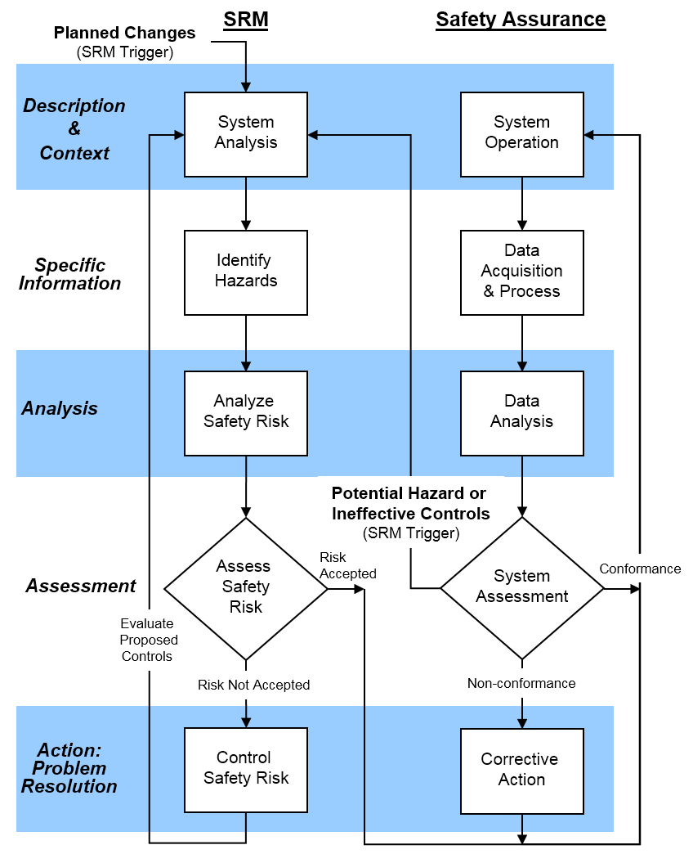

Safety Risk Management receives by far the most attention of any aspect of aviation safety management systems (SMS). It is, as you might say, “where the action is,” in terms of managing risk and the most focused-upon element in an aviation SMS.

Despite the fact that other aspects of aviation risk management processes provide equally valuable assistance in developing an aviation SMS, SRM deals most directly with risk exposure.

SRM is complex, as it:

Requires as much “documenting what you are doing,” as “doing it”;

Will be the area of your SMS program where you develop **risk management tools**; and

Have many working parts needed to adequately practice SRM?

In this discussion, we'll explore the 4 important elements of Safety Risk Management (SRM).

1 - Safety Risk Management Is a Process

The most important thing to always keep in mind about SRM is that it is a process. This process is circular, and loops back upon itself in a never-ending fashion. And this is what one would expect from a fully-functional risk management system: the ability to perpetually demonstrate continuous improvement in an ever-changing environment.

Different industries will use SRM slightly differently, such as by stressing the importance of different SRM elements, but the basic principles are the same everywhere:

**Hazard identification**, including identification of risks, mechanisms of hazards, and other safety weaknesses;

**Understand** the safety behaviour (human factors) and bureaucracy that influence safety; and

Development of **control measures** designed to mitigate exposure.

Other resources online will usually identify anywhere from 3-5 stages in the risk management process, but the basic points are understanding hazards and risks, and then taking measures to control them.

2 - SRM Is One of the 4 Components/Pillars of SMS

The four components, (also referred to as "pillars") of SMS are the cornerstone of safety. They were created by the **International Civil Aviation Organization (ICAO)** and every civil aviation authority uses the four pillars as the centrepiece of their SMS requirements.

As said, while the four pillars are supposed be equal, in actuality SRM receives the most treatment by aviation service providers and civil aviation authorities.

Why is it important that SRM is one of the four pillars? Because it acknowledges the fact that SRM is a worldwide-acknowledged cornerstone of safety management systems:

Determines need for risk controls;

Evaluates adequacy of existing controls; and

Assesses whether or not areas of exposure within acceptable limits.

These are the basic components of the SRM process as defined by most civil aviation authorities.

3 - Assess and Control Hazards, Risk, and Consequences

Much of safety risk management quality revolves around the ability to adequately assess various safety elements such as:

Effectiveness of safety risk controls;

Likelihood of hazard or mishap occurring;

Most realistic level of severity should the hazard manifest itself; and

What kinds of risk control measures are needed to reduce exposure?

The ability to control these elements will depend on the ability to assess them. Poor assessments lead to poor controls. Assessments include tools and processes, including:

Risk analysis;

Hazard and risk register; and

A risk matrix.

Based on the findings of the analysis and assessment, safety managers should be able to identify which hazards and risks need managing in order to maintain acceptable levels of risk exposure. Risk controls include, but are not limited to:

Administrative safety policy and procedures;

Checklists;

Aviation safety training;

Revised operational processes to eliminate or reduce risk;

Engineering controls to isolate people from hazards;

Personal protective equipment (PPE);

And so on.

During aviation SMS implementation, this aspect of SRM will occupy much of a safety manager’s time.

4 - Define Acceptable Level of Safety (ALoS)

**Acceptable Level of Safety (ALoS)** establishes an aviation service provider’s minimum level of acceptable risk for a hazard or risk. Acceptable describes the need for no further mitigatory actions on the part of the service provider for the safety concern in question. This valuation will be made based on the probability and severity of the safety concern in question.

Absolute safety is impossible. At the same time, service providers need to be able to establish thresholds for how much risk is acceptable. ALoS is the answer to this problem. What this means is that ALoS marks the point at which, for a given hazard/potential mishap:

The current level of safety performance is satisfactory;

It would be impractical or far too expensive to take the measures needed to lessen exposure; and

Risk controls are strong enough that the residual risk is willingly taken on by the service provider.

It’s **up to each provider to establish how much exposure is and what isn’t acceptable**. In this way, service providers define their ALoS, and then show to civil aviation authorities (e.g., with safety data), that they operating within an acceptable range of risk.

While SRM is stressed more than other pillars, it nevertheless depends upon them.

Safety Assurance monitors SRM processes to ensure that SRM is working (SRM is design and SA tests the design);

Safety Promotion develops the kind of aviation safety culture that allows SRM/SA relationship to flourish; and

Safety Policy documents many SRM resources, activities and affords employee protections to participate in SA monitoring activities.

**14.Safety Culture: Concepts**

Research shows that only 10% of all accidents are caused by unsafe conditions; 90% of all accidents are the result of organizational and human factors where latent conditions combine with active failures to produce an accident. Since the greatest threats to aviation safety originate in organizational issues, making the system even safer will require action by the organization.

The International Civil Aviation Organization (ICAO) has identified a number of areas in which certain elements of aviation safety programs may be further supported and enhanced, through Safety Management Systems (SMS).

The Civil Aviation Authority of New Zealand defines Safety Management System as a formal organizational system to manage safety. It integrates a range of safety management tools, including senior management commitment, hazard identification, risk management, safety reporting, occurrence investigation, remedial actions and education. An effective Safety Management System generates an enhanced safety culture and provides the necessary management environment for an organization to readily identify and resolve systemic safety problems.

One important tenet of Safety Management System is the attention to organizational safety culture.

Uttal (1983) defines organizational culture as "the shared values (what is important) and beliefs (how things work) that interact with an organization's structures and control systems to produce behavioural norms

On the other the hand, safety culture refers to the extent to which individuals and groups will commit to personal responsibility for safety; act to preserve, enhance and communicate safety concerns; strive to actively learn, adapt and modify (both individual and organizational) behaviour based on lessons learned from mistakes; and be rewarded in a manner consistent with these values. Safety culture is commonly viewed as an enduring characteristic of an organization that is reflected in its consistent way of dealing with critical safety issues

Safety Management System provides an organizational framework to effectively manage safety and serves as the very structure that generates a positive safety culture. SMS frameworks have shown effectiveness when not only adopted as part of a business, but when adopted as part of regulatory oversight operations as well.

Organizational Type

Organisations can be distinguished along a line from pathological to generative:

**Pathological:** The organisation cares less about safety than about not being caught.

**Reactive:** The organisation looks for fixes to accidents and incidents after they happen.

**Calculative:** The organisation has systems in place to manage hazards, however the system is applied mechanically. Staff and management follow the procedures but do not necessarily believe those procedures are critically important to their jobs or the operation.

**Proactive:** The organisation has systems in place to manage hazards and staff and management have begun to acquire beliefs that safety is genuinely worthwhile.

**Generative:** Safety behaviour is fully integrated into everything the organisation does.The value system associated with safety and safe working is fully internalised as beliefs, almost to the point of invisibility.

Four Critical Elements of Safety Culture

An organization's culture is defined by what the people do. The decisions people makes reflects the values of the organization. The following are four critical elements of safety culture, these activities would make up an **"**informed culture**"** - one in which those who manage and operate the systems have current knowledge about the human. technical, organizational and environmental factors that determine the safety of the system as a whole.

**Reporting culture**

people are encouraged to voice safety concerns, report their errors or near-misses

when safety concerns are reported they are analysed and appropriate action is taken

**Flexible Culture**

a culture capable of adapting effectively to changing demands

ability to switch from bureaucratic, centralized mode to a more decentralized professional mode

**Learning Culture**

people are encouraged to develop and apply their own skills and knowledge to enhance organizational safety

staff are updated on safety issues by management

safety reports are fed back to staff so that everyone learns the lessons

**Just culture**

people are encouraged, even rewarded, for providing essential safety-related information

errors must be understood but wilful violations cannot be tolerated

the workforce knows and agrees on what is acceptable and unacceptable

|  |
| --- |
|  |

A Just Culture is, "A way of safety thinking that promotes a questioning attitude, is resistant to complacency, is committed to excellence, and fosters both personal accountability and corporate self-regulation in safety matters."

A Just Culture promotes safety by supporting the fact that humans are vulnerable to errors; errors will always occur; and some errors should not carry with them a personally harsh, punitive, resolution when in fact the system itself might be flawed. However, a clear line must be drawn that differentiates between what is common everyday human error versus flagrant or wilful violations that could, and should, be dealt with in a stricter manner.

**15.How aviation safety has improved?**

* Safest form of travel

Despite the recent tragic loss activity, flying is often said to be the safest form of transport, and this is at least true in terms of fatalities per distance travelled. According to the Civil Aviation Authority, the fatality rate per billion kilometres travelled by plane is 0.003 compared to 0.27 by rail and 2.57 by car.

Statistically, you have more chance of being killed riding a bicycle or even by lightning. The chances of dying in an air crash in the US or Europe are estimated to be 29 million to one.

* Positive statistics

Fatal accidents have fallen every decade since the 1950s, a significant achievement given the massive growth in air travel since then. In 1959, there were 40 fatal accidents per one million aircraft departures in the US. Within 10 years this had improved to less than two in every million departures, falling to around 0.1 per million today.

The improvements in safety are even more impressive when the increase in air traffic is considered. In 2014, the world’s airlines carried a record 3.3 billion passengers in 2014. There were 641 fatalities and 12 fatal accidents last year, according to the International Air Transport Association (IATA).

While the fatality rate significantly increased year-on-year (there were 210 fatalities in 2013), IATA says commercial aviation safety is still at “the lowest rate in history” based on hull losses per one million flights.

By these figures, the 2014 global jet accident rate was 0.23, the equivalent of one accident for every 4.4 million flights. This was actually an improvement over 2013 when the global hull loss rate stood at 0.41 (an average of one accident every 2.4m flights). Both beat the five-year rate (2009-2013) of 0.58 hull loss accidents per million flights. Go back 50 years – when airlines carried only 141 million passengers – there were 87 crashes killing 1,597 people.

* Engineering excellence

The improvement in airline safety is down to a combination of several factors, although the introduction of the jet engine in the 1950s stands out as a major development. Jet engines provide a level of safety and reliability unmatched by the earlier piston engines. Today, it is said that engine manufacturers have almost eliminated the chance of engine failure.

The introduction of electronics, most notable the introduction of digital instruments – known as the ‘glass cockpit’ in the 1970s – and the advent of fly-by-wire technology in the 1980s are also notable achievements, driving safety improvements. Improvements in sensors, navigation equipment and air traffic control technology, such as anti-collision control systems, have also played a role.

 In 20 years’, time we may see more fundamental changes in aviation technology, driven by the economic and environmental concerns of fossil fuels.

* Human factors

While technology has helped drive improvements in the aviation industry’s safety record, great strides in safety management systems and insights into human factors have also contributed significantly.

* Learning process

Improved safety is also a reflection of the aviation industry’s first-class risk management and increasing ability to identify problems before they become a significant issue. Air accident investigations and aircraft safety inspections are now more effective, while improvements in manufacturing technology and better-quality control are also making aircraft safer.

Where next for safety?

While the accident rate improved yet again in 2014, questions remain over the industry’s ability to maintain safety improvements in the future.

IATA notes that, given the projected growth in air travel, hull losses would double without further safety improvements. It has set a goal of further reducing the  
accident rate, but says that new and improved ways of managing safety will be required, such as with the greater use of data analytics.

Tapping into the potentially vast pool of data collected by more than 27 million flights each year – rather than just the handful of flights where something goes wrong – will be key to improving safety in the future, according to IATA. For example, the airline industry is now looking to make greater use of data through IATA’s Flight Data Exchange (FDX), which uses flight recorder data to identify systemic risk issues.

New technology - new risks

The aviation industry’s impressive safety record in recent decades is in large part a reflection of technological developments introduced and then honed in the second half of the 20th century. Subsequent generations of jet aircraft have generally proved safer than the last.

The piston-driven aircraft that dominated the world’s airline fleet in 1960 had an accident rate of 27.2 accidents per million departures. The second generation of aircraft in the latter half of the 1960s and early 1970s, which included the Boeing 727 and the DC-9 jet airliners, had an accident rate of 2.8 accidents per million. The current generation of aircraft have an accident rate of 1.5 accidents per one million departures.

Next generation

Aircraft design may eventually have to change more dramatically, especially if flying is to be kept affordable as fuel costs climb in the future. This could bring about new forms of propulsion – such as electric, hybrid or solar powered planes – radical new airframe designs, as well as new techniques, like assisted take-offs or unpowered landings.

New materials and computer-aided aviation

In the meantime, the aviation industry continues to innovate, most recently with the introduction of composite materials and the increasing use of digital technology and electronics.

**16. About ICAO**

​​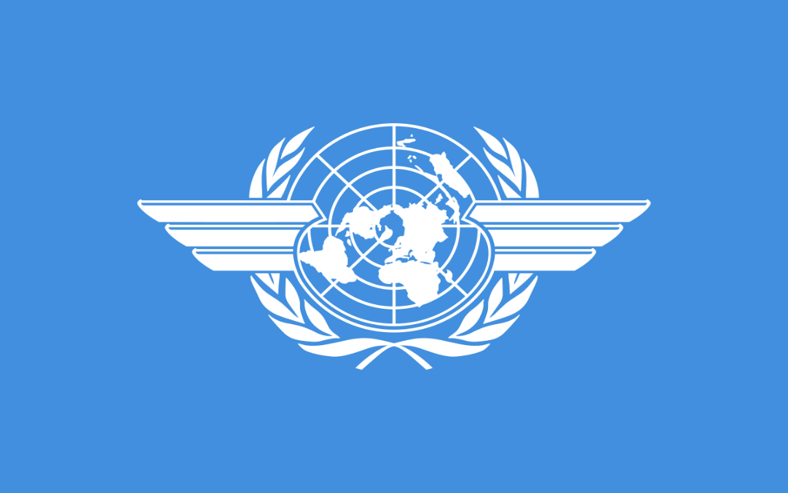

The **International Civil Aviation Organization (ICAO)** is a UN specialized agency, established by States in 1944 to manage the administration and governance of the Convention on International Civil Aviation (Chicago Convention).

ICAO works with the Convention’s 193 Member States and industry groups to reach consensus on international civil aviation Standards and Recommended Practices (SARPs) and policies in support of a safe, efficient, secure, economically sustainable and environmentally responsible civil aviation sector. These SARPs and policies are used by ICAO Member States to ensure that their local civil aviation operations and regulations conform to global norms, which in turn permits more than 100,000 daily flights in aviation’s global network to operate safely and reliably in every region of the world.

In addition to its core work resolving consensus-driven international SARPs and policies among its Member States and industry, and among many other priorities and programmes, ICAO also coordinates assistance and capacity building for States in support of numerous aviation development objectives; produces global plans to coordinate multilateral strategic progress for safety and air navigation; monitors and reports on numerous air transport sector performance metrics; and audits States’ civil aviation oversight capabilities in the areas of safety and security.

**17.About IATA**



IATA's full form is International Air Transportation Association. It represents, leads and serves airline Industry.

It is a trade association of world's airlines. Its major responsibility is to serve and support Aviation with global standards for airlines safety, security, efficiency and sustainability.

There are several listed functions of IATA, few important functions are listed below:

Improve the regulatory and legal environment like consumer protection, infrastructures etc.

Monitor and maintain high level of membership satisfaction.

Ensure 100% IATA members are aware of requirements of resolution 753 i.e. end to end baggage tracking.

Commencement of different programs and certifications like cargo management, distribution and payments etc for better insights and learnings for the people working or will to work with Aviation industry.

Help formulate industry policies on critical Aviation issues.

**18. Required Skillset for Aviation**

Aviation at the core requires each and every member to work as one team. Thus, being a team player is not a requirement it is mandatory in this field as a slight lapse on any individual’s part and the lives many others are at stake. Thus, some key skills that aspirants need to possess in order to perform well in the aviation industry are:

|  |  |
| --- | --- |
| Team worker | Level headed |
| Reliable | Presence of mind |
| Determination | Language skills |
| Clear speech and voice | Good written English/Hindi |
| Good health & physical fitness | Confidence |
| Technical skills & understanding | Pleasant & friendly personality |
| Agility & good sense of balance | Patience |
| Polite | Punctuality |

Aviation Eligibility Criteria

In order to pursue a job as a cabin crew or ground staff in the aviation industry aspirants can be from any stream (arts/commerce/science). But people aspiring to become an engineer or a pilot should have pursued Science at the school as well as graduation level.

Course curriculum for Aviation

The curriculum of a course offered in the Aviation industry sphere varies as per the degree that is offered to candidates on completion of the course. Apart from this, it is worth knowing that course curriculum may also vary from college to college.

Aviation Job Profiles

A career in Aviation industry is such that aspirants would not have fixed work hours/shifts. While the first profession that comes to mind when thinking of a career in the Aviation industry is that of a Pilot but it is worth knowing that there is a plethora of other career profiles that candidates can pursue in this field. Some of the popular job profiles that candidates can hope to pursue in this field are as mentioned below:

|  |  |
| --- | --- |
| Aircraft Electrical Installer or Technician | Aircraft Manufacturing Engineer |
| Pilot | Airport Operations Manager |
| Air Traffic Controller | Aviation Maintenance Technician |
| Quality Control Personnel | Flight Steward/Stewardess (Airhostess) |
| Ground Staff | Air Ticketing Staff |

**19. Advantages of Air Transport**

Following are the advantages of air transport

* High Speed: It is the fastest mode of transport and therefore suitable for carriage of goods over a long distance. It requires less time.
* Quick Service: Air transport provides comfortable, efficient and quick transport services. It is regarded as best mode of transport for transporting perishable goods.
* No Infrastructure Investment: Air transport does not give emphasis on construction of tracks like railways. As no capital investment in surface track is needed, it is a less costly mode of transport.
* Easy Access: Air transport is regarded as the only means of transport in those areas which are not easily accessible to other modes of transport. It is therefore accessible to all areas regardless the obstruction of land.
* No Physical Barrier: Air transport is free from physical barriers because it follows the shortest and direct routes where seas, mountains and forests do not obstruct.
* Natural Route: Aircrafts travels to any place without any natural obstacles or barriers because the custom formalities are compiled very quickly. It avoids delay in obtaining clearance.
* National defence: It plays a significant role in the national defence of the country because modern wars are conducted with the help of aero planes. Airways has an upper hand a destroying the enemy in a short period.

**20.Disadvantage of Air Transport**

In spite of many advantages, air transport has some disadvantage also.

* Risky: Air transport is the riskiest form of transport because a minor accident may put a substantial loss to the goods, passengers and the crew. The chances of accidents are greater in comparison to other modes of transport.
* Very Costly: Air transport is considered costlier as compare to other mode of transport. The operating cost of aero-planes are higher and it involves a great deal of expenditure on the construction of aerodromes and aircraft. Because of this reason the fare of air transport is high that common people can’t afford it.
* Small Carrying Capacity: The aircrafts have small carrying capacity and therefore these are not suitable for carrying bulky and cheaper goods. The load capacity cannot be increased as it is found in case of rails.
* Unreliable: Air transport is unreliable as it depends of the weather forecast. Normally if the weather is not certain the flight may get delayed.
* Huge Investment: Air transport requires huge investment for construction and maintenance of aerodromes. It also requires trained, experienced and skilled personnel which involves a substantial investment.

**21. Top 10 Most Famous Flight Attendants throughout History**

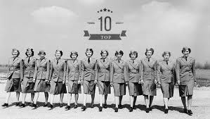

Being a flight attendant is not an easy task – you need to go through weeks of training and you will have the responsibility of guiding every passenger on board if an emergency situation ever happens. In a long line of flight attendants, quite a few showed bravery, strength and uniqueness. We would like to present a list of top ten cabin crew members who stood out in history.

1. Heinrich Kubis

He was the world’s first flight attendant. Yes – he. And not only he was a male cabin crew, he cared for passengers not on a plane, as one might think, but a zeppelin. He started his career in 1912, working for a German airline DELAG on a zeppelin named Schwaben. He even worked on the infamous zeppelin – Hindenburg. When Hindenburg burst into flames, Kubis, once the zeppelin was close enough to the ground, helped the passengers to jump to safety before jumping out of it himself.

2. Ellen Church

Ellen Church was the first female flight attendant who started her career in the 1930s. In fact – she was a pilot too. Unfortunately, back then, airlines were not interested in hiring women. Or any job aboard a plane. So Church, also being a registered nurse, promoted the idea that women nurses would handle tasks that the co-pilots used to do – hauling luggage, handing out lunches and helping passengers.

3. Edith Lauterbach

Edith Lauterbach worked as an air hostess in 1944 and was the first out of many to start the fight for the rights of women in the aviation world. Together with three other women, she founded the Air Line Stewardesses Association – the ancestor of today’s Association of Flight Attendants-CWA, the aviation industry’s main union for in-flight service workers. Thanks to Lauterbach and her colleagues, sexist work rules ceased existing and a flight attendants’ pay doubled throughout the years.

4. Ruth Carol Taylor

Ruth Carol Taylor was the first African-American flight attendant in the United States who started her career in 1957. Wanting to break the colour barrier, she applied to work as a flight attendant for Trans World Airline. She was rejected for her race, but she did not let her hands down and soon got the job at Mohawk Airlines. Taylor spent much of her career and life as an activist for the minority of women’s rights.

5. Momi Gul Durrani

Momi Gul Durrani was one of Pakistan International Airlines’ cabin crew members in the 1950s and 1960s. She had facial features suited for the camera and for such reason, PIA showed Durrani in many of their advertisements. The most famous saying about her was “when she smiled, she made others smile”. Soon she gained popularity as a kind and beautiful stewardess. Sadly, she was on duty aboard PIA Boeing 720B jetliner which crashed near Cairo Airport. Durrani died together with the 114 people on board.

6. Neerja Bhanot

Neerja Bhanot was a senior flight attendant on Pan Am Airlines. On the 5th September, 1986, Bhanot died only at the age of 23 in a hijacking of the aircraft. But she died a hero. As a senior cabin crew, she took charge of the plane and its passengers, shielding them from the terrorists that had boarded Pan Am Flight 73 flying from Mumbai to New York. After 17 hours, terrorists opened fire and set off explosives. Bhanot opened the doors and helped the passengers escape, not running to safety herself. She died shielding three children from bullets. One of the passengers, then a seven-year-old, is now a captain with a major airline and has stated that Bhanot was his inspiration and he owes her his life.

7. Ulrike Patzelt

Ulrike Patzelt, or Uli Derickson (after marriage), was a German-American flight attendant who is known for her courage protecting 152 passengers and crew members during a hijacking of TWA Flight 847 that happened in 1985. With her calm demeanor and the help of German language, she was able to speak and negotiate with the Lebanese terrorists. She shielded anyone who they tried to hurt and fought for other passengers’ safety. After many negotiations and political moves, the hijackers released them after fifteen days. Every passenger on that flight is thankful for Patzelt’s brave acts.

8. Barbara Jane Harrison

In 1968, Barbara Jane Harrison gave up her life to save the passengers of a Boeing 707-465 belonging to Intercontinental for British Overseas Airways Corporation. The aircraft took off, but within 20 seconds one of the jet engines burst into flames. Three minutes later, the plane landed and the cabin crew started the evacuation procedures. Barbara was one of the brave flight attendants, that instead of jumping to safety came back into the flames to save a disabled man. Sadly, she died in the fire, but for her bravery, Queen Elizabeth II awarded her a George Cross, Britain’s highest award for civilian bravery.

9. Vesna Vulovic

Vesna Vulovic was the sole survivor of the DC-9 plane of Yugoslavian airlines. Yugoslavia was then torn by war, and a fascist group planted a bomb in the aircraft Vulovic boarded. While flying through the city of Srbska-Kamenice, the explosive detonated. The D-9 was torn to pieces and crashed into a mountainside. All 28 passengers died that day, but miraculously, Vulovic survived. She is considered to be one of the luckiest people alive, and despite the horrific crash, after she regained her health, she continued working for airlines, proud to be part of cabin crew.

10. Johanna Sigurdardottir

Johanna Sigurdardottir is a known former politician and Prime Minister of Iceland. But before that she started her career as a flight attendant for Iceland’s main airline (before Iceland Air) Loftleidir. She is not only the first female Prime Minister in the world, but also the first openly gay head of government as well. A professional leader and a brave activist – the strong traits cabin crew are known to have.

**22.Who is the father of civil aviation in India?**

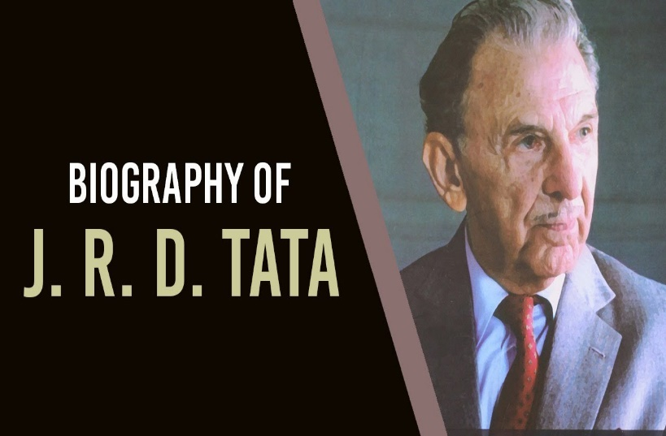

Jehangir Ratanji Dadabhoy (JRD) Tata’s life was a convergence of influences and interests. Born in 1904 in Paris, to a French mother and Indian father, he successfully straddled two cultures, eventually receiving both the French Legion of Honor and India’s highest civilian award, the Bharat Ratna.

His business life was equally diverse. He became Chairman of Tata & Sons, India’s biggest industrial group, in 1938. The group was founded by his father’s cousin but under JRD’s leadership it went from a $100 million business controlling 14 companies to a $5 billion concern with nearly 100 companies.

Despite the depth of such distractions, JRD’s overriding passion was aviation. His hero was the French piloting ace Louis Blériot, the first man to cross the English Channel by air. Bleriot lived near the Tata’s French country home and once allowed a co-pilot to give the 15-year-old JRD a ride. From that moment on, JRD was determined to fly.

Having moved to India, in 1929 he achieved his goal. He became the first person in the country to be issued with a pilot’s license.

A year later, he competed for the Aga Khan Trophy, which was being offered to the first Indian to fly solo from India to England or vice versa. JRD was flying from Karachi to London and landed en route at Aboukir Bay in Egypt. There he discovered another competitor, flying in the opposite direction, stranded by the lack of a spark plug. JRD willingly gave him his spare one and was ultimately defeated by a couple of hours.

The experience only strengthened his love of flying, however. In 1932, JRD set up Tata Airlines, the first Indian commercial carrier to transport mail and passengers within India. The company was based out of a small hut with a palm thatched roof at Juhu Airstrip in Bombay (Mumbai). JRD flew the first leg of the inaugural Karachi-Madras (Chennai) journey himself, taking mail from Karachi to Bombay via Ahmedabad using a single-engine De Havilland Puss Moth. In its first year, Tata Airlines flew 160,000 miles, carrying 155 passengers and more than 10 tonnes of mail.

Tata Airlines became Air India in 1946. Two years later, following Indian independence, the government took 49% of the company, also giving itself the option to acquire an additional 2%. Following JRD’s recommendation, the government established Indian Airlines to run domestic services while JRD took the helm of Air India International, which was granted a license to operate international flights.

Five years later, the Government of India exercised its option to purchase a majority stake in the carrier. Despite the nationalization of the airline, JRD remained in charge of Air India until 1978.

His love of aviation never diminished and his contribution to the industry is reflected in numerous awards and achievements. In 1979, he won the Tony Jannus Award, and in 1986 he received the Edward Warner Award given by the International Civil Aviation Organization. He was also Chairman of IATA from 1957–1958, an indication of his standing and his vision for a fledgling industry.

Particularly telling in the modern aviation environment is JRD’s commitment to working together. Consensus was his modus operandi and he became famous for courting opinion before taking a decision. He was also quick to bridge the gap between workers and management and Tata’s benefits, such as free medical aid, were later adopted by India as statutory requirements. As JRD put it: “No success in material terms is worthwhile, unless it serves the needs or interests of the country and its people.”

It is in India though that his impact on aviation is greatest. He was named Honorary Group Captain of the Indian Air Force in 1948 and an Honorary Air Commodore of India in 1966. In 1982 he recreated his legendary first journey for Tata Airlines flying a De Havilland Leopard Moth in an effort to instil future generations with his entrepreneurial spirit and love of aviation. For JRD, the flying experience was “the greatest adventure” of his life.

**23. Air Hostess Job Description**

Air hostesses, commonly called flight attendants or stewardesses, tend to passengers on a flight. They review safety practices before the flight, bring passengers requested items such as pillows or earpieces, serve food and drinks, and ensure that passengers are comfortable throughout the flight. Air hostesses also conduct safety checks at various times during a flight, instruct passengers during a plane’s descent, and assist in the deplaning process after landing.

Air hostesses are employed by all major airline companies. According to the most recent statistics from the Bureau of Labor Statistics (BLS), a 10% employment growth rate in this field is expected between 2016-2026. The use of larger planes, with a greater number of passengers on board each flight, is believed to play a major role in this projected employment growth.

Air Hostess Duties and Responsibilities

Air hostesses are generally assigned several tasks that must be completed for each flight. We have examined several job listings and found the following to be among the most commonly mentioned for this occupation:

* **Attend to Passenger Comfort and Safety**: The main duty of an air hostess is to ensure the comfort and safety of a plane’s passengers. Air hostesses review emergency and safety procedures prior to take-off, which includes demonstrating the use of any equipment. They also fill passenger requests, serve food and beverages, and tend to sick passengers, if needed.
* **Assist Passengers in Deplaning**: It is up to air hostesses to instruct and assist passengers throughout the descent and deplaning process. They ensure that passengers are safely in their seats as the plane descends and that all garbage and loose objects have been removed and secured. Once the plane has landed, air hostesses assist passengers in removing all carry-on luggage and direct them to the exits to depart the plane.
* **Conduct Pre- and Post-Flight Checks**: Air hostesses typically complete a pre-flight check that includes testing and ensuring that all safety equipment is in working condition. Following the deplaning process, air hostesses conduct a post-flight check to make sure all passenger items have been removed and seats and trays are placed in proper positions. They might do some light cleaning of an airplane’s interior as part of their post-flight duties.

Air Hostess Skills

Great air hostesses are interested in world travel, very good at customer care, highly sociable, and able to carry out a variety of tasks under time pressure. They should also be detail-oriented, organized, and possess the ability to work in a team environment. Air hostesses should be able to and react to crises and stressful situations in a calm and reassuring manner. Finally, air hostesses should be in good physical condition and be able to sit and stand for long periods of time. In addition to these abilities, air hostesses should display the following skills and capabilities:

* Communicating clearly with others
* Reassuring passengers in the event of an emergency, making sure they follow safety procedures
* Ensuring that passengers are made comfortable
* Maintaining a calm demeanour, positive outlook, and an empathetic nature
* Exhibiting excellent interpersonal skills
* Working with a culturally diverse population
* Looking and acting like a professional at all time

Air Hostess Tools of the Trade

Air hostesses must draw on required knowledge and the use of some equipment in order to complete all job tasks. If you wish to become an air hostess, you must have an understanding of the following:

* **Emergency equipment**– from breathing apparatus to defibrillators, air hostesses should be familiar with various equipment needed to address in-flight emergencies
* **First aid** – it is important for air hostesses to know how to administer basic first aid, such as wound dressing and CPR
* **Survival training**– in case of severe emergency, air hostesses are trained in survival skills—from creating a shelter to gathering food, finding safe drinking water, and attracting help
* **Foreign languages**– air hostesses are often required to communicate with people of diverse cultural backgrounds; it is helpful for them to be fluent in at least one, and ideally more, languages in addition to English

Air Hostess Education and Training

There are no formal degree requirements associated with being an air hostess; most employers require only a high school diploma. Many airlines require that newly hired air hostesses complete company-led emergency and flight attendant training programs.

Air Hostess Salary

According to the BLS, air hostesses are paid a median annual salary of $48,500. Those in the 10th percentile earn $26,570; those in the top 10 percent are paid $78,650. The highest mean annual wages for air hostesses are paid primarily in North-western states. Washington ($70,500), Oregon ($67,380), and Arizona ($63,710) are the top three states in the U.S. when it comes to mean annual salaries for air hostesses.

Air Hostess Resources

If you’re looking for more information about what is involved in working as an air hostess, you can refer to the helpful books, blogs and other references we have provided below:

Association of Professional Flight Attendants (APFA) – From news about current events and trends in the field to meetings and events providing networking and learning opportunities, APFA offers a wide range of benefits to air hostesses.

Association of Flight Attendants-CWA (AFACWA) – This organization, offering an overview of air hostess issues and current news in the field, is the largest labor union for flight attendants, representing nearly 50,000 professionals in the field.

I Heart Cabin Crew – This site offers blogs by and about air hostesses, providing career tips, best practices, flight attendant lifestyles, and many other details.

The Flight Attendant Life – From personal insights into this career to the best shoes to wear while working, this blog gives an in-depth perspective of working as an air hostess.

**The Essential Guide to Becoming a Flight Attendant** – Written by an air hostess and flight attendant consultant, this book provides a detailed look at this career, including benefits and schedules. The book includes role-playing scenarios and details about training programs.

**Fly Girls Guide: How to Become a Flight Attendant** – Based on the author’s YouTube video series, this book explores what it takes to become an air hostess, from creating a résumé to interview tips and much more.

**24. Five Characteristics of Effective Aviation Safety Cultures**

“Safety culture” is a phrase that gets thrown around a lot in aviation safety management systems (SMS) as a vague reference to different aspects of safety.

Understanding the meaning of aviation safety culture is less a practice in philosophy as it is recognition of what it looks like in actual practice for:

Safety management’s responsibility;

Employees’ responsibilities;

Management-employee relationships;

Employee actions when nobody is watching; and

The structure of an aviation SMS.

Understanding what healthy and unhealthy safety culture looks like, and then incorporating healthy aspects into your own SMS is certainly easier said than done.

If you don’t have a firm grasp on what safety culture means for your organization, chances are that

your safety culture is not very well developed; or

you are starting a new safety job; or

you working on a new SMS implementation.

To create a strong culture of safety, aviation safety management must encourage the following attributes in their safety program.

1 – Build Safety Responsibility from the Bottom Up

Building from the bottom up is a serious aviation safety management commitment to recognizing that hazard identification and subsequent mitigation activities starts with front-line employees. By "recognizing," we mean building communication structures that build confidence through:

Knowledge;

Hazard identification ability; and

Safety responsibility.

The last bullet point, safety responsibility, is an aspect of safety culture that often goes unaddressed, or unnoticed. One of the primary problems we have seen in most aviation SMS is that organizations who kill a sense of safety responsibility in front-line employees struggle with:

corporate culture,

management tyranny, or

excessive top-down structure.

It creates a mindset in workers that:

management will deal with it, or

2 – Open Dialogue about Human Error

When employees make mistakes, the normal response in many organizations is to not discuss it openly. The reasons seem rather clear: the most obvious being the idea of making the people involved uncomfortable by “singling them out” is contrary to a non-punitive safety culture.

But in fact, the opposite is true.

Practicing an open dialogue about safety issues, without judgment, makes several things about errors very clear:

Valuable insights into the SMS program’s vulnerabilities;

A key safety learning opportunity; and

A natural part of any program.

An old manager used to tell me that the mistakes aren’t a problem so long as you don’t repeat them, and having open dialogues about human error stresses the same points.

If anything, not openly discussing safety issues for fear of making employees uncomfortable actually has some rather insidious side effects. For one, it communicates to employees that mistakes are unacceptable. More importantly, it implies that management may be hiding safety information. Which is another way of saying “lack of transparency.”

3 – Practice of Healthy Unease

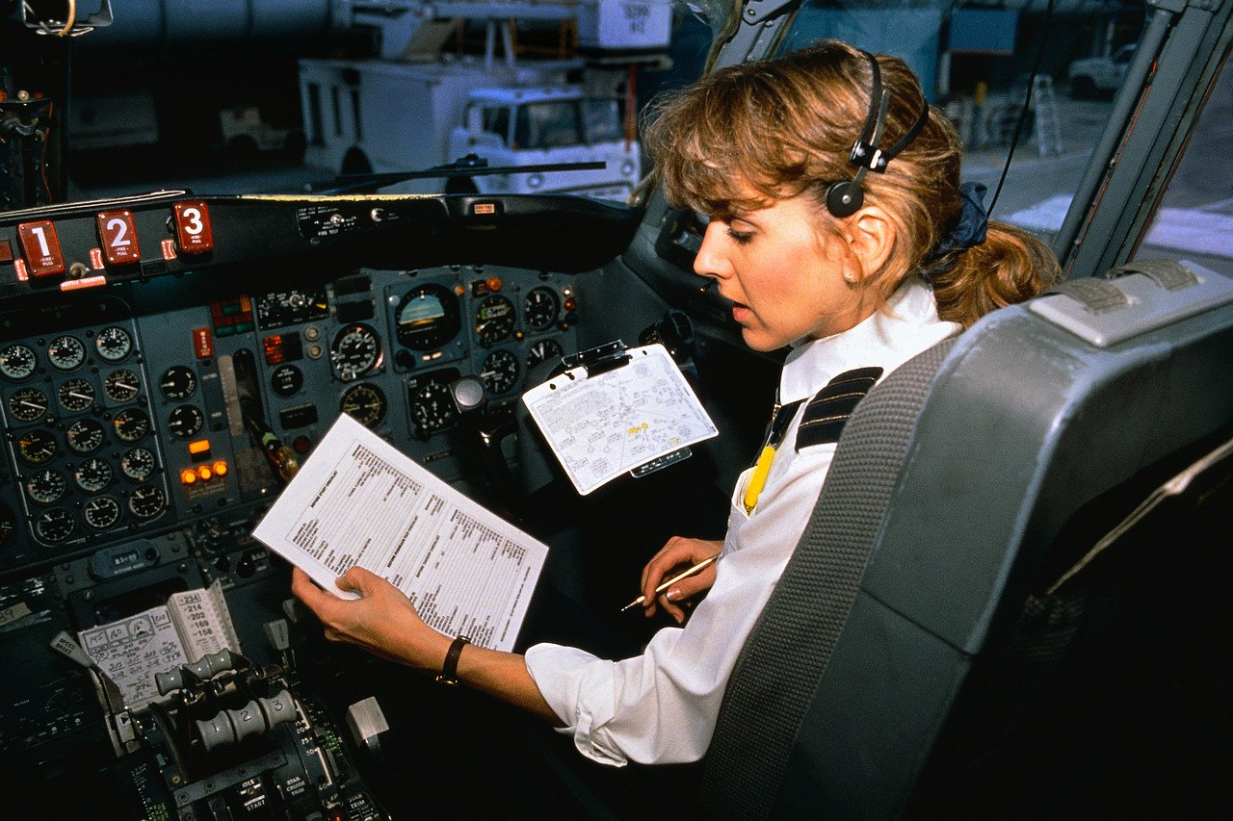

I sometimes tout that past success is not a future guarantee. Yet no matter how complicated or hazardous an activity is, most people don’t feel unsafe when they have effectively performed a task many times. Successful repetition has a way of:

Encouraging employees to let their guard down;

Terminate a mindset of “continuous learning”;

Make employees complacent about their task (in terms of safety); and

Inspire overconfidence about safety concerns.

The main question is: how do healthy safety cultures tackle this natural human reaction to repetition? Organizations can’t force employees to be hyper-vigilant at all times. The most practical approach to instilling “healthy unease” into actual practice is to have an SMS policy of “trust but double check.”

Such a prescription doesn’t try and force-feeds a feeling of healthy unease so much as a practice of healthy unease concerning aviation safety hazards.

4 – Clear about Teamwork and Blamelessness

Teamwork is an allusive word in aviation safety management systems, as it can mean many different things. But aviation SMS’ core value is risk management, and teamwork in terms of risk management means that the failure of one person is also the failure of the whole.

When problems do occur, the natural reaction is to:

Start pointing fingers;

Become defensive; and

Use words like “him,” “her,” or “they.”

Some of you may be thinking that I am contradicting myself by saying not to “point fingers” when earlier I advocated for “singling out.” But this is precisely the problem many organizations struggle to grasp: **singling out and blame are not the same thing**. Singling out is simply pointing out the specific actions and mindset that lead to a problem, whereas blame is assigning “fault.”

Healthy aviation safety cultures are able to speak openly about the relationship between a specific individual’s actions (singling out) and the environment that permitted such actions to lead to a problem. The focus on the environment as leading to the problem is ultimately how organizations accept failure as a whole rather than assigning fault, and reinforce the idea that the organization is a team.

5 – Employees Are Expected to Question and Act

Healthy aviation safety cultures universally share two things in common when it comes to the behavior of employees:

Employees are involved through assertiveness; and

Employees are empowered to take action when things don’t seem right.

In many ways, empowerment is a natural outcome of cultivating safety responsibility in employees. Part of that responsibility is to ask questions and stop when something seems “wrong.”

A necessary part of having empowered employees is that aviation safety management systems have a zero tolerance policy towards intimidating behaviors. Intimidating behavior can come in many forms from both management and front-line employees – but such behavior needs to be heavily discouraged.

Safety Tools to Cultivate Safety Culture

Much of a safety culture will be a natural result of how companies react to and treat various safety issues, accidents, and problems. Beyond this, there are myriad aviation risk management tools in which organizations can help instill certain values in management and employees:

Safety training, both informal and formal;

Regular safety promotion;

Aviation safety surveys; and

Aviation safety management system software;

These are just some of the place’s organizations can help streamline methods of promoting a positive safety culture.

Monitoring particular aspects of the aviation SMS processes are required to justly claim that "our safety culture is improving." There are many safety culture indicators available in your organization. Use these indicators to back up your claims of "strengthened safety culture." These indicators may include:

Hazard reporting rates;

Number of safety meetings held; or

Responsiveness to completing routine safety tasks.

These are just a few elements that can be monitored in your SMS. Don't limit yourself to using only these. The point is that you will be in a better position to back up your claims of a "stronger safety culture" when you can back up your assertions with statistics, such as:

Improved hazard reporting 15% over last year;

Reduced time to close issues by 4 days over last year;

85% of corrective and preventive actions completed on time this year vs 45% last year.

The point is that as a safety professional, you will definitely appear more "professional" when you have statistics to back you up. The easiest, most cost effective way to tracking these statistics is by adopting a best-in-class aviation SMS database solution.

Many of the better SMS software programs provide this information with only a few clicks of the mouse. Safety professionals need professional tools to "appear more professional." Good luck improving your safety culture.

**25. What are Safety Objectives in Aviation Safety Programs?**

Safety objectives in aviation SMS programs are the criteria risk management programs use to fulfil safety goals, and define key performance indicators. Safety objectives are how SMS programs meet specific performance benchmarks.

Creating safety objectives is one of the most important tasks safety managers will fulfil. The process of creating safety objectives demonstrates their role and function in a safety management system:

Create a list of safety goals;

For each safety goal, several objectives are created that help reach that goal;

For each objective, an appropriate key performance indicator will be used to measure performance of that objective; and

Periodically - usually on an annual basis - safety objectives will be updated.

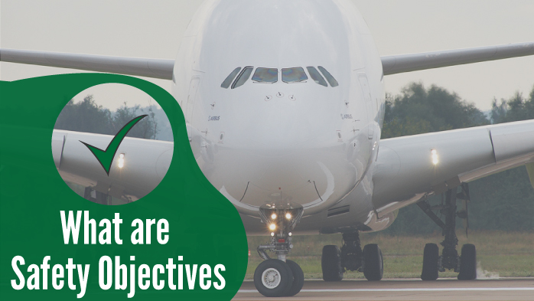

As safety objectives are reached, they will need to be changed out to further along continuous improvement towards their parent goals. If safety objectives cannot be reached, they will need to be re-evaluated. The most important rules for creating safety objectives are that they are:

Specific;

Measurable; and

Relevant.

Some examples of safety objectives for a parent safety goal of "Develop a hazard reporting culture" are:

Increase hazard reporting 10% over previous year;

Reduce average day for hazard reporting for new employees to less than 14 days;

Train at least 95% of employees on hazard identification; and

Reduce distribution of high-risk issues by 10%.

Once these safety goals are established, you can link them to a corresponding key performance indicator to track performance.

**26. Eleven Airplane Safety Features We Never Knew Existed**

It’s a truth that frequent flyers hear time and again and probably take for granted, but your airplane ride might just be the safest part of your day.

Last year was the safest year ever for commercial aviation, Aviation Safety Network data shows, and the average yearly number of aviation fatalities has been falling steadily since 1997. It’s all thanks to the continuing safety-driven efforts by international aviation organisations, and the evolving technology and design of modern aircraft.

Since the dawning of commercial airliners, more than 50 years ago, more than one billion flight hours have been wracked up. This accumulation of experience and information have given airlines, designers and manufacturers the insight needed to make constant improvements to the design of aircraft.

Every detail of your plane, from the cockpit and wings to cushion covers and floor plan, has been carefully considered with safety in mind. Even if you fly all the time, you may be surprised by just how many safety features are hidden in plain sight, and the little details you never even knew existed.

The next time you board a flight, you may want to pay closer attention. Here are the hidden safety features that can not only make your journey more comfortable, but might make all the difference in the unlikely event of an emergency situation.

1.This is why airplanes still have ashtrays.

Smoking is banned on aircraft, so why do they still have ashtrays? Despite the rules, ashtrays in bathrooms are a legal requirement by the Federal Aviation Administration (FAA), according to Time. This is because, despite of all the warnings, people might still try and get away with a crafty smoke in the loos, and if they do, there needs to be somewhere safe to stub out their cigarette - a lavatory’s waste bin contains flammable material, so you can rule that out.

The regulation is taken so seriously that a Mexico-bound British Airways flight was grounded in 2009 after it was discovered not to have any ashtrays on board.

2.We never knew a secret bedroom onboard

When they're not at the beck and call of demanding passengers, have you ever wondered where the crew go to catch a break?

Most long-haul aircraft are designed with crew compartments, which is a little somewhere for attendants to grab a nap and have a breather. Pilots, however, go one better and have a secret bedroom.

Typically located behind the cockpit and above first class, these small rest cabins usually contain a bed, reclining seats and, if they’re lucky, a bathroom and TV, according to The Independent.

3.The escape plan marking system

In the unlikely event of a fire, things inside the cabin can get pretty smokey and fast. After several onboard fires resulted in huge amounts of thick smoke, aircraft started installing a FPEEPMS, or Floor Proximity Emergency Escape Path Marking System, to you and us.

These markings, which are on the floor or at near-floor level, use photoluminescent elements, which can be seen in poor visibility. This makes it possible for passengers to read the exit signs while remaining down on their hands and knees to avoid smoke inhalation.

4.There are hand cuffs

They might be cable-ties or they might be of the heavy duty, stainless steel variety, but you can bet there is some kind of device for passenger restraint on board your plane.

A number of conventions - including the Tokyo Convention (1963) and the Montreal Convention (1971) - outline the rules and regulations concerning discipline on board of an aircraft, according to the BBC. Under these agreements, it’s up to a plane's captain to decide whether a passenger needs to be restrained. Cabin crew is also permitted to request help from passengers to detain an individual, should they need it.

5.That tiny hole in the window

If you’ve ever sat in a window seat, you’ll likely have noticed a tiny hole in the bottom of the window, and yes, it’s supposed to be there. Known as a bleed hole, these tiny features act as a sort of safety valve.

According to Mark Vanhoenacker, a British Airways pilot who reports about aviation, the pressure inside an aircraft during flight is much greater than the pressure outside. Windows are triple-glazed and the outer two cabin windows are designed to contain this difference in pressure, but it’s the outer pane that bears most of this pressure, thanks to the breather hole.

6.A secret latch to open the lavatory from outside

So, here’s the bad news: Your lavatory is never really locked. On the outside door of an airplane loo is a little metal plate saying “lavatory.” It’s not just aesthetic, because flip that plate and you’ll find a secret latch underneath that can be used to lock/unlock doors from the outside.

According to The Express, some airlines use this to lock washrooms during take-off and landing to stop people going in. It’s also a safety mechanism to prevent someone from locking themselves away, giving flight crew emergency access if needed.

7.Check out the yellow hooks on the wings

If you’re the lucky passenger in “William Shatner’s Seat” (see the first entry on our list), you’ll have a good view of these bright yellow little features.

In event of a landing on water, these little hooks, which are located about a third of the way to the tip of the wing, may prove to be very useful, according to Reader's Digest. When emergency exits are opened and the inflatable slide is rolled out, a rope is attached to the hooks, which gives passengers something to grasp as they evacuate, should the wings be slippery.

8.A camera in the cockpit

Despite some pilots objecting, citing privacy laws, several airlines have rolled out cockpit surveillance, which records everything that goes down on a plane’s flight deck.

Air-safety watchdogs have been advocating the use of cockpit video cameras for several years, despite fierce opposition from pilots, who argue that it will interfere with the decision-making process.

The argument in favour is that the camera footage supplements black-box voice and flight-data recorders - which pilots also opposed when they were first mandated. So far, the FAA has refused to make them compulsory, saying the evidence wasn’t compelling enough to do so.

9.The little black triangle

Airplane windows are a useful safety feature in themselves, allowing crew to check mid-flight for ice or other potential problems that the wings might have.

The Shatner reference comes from an episode of the 60’s sci-fi show Twilight Zone called Nightmare at 20,000 Feet, in which the actor features. From his airplane seat, his character sees a gremlin on the wing, which is not a problem most flights have to contend with in the real world.

10.Onboard gas masks

If there’s a fire onboard, cabin crew are the first line of defence - it’s their job to try putting out the blaze. This is why the plane carries gas masks, and why they are for flight attendants only. Another, reason flight crew are issued with gas masks is because they are portable. Passenger oxygen masks are restrictive, but a gas mask allows crew to move up and down the plane to deal with any potential problems. It’s a practical thing.

11.Can you spot the undercover sky marshal

How closely do you watch other passengers during a flight? Could the woman sat next to you be an undercover sky marshal, hiding in plain sight? You better hope you never find out - because if you do, things have just got ugly.

Sky marshals are mysterious agents of the skies, tasked with handling dangerous situations aboard commercial flights. And, if he or she is doing their job properly, you’ll never even know they’re there. A sky marshal will only act in case of a suspected act of terrorism or other serious threat, and though they do carry weapons, they’ll only be used in extreme situations.

**27. Civil Aviation**  
Civil Aircraft is a rather big group of aircraft. It refers to all non-military flights and activities in aviation.  
  
General Aviation  
General aviation refers to all civil flights other than scheduled airline flights, both private and commercial. General aviation flights range from gliders and powered parachutes to large, non-scheduled cargo jet flights. Because of the huge range of activities, it is difficult to cover general aviation with a simple description — general aviation may include business flights, private aviation, flight training, ballooning, parachuting, gliding, hang gliding, aerial photography, foot-launched powered hang gliders, air ambulance, crop dusting, charter flights, traffic reporting, police air patrols, forest fire fighting, and many other types of flying.

* Ballooning: Ballooning is a type of civil aviation that uses buoyancy to float in the air. This buoyancy is generally created by filling a large fabric envelope with hot air or gases that are lighter than the surrounding atmosphere. The less dense balloon lifts the basket tied underneath that carries people and cargo into the air. A balloon has no propulsion system, so it floats with the wind.
* Soaring: Soaring is a type of general aviation where the flight of a motor less aircraft involves using air currents and thermals to fly long distances. Aircraft used for this purpose are called gliders or sailplanes, and often have very clean designs made of metal or fiberglass to improve glide ratio.
* Private Aviation: Private aviation is the part of general aviation that involves flying not for hire. In a private flight, the pilot is not paid, and the aircraft owner/operator does not receive money for the flight (other than rent from the pilot, in some cases). In many countries, private aviation operates to less strict standards than commercial aviation. Private pilots normally are not required to demonstrate the same level of proficiency on their flight tests, and take fewer and less rigorous medical examinations. Many small aircraft are private planes.
* Scheduled Airline Flight: An airline is a part of civil aviation that provides air transport services for passengers or freight, generally with a recognized operating certificate or license. Airlines vary from those with a single airplane carrying mail or cargo, through full-service international airlines operating many hundreds of airplanes. Airliners may fly intercontinental, intracontinental, or domestic.
* Military Aviation: Military aviation is the use of aircraft and other flying machines for the purposes of conducting or enabling warfare, including national airlift (cargo) capacity to provide logistical supply to forces stationed in a theatre or along a front. The wide variety of military aircraft includes bombers, fighters, fighter bombers, transports, trainers, and reconnaissance aircraft. These varied types of aircraft allow for the completion of a wide variety of objectives. Many automatic devices assist the crews in obtaining results not achievable by human means. Machines can carry out many tasks including locating, tracking, and destroying targets.
* Transport aircraft: Transport aircraft are primarily used to transport troops and war supplies. Cargo also may be discharged from flying aircraft on parachutes, eliminating the need for landing. The aerial tanker can refuel fighters, bombers, and helicopters while in flight. This means that an aircraft can go to any point on the globe without landing transport troops. This can be important in remote areas.  
    
  Experimental aircraft are designed in order to test advanced aerodynamic, structural, avionic, or propulsion concepts. These are usually well instrumented, with performance data telemetered on radio-frequency data links to ground stations located at the test ranges where they are flown.  
    
  Today, aircraft manufacturers tend to design planes with multi-role abilities, with both bomber and fighter qualities, so the distinction is becoming relative or obsolete for new aircraft.

**28. Safety Management**

Safety management is commonly understood as applying a set of principles, framework, processes and measures to prevent accidents, injuries and other adverse consequences that may be caused by using a service or a product. It is that function which exists to assist managers in better discharging their responsibilities for operational system design and implementation through either the prediction of system’s deficiencies before errors occur or the identification and correction of system’s deficiencies by professional analysis of safety occurrences.

Safety management implies a systematic approach to managing safety, including the necessary organisational structure, accountabilities, policies and procedures.

Definition

Safety management is an organisational function, which ensures that all safety risks have been identified, assessed and satisfactorily mitigated.

Objective

The objective of safety management in the aviation industry is to prevent human injury or loss of life, and to avoid damage to the environment and to property.

Scope

The primary focus of safety management in aviation is on safety of flights encompassing also all associated and support services, which can have an impact on safety, for example air navigation services, aerodrome operations management, etc. Occupational safety and related health & environmental issues fall outside the scope of SKYbrary articles on safety management and are generally dealt with by a separate management system.

Introducing Safety Management in Aviation

The concept of proactive safety management in aviation originated in the mid-1990s. It encompasses a business-like management approach to the safety of flight operations.

In retrospect the initial and fragile “fly-fix-fly” system (1920s - 1970s), was reactive in nature, i.e. the emphasis was put on individual risk management, intensive training and accident investigation. This approach was gradually replaced by a new system-based concept. From the 1970s to the mid-1990s the adopted model was mainly influenced by the progress of technology and shifted the concern towards human error. The focus was to contain and mitigate the human error through regulation and training; lessons were being learned from incident investigations and other industries. In spite of substantial investment of resources in human error mitigation, the major reason for safety breakdowns continued to be attributed to unsatisfactory human performance as a recurring factor. From the mid 90’s onwards, a new approach towards managing safety was adopted, proactively utilising and analysing routinely collected safety-related data.

Reactive Safety Management

According to ICAO Safety Management Manual (Doc 9859) safety management in aviation industry is a combination of the two described perspectives, traditional and modern. The reactive (or traditional) safety management approach is useful when dealing with technological failures, or unusual events. It is generally described by the following characteristics:

The focus is on compliance with the minimum safety requirements;

The level of safety is based on reported safety occurrences, with its inherent limitations, such as: examination of actual failures only; insufficiency of data to determine safety trends; insufficiency of insight regarding the chain of causal and contributory events; the existence and role of latent unsafe conditions.

Proactive Safety Management

The proactive approach in the safety management is based on following a risk management strategy that includes identifying hazards before they materialise into incidents or accidents and taking the necessary actions to reduce the safety risks. Components of a proactive safety management strategy are:

Unambiguous safety policy ensuring the senior management commitment to safety;

Hazard identification and risk assessment using state-of-the-art risk assessment methods;

Safety reporting systems used to collect, analyse and share operational safety related data;

Competent investigation of safety occurrences with sole purpose of identifying systemic safety deficiencies;

Safety monitoring and safety oversight aimed to asses safety performance and eliminate problem areas;

Dedicated safety training for personnel

Safety lesson dissemination and sharing best practices among operators and service providers;

Building a corporate safety culture that fosters good safety practices and encourages safety communications in a non-punitive environment

None of these components will, on their own, meet expectations for improved aviation safety management. An integrated use of all these components will increase a system’s resistance to unsafe acts and conditions. The consistent integration of the components of proactive safety management is commonly referred to as a Safety Management System (SMS).

The growing recognition of the role and importance of safety management has led to the progressive implementation of safety management systems by aviation service provider organisations (airlines, air navigation service providers, airport operators) in the last few years. This process is managed and monitored by States through dedicated safety programmes in line with International Civil Aviation Organisation (ICAO) recommendations.

Improving corporate safety performance by proactively managing the safety of provided services is increasingly recognised by all aviation sectors as a prerequisite for sustainable business management and operational growth.

The Cost of Safety

Safety comes at a price. All organisations have limited resources to devote to safety, and must deal continually with the conflicting goals of safety versus productivity, efficiency, or customer service objectives, which ultimately determine profitability. Financial health in any business will be influenced not only by good management and internal efficiency, but by the external economic environment.

A stated commitment to safety is necessary but not sufficient to enable safety improvements. The commitment must be supported by appropriate resourcing - of technology and equipment, training and expertise, policies and systems that promote operational safety.

One indicator of a positive safety culture is the extent to which these resources for safety are immune from an organisation’s financial situation. The commitment to safety should be consistent and visible regardless of any financial pressures facing the organisation, whether internally or externally generated.

The extent to which an organisation’s financial health operates and is committed to safety (as stated) will be apparent from information about the following decisions and practices:

What budgetary changes affecting safety are made when ‘times are tough’? For example, is some safety-related training seen as dispensable and is cut or postponed?

To what extent are productivity or efficiency pressures increased at these times? For example, is ‘cutting corners’ encouraged or condoned more often?

Do management priorities, messages and most importantly their actions change from a focus on safety to other organisational goals, such as the ‘bottom line’?

**29. 10 things you didn't know about being an air hostess**

In my four years working as a flight attendant for different airlines, including British Airways, I’ve been inundated with questions about what it’s really like to be an air stewardess. From strict grooming protocol to what passengers get up to when they think no one is watching, it’s time to bust some myths and reveal a few surprising truths about life at 30,000 feet.

1. We can survive a situation like the television series Lost.

Survival training is one of the many skills in cabin crew’s toolkit. We know how to create a shelter, gather food, find safe drinking water and attract help in the Arctic, jungle, rainforests and deserts, which means you really are safe in our hands.

2. Most of us haven’t joined the Mile-High Club

The truth is that not many hostesses have sexual encounters on board - they’re tired, bloated and have often just dealt with passengers’ bodily fluids, so frisky is the last thing they're feeling. Any passengers who do get 'hot under the collar' at high altitudes get busy in the toilets, but cabin crew can open doors from the outside, so beware. And for those thinking their complimentary blanket affords secrecy, we can still hear and see you when the lights are off - so keep your hands to yourself, ladies and gentlemen.

3. No drinking the night before a flight

There are no exceptions to this rule. All cabin crew can be subjected to alcohol and drugs testing before a flight as it is illegal to be intoxicated on an aircraft, meaning stewards must be booze-free for at least 12 hours before take-off.

4. We’re not allowed to gain weight

Once you’re issued with a uniform, that’s it - you can’t change it for a size bigger if you find you’ve put on a few pounds.  The airline will give you one month to lose the weight - otherwise you will be put on a weight management programme.

5. We can deliver babies in mid-air

If you find your in-flight movie interrupted by labour pains, don’t worry about going it alone. We're trained in how to safely deliver babies until the emergency services can take over on the ground. Your little one might even find itself with free air travel for the rest of its life - though don’t get your hopes up if the miracle of birth occurs on a budget airline.

6. We get quizzed before each flight

Before embarking on every journey, we undergo a briefing with the senior cabin crew member, in which we are asked two emergency procedure questions and one medical. Failure to answer correctly means being taken off the flight.

7. We know the best places to have a good time

It’s well known that cabin crew love to party, and once a destination has been reached, it’s all about having fun - whether that’s at a luxurious cocktail bar or an exotically located Irish pub. Instead of buying a travel guidebook just ask cabin crew for some tips, or better yet, tag along on their nights out. Flight attendants have been known to have wild pool parties, blag their way into VIP areas and even wake up with errant farmyard animals in hotel rooms a la the film The Hangover, so if we’re having a party, you want to be invited.

8. Many have previously trained in different professions

A lot of people take to the skies after having left another career, so we work with ex-teachers, lawyers, nurses, policemen: you name it, there’s a place on board for everyone.

9. Grooming standards are strict

Wonder why cabin crew always look immaculate? That’s because they’re disciplined if grooming standards aren’t followed to the letter. Skirts can’t go above the knee, heels must not be higher than three inches, lipstick has to be a certain shade of red and constantly applied, and nails must always be manicured with only pink, red or French polish. Some airlines have also been known to check the colour of your bra before a flight, so being on your best beauty behaviour is a must.

10. We’ve seen everything

Mid-flight strip-teases, mothers putting their babies in overhead lockers, sanitary pads doubling up as eye masks - it's all in a day’s work.

**30. Aviation Safety Network releases 2019 airliner accident statistics**

The Aviation Safety Network today released the 2019 airliner accident statistics showing a total of 20 fatal airliner accidents, resulting in 283 fatalities.

Despite the high-profile Boeing 737 MAX accident, the year 2019 was one of the safest years ever for commercial aviation, Aviation Safety Network data show. Yet, while the number of fatalities has decreased, the number of accidents has increased to a level above the five-year average.

Over the year 2019, the Aviation Safety Network recorded a total of 20 fatal airliner accidents, resulting in 283 (occupant) fatalities. This makes 2019 the seventh safest year ever by the number of fatal accidents and the third safest in terms of fatalities. The safest year in aviation history was 2017 with 10 accidents and 44 lives lost.  
Looking at that five-year average of 14 accidents and 480 fatalities, last year showed a markedly higher number of accidents.

Thirteen accidents involved passenger flights, six were cargo flights. One out of 20 accident airplanes were operated by airlines on the E.U. “blacklist”, down by two compared to 2018.

Surprisingly more than half of the accidents occurred in North America (compared to just one in 2018 and three in 2017). Five accidents occurred in remote or rugged parts of Canada and Alaska. Despite progress made through various safety initiatives by Canadian and U.S. regulators, this still is an area of concern.

The Aviation Safety Network is an independent organisation located in the Netherlands. Founded in 1996. It has the aim to provide everyone with a (professional) interest in aviation with up-to-date, complete and reliable authoritative information on airliner accidents and safety issues. ASN is an exclusive service of the Flight Safety Foundation (FSF). The figures have been compiled using the airliner accident database of the Aviation Safety Network, the Internet leader in aviation safety information. The Aviation Safety Network uses information from authoritative and official sources.